# Twenty killed and at least 74 injured in spate of shootings across US over the weekend

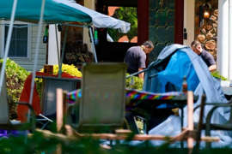

© Provided by The Independent

Twenty people were killed and at least 74 injured in a spate of shootings across the United States over the weekend.

Police in Chicago say that in their city alone 36 people were shot, eight fatally, including a 15-year-old boy, since Friday night.

Violence also broke out in Minneapolis, Minnesota, in the early hours of Saturday morning when two people were killed and eight injured in an altercation outside a nightclub.

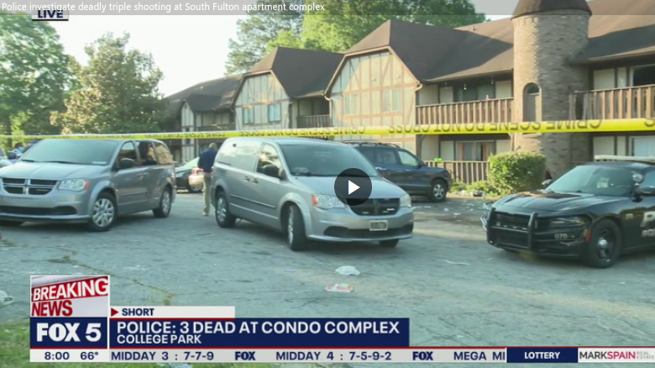

This was followed by a string of shootings in [New Jersey](https://www.independent.co.uk/topic/new-jersey), [South Carolina](https://www.independent.co.uk/topic/south-carolina), [Georgia](https://www.independent.co.uk/topic/georgia) and [Ohio](https://www.independent.co.uk/topic/ohio).

Police say that the Minneapolis killings took place when two men standing in a crowd exchanged words, pulled out guns and fired at each other.

When police arrived at the incident they found an “exceptionally chaotic scene”, with multiple gunshot victims on the ground, according to 5ABC.

One of the gunmen, who has not been identified, was killed, along with Charlie Johnson, a recent graduate of the University of St Thomas School of Engineering.

The second alleged gunman, Jowan Contrail Carroll, 23, was arrested on probable cause of murder, according to the Bloomington Police Department.

Three men and five women were among the injured, with one of the victims reportedly in critical condition.

Two people were killed and 12 injured at a shooting at a 90s-themed party in Fairfield Township, New Jersey, on Saturday night.

A 30-year-old man and a 25-year-old woman, who have not yet been named, were both killed when gunfire broke out.

Police say they have not made any arrest in the case and the investigation is ongoing.

A 16-year-old girl was killed and seven others were injured in a shooting on Saturday night at Bicentennial Park in Columbus, Ohio, police said.

Five victims were taken to hospital but are expected to survive, and two others sustained non-gunshot injuries fleeing the scene.

Authorities said the shooting took place at a private event that had been promoted on social media.

A 14-year-old boy was killed and 14 others were injured during a shooting at an unauthorised concert in North Charleston, South Carolina, on Saturday night.

North Charleston Police Deputy Chief Scott Deckard said that the shooting took place after a fight broke out near the concert stage.

Police have not released information on any suspects in the case.

Three people were killed and five injured in the early hours of Sunday morning in a shooting outside a bar in Youngstown, Ohio.

Officials say that one of the shootings happened in the bar “but they stemmed from an incident which began there” and officers found a “chaotic and tragic” scene.

Police say they have not made any arrests but investigators have spoken to several people, but htye have not released details on how many weapons were used in the shooting.

“It is not easy for me to get the call in the middle of the night from the chief or one of his team to tell me about incidents like this, and it pains me,” said Mayor Jamael Tito Brown.

Police in the Atlanta area found three people shot to death in a condominium building after they responded to reports of gunshots early on Sunday morning.

Officials in South Fulton say that all three victims died at the scene but police have not released any details on suspects in the case or a motivation for the triple slaying.