# https://www.bbc.co.uk/news/world-europe-56616778

# Russian 'troop build-up' near Ukraine alarms Nato

* [Ukraine conflict](https://www.bbc.co.uk/news/topics/crr7mlg0d21t)

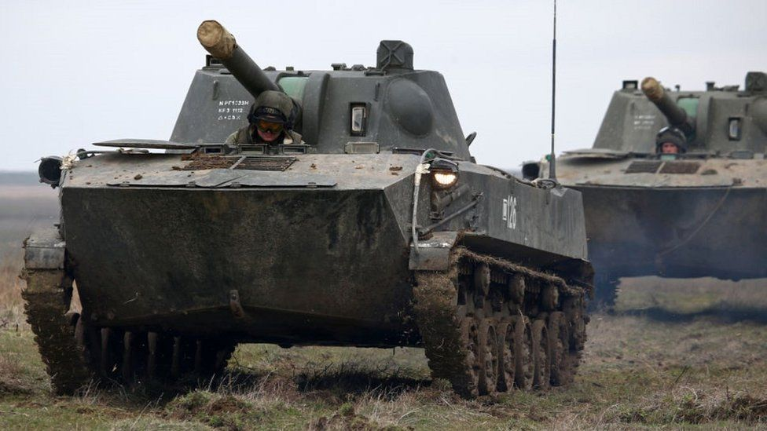

image copyright Getty Images

image caption Russia has been conducting military manoeuvres in Crimea

**Russia has warned Nato against sending any troops to help Ukraine, amid reports of a large Russian military build-up on its borders.**

Kremlin spokesman Dmitry Peskov said Russia would take "additional measures" if Nato were to make such a move.

Sporadic, low-level clashes continue in eastern Ukraine between Ukrainian troops and Russian-backed separatists.

US forces in Europe are now on higher alert, citing "escalations of Russian aggression" in the area.

A Nato official told Reuters news agency that Russia was undermining efforts to reduce tensions in eastern Ukraine and Nato ambassadors had met on Thursday to discuss the situation.

"Allies share their concerns about Russia's recent large-scale military activities in and around Ukraine," the official said.

Ukraine's President Volodymyr Zelensky joined the criticism, saying "military exercises and possible provocations along the border are traditional Russian games".

Meanwhile, Mr Peskov accused Ukrainian forces of staging "provocations" on the frontline in eastern Ukraine, where a fragile ceasefire is violated daily.

In the worst flare-up in recent months, four Ukrainian soldiers died in separatist shelling on 26 March near Shuma, a village in the Donetsk region. There have been only low-level incidents since then.

## What is the scale of Russian involvement?

Last month Russia conducted military exercises in Crimea, the Black Sea peninsula it annexed from Ukraine in March 2014.

The rebels in the Donbas region of eastern Ukraine also rely on Russian help. Western governments say Russia has deployed regular troops there, along with heavy weapons. That is denied by the Kremlin, which says Russian "volunteers" are helping the rebels, who seized a swathe of the Donetsk and Luhansk regions in April 2014.

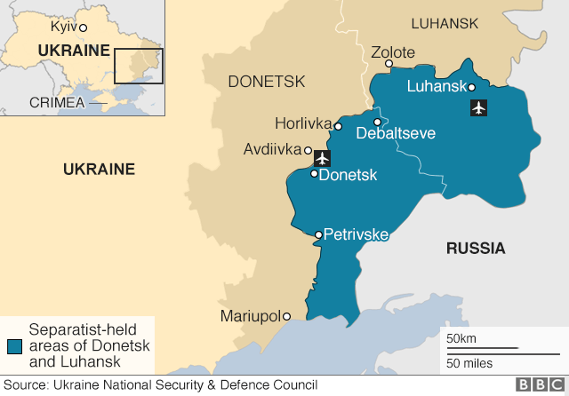

Unverified video on Twitter in recent days purports to show Russian tanks, artillery and armoured vehicles heading to the Ukrainian border.

Ukraine's army commander Gen Ruslan Khomchak says Russia has deployed 28 battalion tactical groups near Ukraine's eastern border and in Crimea, which would amount to 20,000-25,000 troops. Russian officials have not confirmed that, nor given any precise figures.

According to Gen Khomchak, Russia also has nearly 3,000 officers and military instructors in the rebel units in eastern Ukraine.

"The Russian Federation moves its armed forces within its territory at its discretion," Kremlin spokesman Mr Peskov said. He added that "it should not worry anyone and does not pose a threat to anyone".

* [Will a deal with Russia bring peace to Ukraine?](https://www.bbc.co.uk/news/world-europe-49986007)

The Russian military has confirmed that an airborne assault brigade - about 4,000 troops - is being redeployed to Crimea from Volgograd in southern Russia this year.

Since 2014 Russia has considerably beefed up its military presence in Crimea, including its key Sevastopol naval base.