# Evidence suggests Ethiopian military carried out massacre in Tigray

By Africa Eye  
BBC World Service

Related Topics

https://www.bbc.co.uk/news/world-africa-56603022

* [Tigray crisis](https://www.bbc.co.uk/news/topics/cr2pnx1173dt)

media caption Footage shows people in military uniforms shooting unarmed men

**An investigation by BBC Africa Eye has uncovered evidence that a massacre in northern Ethiopia was carried out by members of the Ethiopian military. It also reveals the precise location of the atrocity, in which at least 15 men were killed.**

In early March, a series of five video clips surfaced on social media showing armed, uniformed men leading a group of unarmed men to the edge of a cliff, shooting some at point blank range, and pushing dead bodies over the cliff.

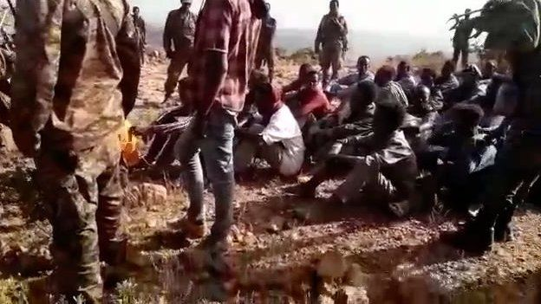

image captionUnarmed men in civilian clothes seen on the ground shortly before the massacre began

The BBC has confirmed that the massacre took place close to the town of Mahbere Dego in Ethiopia's northern Tigray region, where the Ethiopian army is fighting the forces of the Tigray People's Liberation Front (TPLF), previously the region's ruling party.

The fighting began last November when the government launched a military offensive against the TPLF, which Prime Minister Abiy Ahmed accused of attacking a government military base. The TPLF is opposed to efforts by Mr Abiy to increase the power of the federal government, and has said it is committed to "extended resistance".

The conflict has so far displaced more than two million people, according to Tigray's interim administration, and left more than four million people in need of aid.

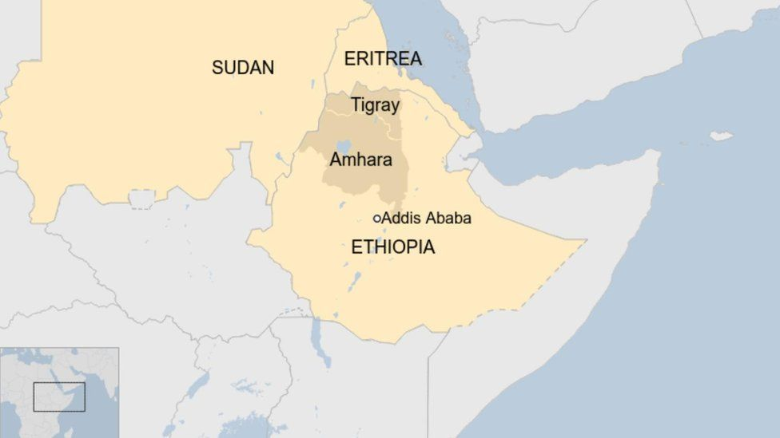

## Geo-locating the footage

The BBC Africa Eye investigations team, working together with analysts from the media outlets Bellingcat and Newsy, set out to establish where the massacre took place.

The first people to post the clips to social media claimed they were filmed near Mahbere Dego. Africa Eye analysed geographical features seen in the videos, including a dirt road, a plateau, and an escarpment with a distinctive profile, and compared them with satellite imagery of the area around the town.

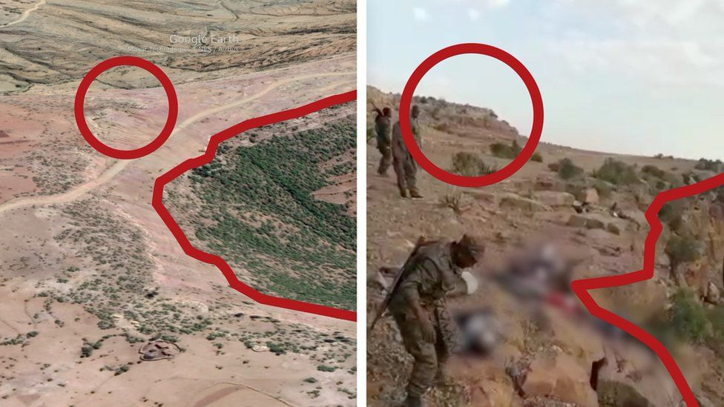

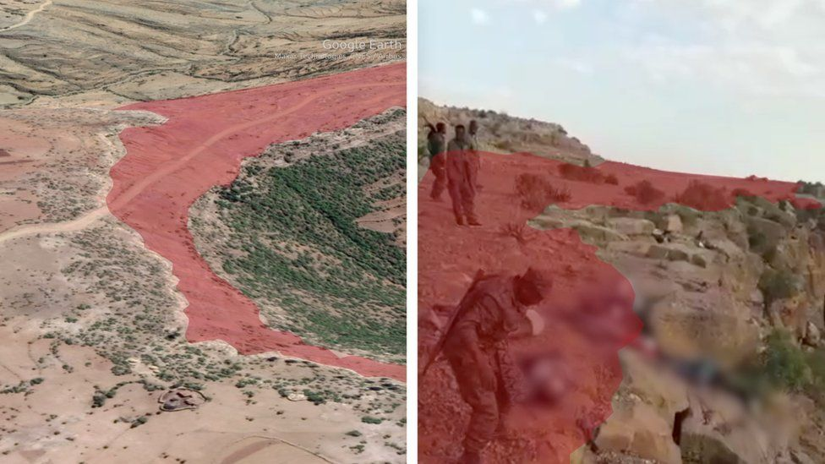

image caption An escarpment with a distinctive profile was used to compare the footage with satellite imagery

The direction and length of shadows cast by the armed men helped to pinpoint the likely time of day and showed that the escarpment was oriented north-south, allowing Africa Eye to identify a likely location.

A ridgeline in the video footage was then overlaid on a topographical map of the location to confirm it was an exact match. A dry riverbed, band of vegetation, and pattern of trees further confirmed the match.

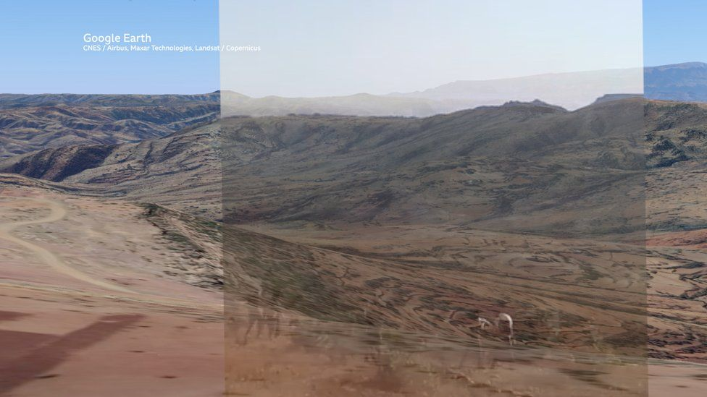

image caption Footage from one of the video clips was overlaid on a 3D rendering of the terrain to find a match

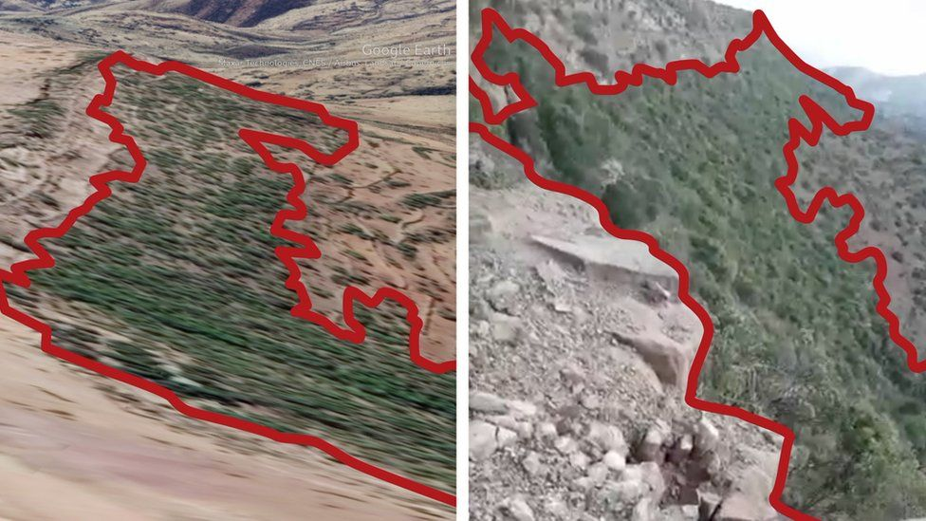

image caption Vegetation seen in the footage was matched against the 3D satellite model

The BBC spoke by phone to a resident of Mahbere Dego, who said the Ethiopian army took away 73 men from the town and surrounding area in January this year, including three of his relatives. He said none of them had been heard from since.

The BBC also spoke to a resident in a neighbouring village who said that his brother was among those killed in this massacre. He said that the killings took place in Mahbere Dego, and gave the same month: January 2021 - the government had declared victory in the conflict in November.

"They killed them at the cliff," he said.

## Identifying the armed men and victims

Africa Eye was not able to confirm the identities of the armed men seen in the video footage, but the details of their uniforms - including the camouflage pattern and arm badge in the colour of the Ethiopian flag - appear to match those worn by the Ethiopian National Defence Force (ENDF).

Other features also match the ENDF uniform, including the cut and style of the pockets. One of the armed men wears a green beret bearing an insignia that appears to closely match the colour and insignia of the ENDF beret.

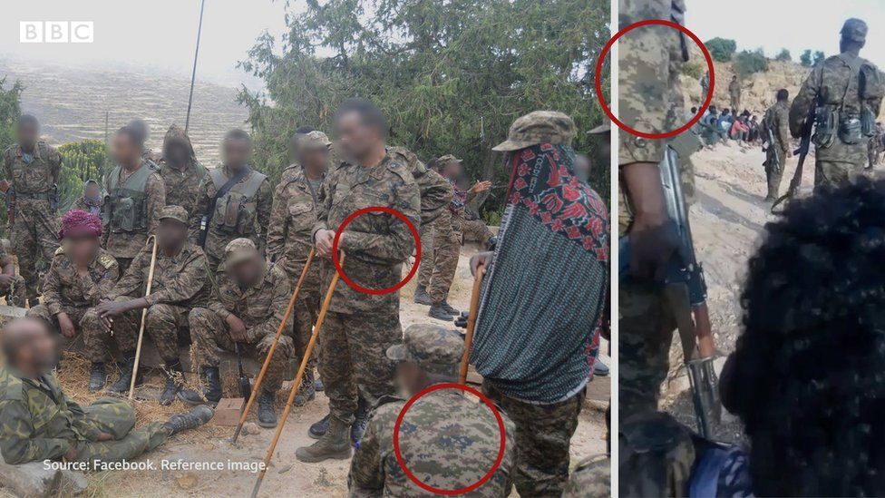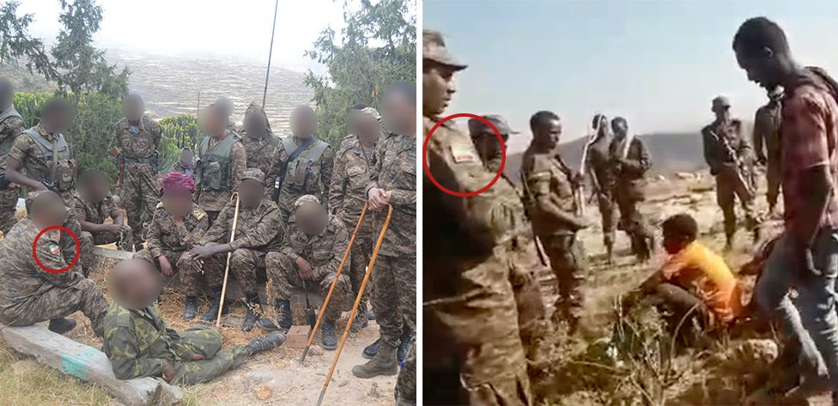

image caption Badges in the colour of the Ethiopian flag and the specific camouflage patterns seen on the armed men in the footage (right) match those worn by ENDF soldiers (left).

The armed men are speaking Amharic, the main official language of Ethiopia. In the first of the five video clips, they can be heard speaking to one another as they stand around the group of unarmed men, who are seated on the floor.

"We should not free these people. Not even one of them should be spared," says a voice off camera.

"We have to get this on video, how these people die," says another voice.

**More about the conflict in Tigray:**

* [Rare view inside Ethiopia's conflict zone](https://www.bbc.co.uk/news/world-africa-56456793)
* [The Nobel Peace Prize winner who sent his troops to battle](https://www.bbc.co.uk/news/world-africa-55145827)
* [MSF 'witnessed soldiers killing civilians' in Tigray](https://www.bbc.co.uk/news/world-africa-56524991)
* ['I lost my hand when a soldier tried to rape me'](https://www.bbc.co.uk/news/world-africa-55832711)

The next four clips show the unarmed men being led at gunpoint towards the cliff edge, and capture the armed men killing several prisoners and pushing the bodies of the dead over the cliff.

In some sections of the footage, the gunmen can be seen firing bullets from close range into the bodies. In others they can be heard insulting and mocking the dead.

"I wish we could pour gas over them and burn them," says a voice off camera in one clip.

"It would have been great if there was gas to burn these people," replies a second voice. "Burn their bodies like the Indians do."

The identity of the victims, who are seen wearing civilian clothes, is not known. They can be heard speaking Tigrinya, the language of the Tigray region. In the footage, the killers appear to suggest they believe the victims belong to the TPLF.

"This is the end of woyane," says a voice of one of the armed men, using a slang term for the TPLF.

"We don't show mercy."

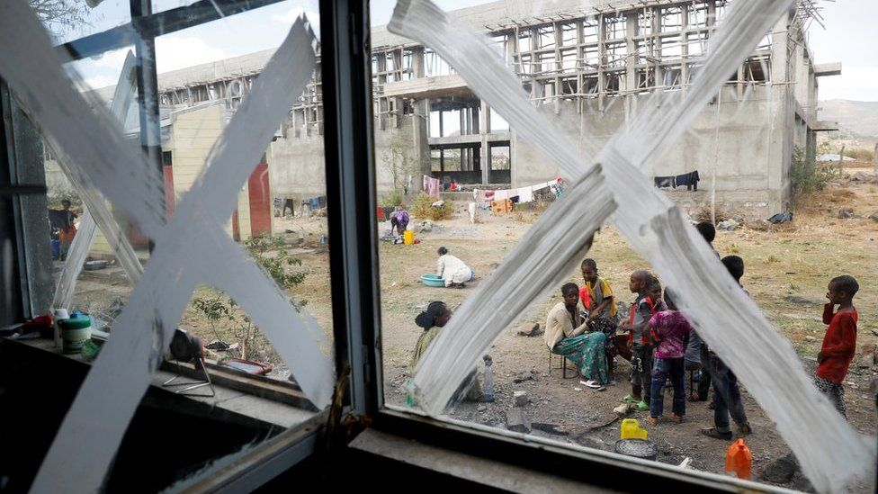

image copyright Getty Images

image caption Displaced people at a temporary shelter in Tigray last month

Laetitia Bader, the Horn of Africa director for Human Rights Watch, told the BBC that observers had seen "a whole magnitude of very serious abuses" in the region in recent months, but that this footage was "obviously particularly alarming".

"We see what appear to be unarmed detained men, who are being executed," she said. "This is absolutely an incident that requires further investigation, because what we are seeing here in these videos could amount to war crimes."

The BBC put the evidence it had gathered to the Ethiopian government, which said in a statement that "social media posts and claims cannot be taken as evidence", adding that the Tigray region was "open for independent investigations to be undertaken".

*Investigation by Aliaume Leroy, Giancarlo Fiorella (Bellingcat), and Jake Godin (Newsy).*

*Additional reporting by Daniel Adamson, Joel Gunter, Chiara Francavilla, Bertram Hill, Carlos Gonzales, Mohammed Osman,* *Samir, and Leila Nathoo.*