<https://www.bbc.co.uk/news/world-africa-56793317>

# Table Mountain fire: Historic buildings destroyed in Cape Town

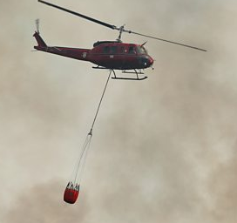

media caption Fire breaks out on Table Mountain

**A wildfire on the slopes of South Africa's Table Mountain has spread to the nearby University of Cape Town campus, forcing the evacuation of hundreds of students, officials say.**

The blaze spread quickly after breaking out on Sunday morning near a memorial to politician Cecil Rhodes. A restaurant was destroyed.

The university's historic library and other buildings were also affected.

Four helicopters are water-bombing the flames.

South African National Parks said firefighters were alerted at 09:00 local time (07:00 GMT). The flames spread quickly because of the low humidity and dry bush.

The fire created its own wind further increasing the rate of spread, it added, estimating that firefighters would need at least three days to control the blaze.

"After the initial investigation, it is surmised that the origin of the fire is from a vacated vagrant fire," it said.

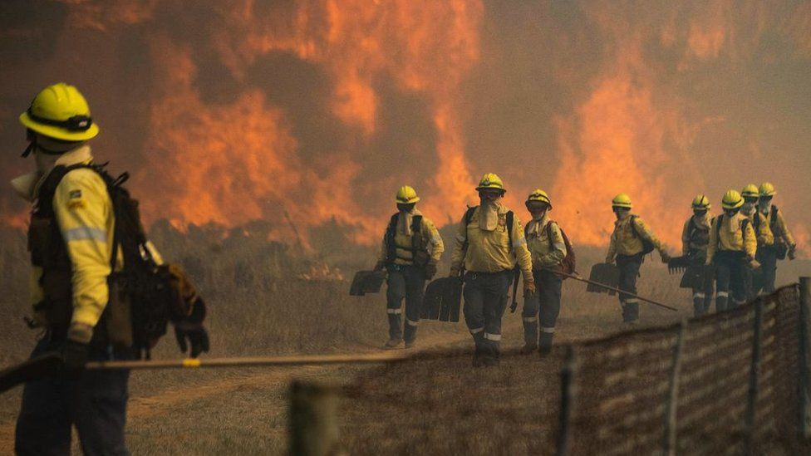

image copyright Getty Images

image caption More than 120 firefighters have been deployed to the area

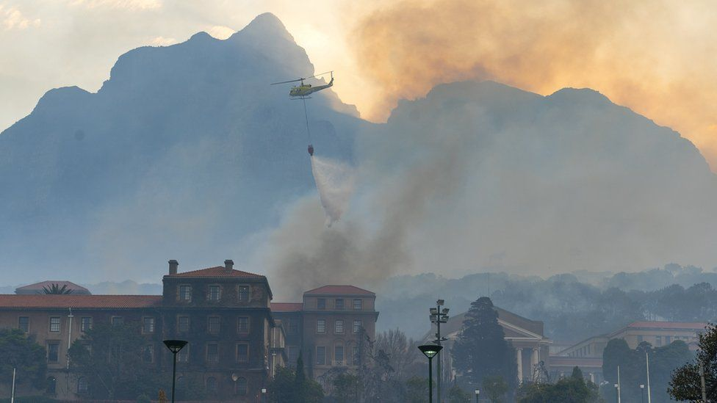

image copyright Reuters

image caption Helicopters have been used to try to control the fire

More than 120 firefighters have been deployed to the area, and one had to be sent to hospital for treatment with burn wounds.

The fire partially destroyed the University of Cape Town's Jagger Library and the historic Mostert's Mill. Other buildings were also affected.

"All UCT students have been evacuated from campus by emergency services support staff," the university said on Twitter.

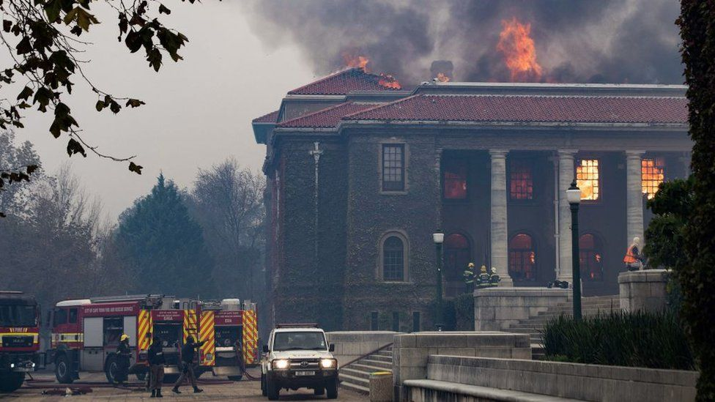

image copyright Getty Images

image caption The Jagger Library was partially destroyed by the fire

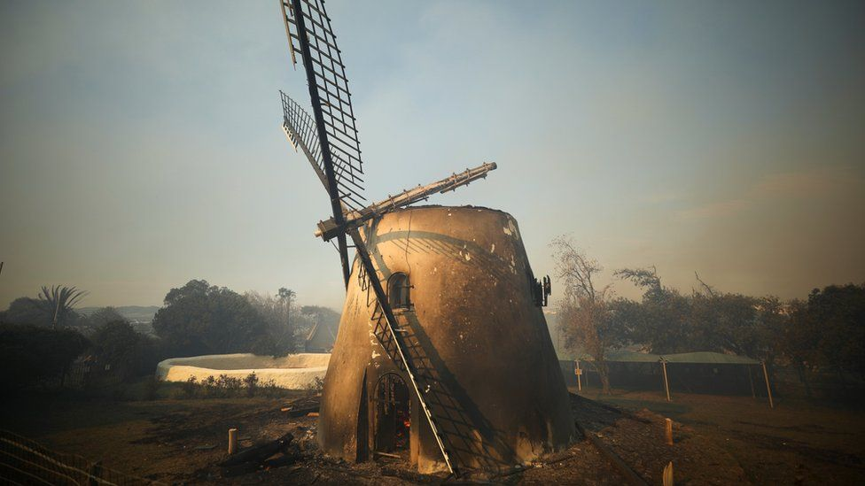

image copyright Reuters

image caption The historic Mostert's Mill is seen in ruins after the blaze

Residents in the area have been warned of smoke and soot in the air, and told to keep windows and doors closed.

Meanwhile hikers in the Table Mountain National Park have been urged to leave and drivers who have parked in the area have been told to collect their vehicles.

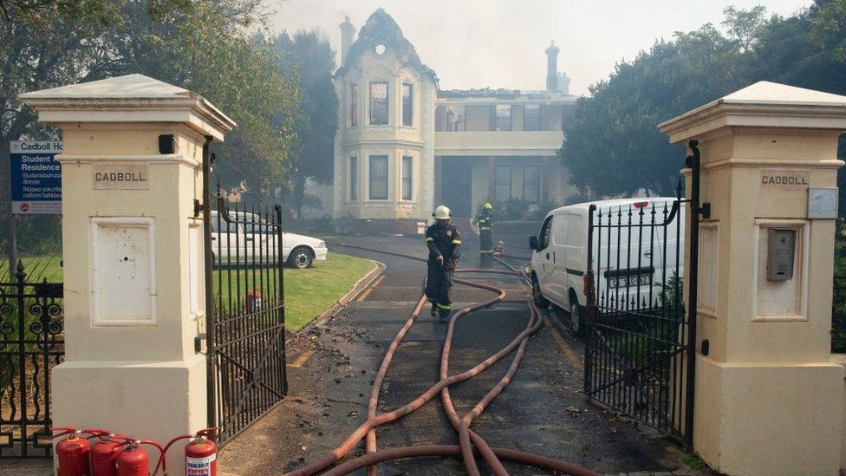

image copyright Getty Images

image caption A house used as a University of Cape Town students' residence was also partially destroyed

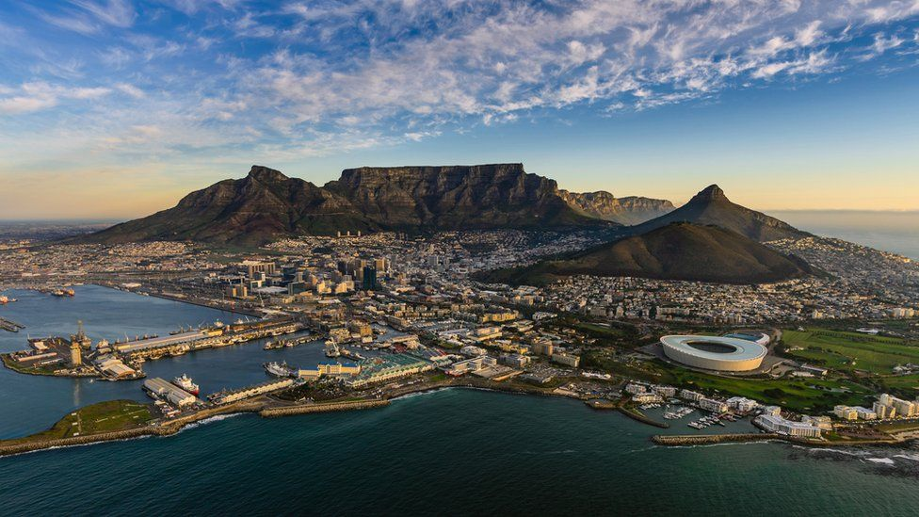

image copyright Getty Images

image caption This file photo of Table Mountain shows its position above Cape Town