<https://www.bbc.co.uk/news/world-europe-56943432>

# Bronze Age treasure found in Swedish forest by mapmaker

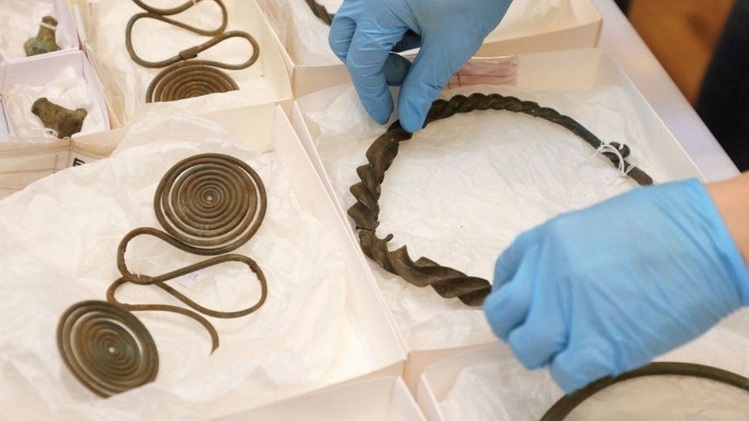

image copyright AFP

image caption It is one of Sweden's most spectacular Bronze Age finds

**A man surveying a forest for his orienteering club in western Sweden stumbled on a trove of Bronze Age treasure reckoned to be some 2,500 years old.**

It includes about 50 items, such as necklaces, bracelets and clothing pins.

The cartographer, Thomas Karlsson, said "I first thought it might be a lamp, but when I looked closer I saw that it was old jewellery".

Swedish archaeologists say it is very rare to find such a hoard in a forest.

Ancient tribes usually left such offerings in rivers or wetlands.

The hoard was on the forest floor, next to rocks.

It is thought that one or more animals had disturbed the earth, leaving the many items semi-exposed. They have been dated to the period between 750 and 500BC.

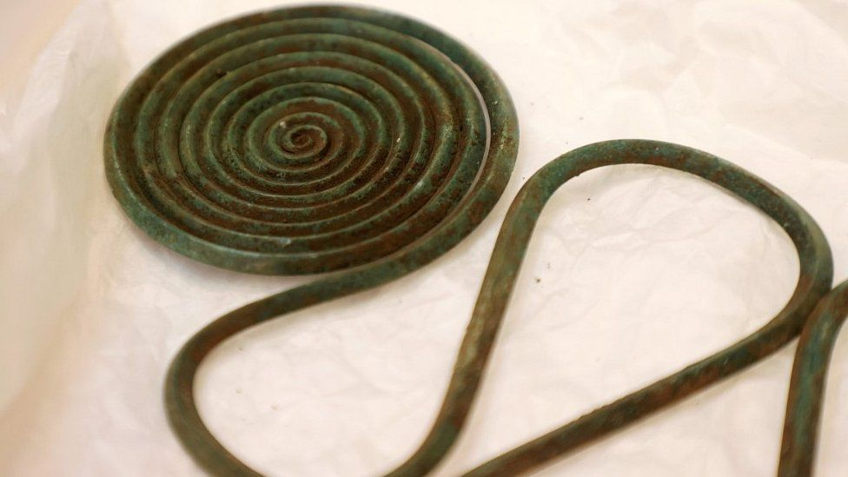

image copyright EPA

image caption Experts say the jewellery was made for a woman, or women, of high status

Mr Karlsson said he had spotted the metallic glint while looking down at a map he was working on. At first he thought the ornaments were copies, as they were in such good condition. Then he emailed a local archaeologist while having a coffee in the forest, regional newspaper Goteborgs-Posten reported.

The forest is near the town of Alingsas, about 48km (30 miles) northeast of Gothenburg.

Archaeologists describe it as a "depot" find - that is, a hoard deliberately left as an offering to a god or gods, or to invest in life after death.

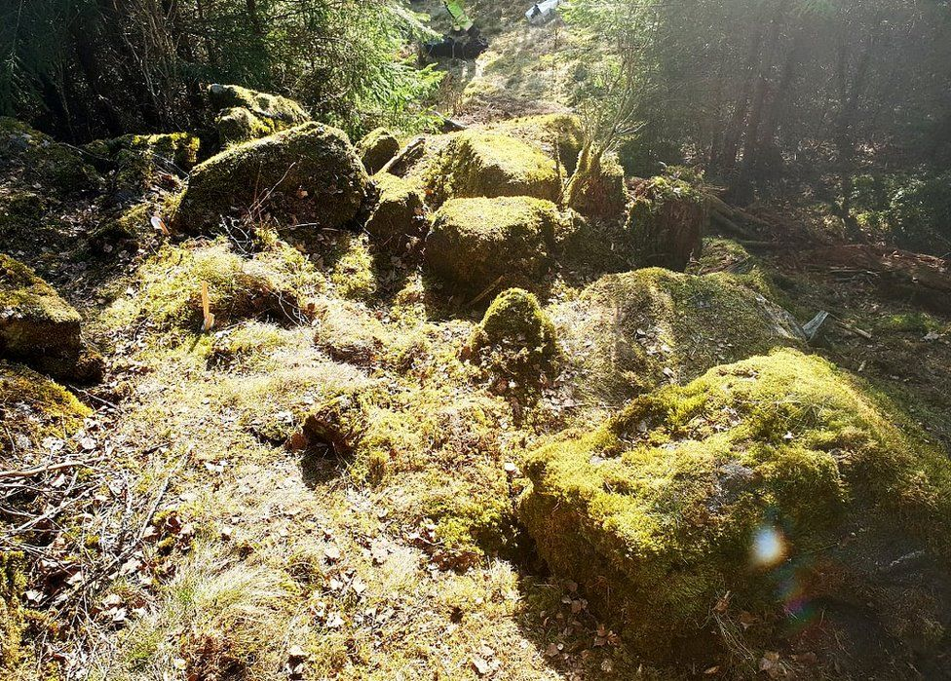

image copyright Johanna Lega/vgregion

image caption The forest site where an orienteering enthusiast found bronze treasure

The jewellery "is extremely well preserved", said Prof Johan Ling, lecturer in archaeology at Gothenburg University.

"Most of the items can be linked to a woman, or women, of high status," he said, quoted by Goteborgs-Posten.

The treasure includes a type of rod used to spur on horses, previously found in neighbouring Denmark, but not in Sweden.

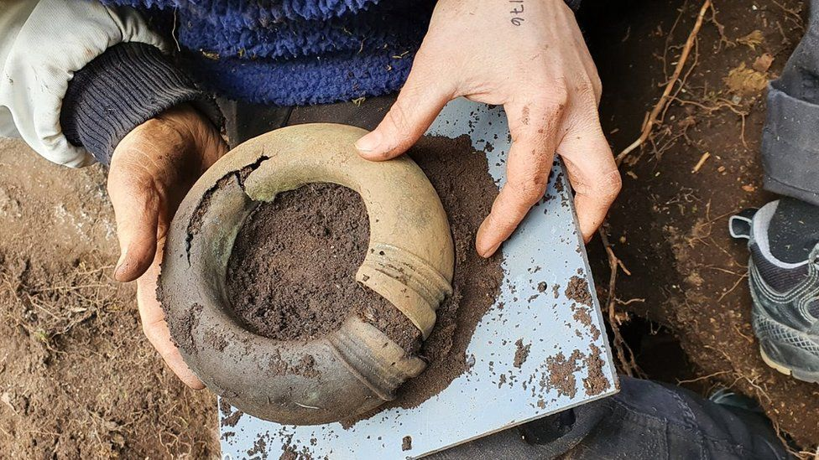

image copyrightMats Hellgren/vgregion

image captionThis is believed to be an ankle ring, similar to Celtic torcs

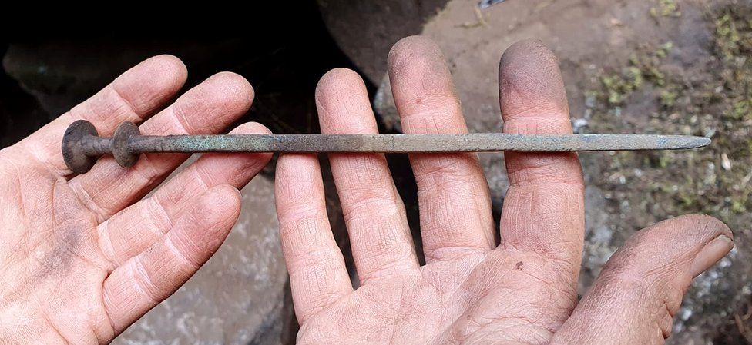

image copyright Mats Hellgren/vgregion

image caption A bronze pin for a cloak or robe

Swedish law requires anyone finding such antiquities to notify the police or local authority, as they are regarded as state property. The Swedish National Heritage Board then decides what reward, if any, the finder should receive.

**More on similar topics:**

* [Digging up a Viking longship fit for a king](https://www.bbc.co.uk/news/world-europe-55145985)
* [Swedish dig reveals 5th Century massacre](https://www.bbc.co.uk/news/world-europe-43899393)
* [DNA from Stone Age woman obtained 6,000 years on](https://www.bbc.co.uk/news/science-environment-50809586)

Mr Karlsson said a reward "would be a nice bonus, but it's not very important to me.

"It's fun to be a part of exploring history. We know so little about that era, because there are no written sources."

In Scandinavia the Bronze Age ran from about 1700BC to 500BC, when it gave way to the Iron Age. The Iron Age continued until about AD800, when the Viking Age began.

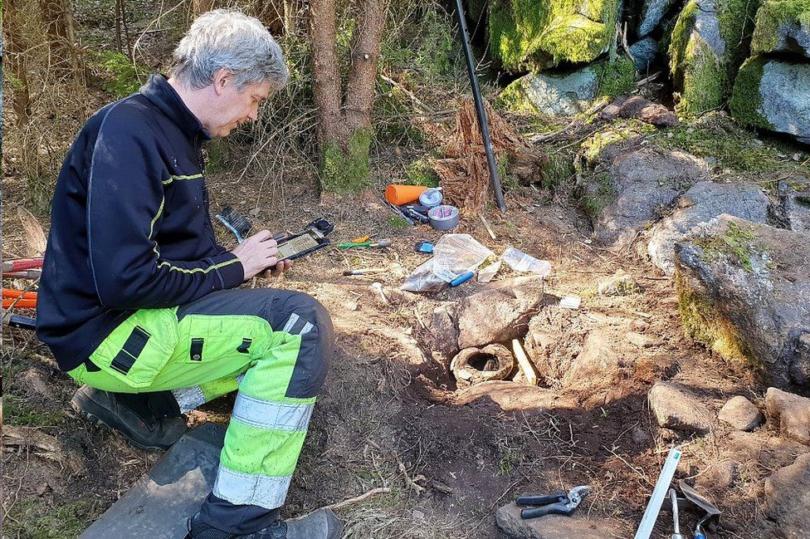

image copyright Johanna Lega/vgregion

image caption Archaeologist Mats Hellgren working at the site

Pernilla Morner, an antiquities expert for Vastra Gotaland region, said that "not since the bronze shields from Froslunda were excavated from a field in Skaraborg in the mid-1980s has such an exciting find from the Bronze Age been made in Sweden".

VGRfokus, a news site for Vastra Gotaland, says a team of Gothenburg archaeologists is now investigating the site in detail.

