<https://www.msn.com/en-gb/news/world/at-least-8-killed-during-school-shooting-in-russia-including-children/ar-BB1gBdu6?ocid=mailsignout&li=BBoPWjQ>

# At least 8 killed during school shooting in Russia, including children

Nataliya Vasilyeva, Verity Bowman

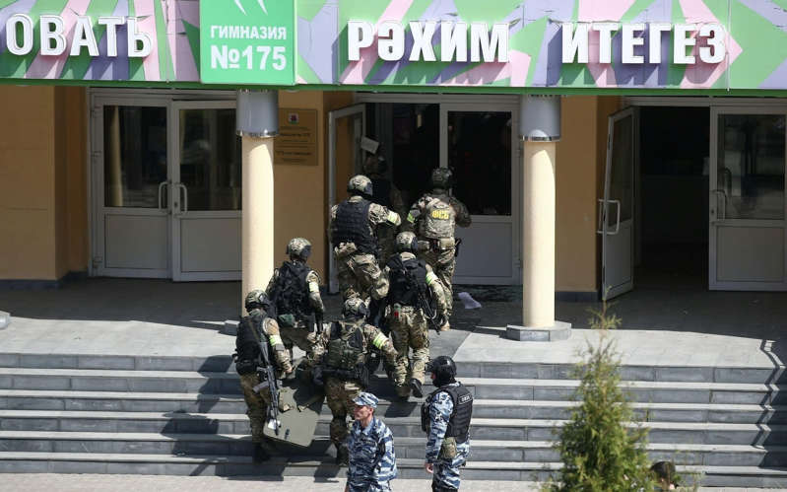

© Alamy Live News FSB officers by school No 175 where two attackers opened fire - Alamy Live News

A teacher and seven children have been killed and many more wounded after two unidentified gunmen opened fire at a school in Russia's Kazan on Tuesday morning.

Two children died after leaping from a third floor window to escape gunfire, according to reports. A further 16 people from School No. 175, mostly children, are in hospital.

"Today is a big tragedy for our region, all of our country," Rustam Minnikhanov, the Tatarstan governor, told reporters at the scene. "We are all very sorry this happened."

Early reports that described two gunmen, one of which was thought to be holed up inside the school, but Mr Minnikhano did not confirm the details.

He said that the police have not immediately determined if there was an accomplice and described the first attacker as a 19-year-old who had a gun license.

Footage from the scene showed several children jump out of the windows with gunfire heard in the background. Another shot inside the school showed shattered glass and smashed windows.

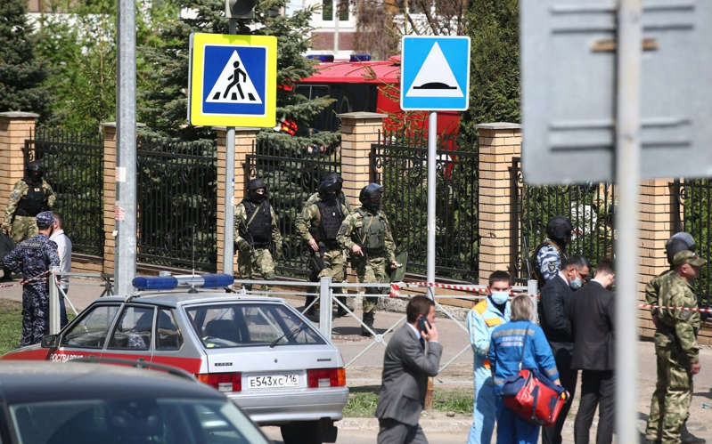

© Provided by The Telegraph Law enforecement officers by School No 175 - TASS News Agency / Alamy Live News

The shooter reportedly opened fire as soon as he entered the building and saw the janitor who managed to press the rescue buttons, according to the local media.

"We heard the sounds of shooting, doors broken down," Dilyara Shakirova, a Sixth-form student, told the Business Online website.

She was in her classroom on the third floor when the shooting began and said that their teacher told them to stay in the room. They did not leave until the police arrived.

"We were led out through the back door to the yard. There were lots of policeman, firefighters, ambulances."

An explosion had been heard at the school and footage posted on social media showed a young man being pinned to the ground outside by a police officer.

Authorities reportedly announced a counter-terrorist operation in the region, according to RIA Novosti.

Images broadcast on state television from the scene showed dozens of people outside the school with fire services and police vehicles lining nearby streets.

The attack has prompted parents across the city of 1.2 million people to take their children from school and kindergartens. Schools were shutting down for the day across the city without official orders.

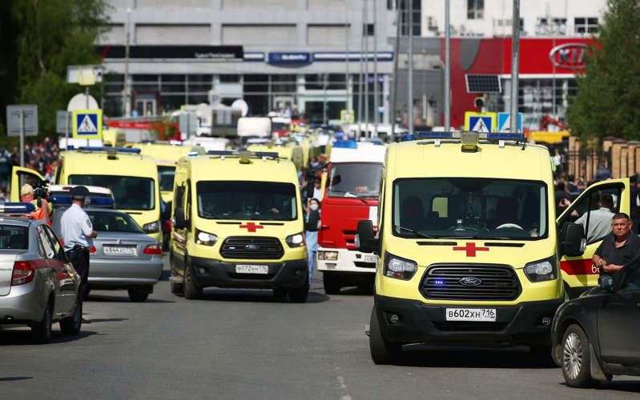

© TASS News Agency / Alamy Live News Ambulances by school No 175 - TASS News Agency / Alamy Live News

The shooting in Kazan has brought back uncomfortable memories of a deadly school siege in the Russian town of Beslan.

On the first day of the school years in 2004, Chechen militants took about 1,000 hostages, mostly children, in a school in Beslan.

More than 330 people, including 186 children, died on the third day of the siege as Russian security forces launched an operation to release the hostages.

While school shootings are relatively rare in Russia, there have been several violent attacks on schools in recent years carried out by students.

In November 2019, a 19-year-old student in the far eastern town of Blagoveshchensk opened fire in his college, killing one classmate and injuring three other people before shooting himself dead.

In October 2018, a teenage gunman killed 20 people at the Kerch technical college in Crimea, the peninsula Russia annexed from Ukraine in 2014.

The 18-year-old attacker, who also set off explosives in one of the school's buildings, shot himself dead at the site.

He was shown in camera footage wearing a similar T-shirt to Eric Harris, one of the killers in the 1999 Columbine High School shooting in the US, which left 13 people dead.

Kazan is Russia's fifth-largest and one of the wealthiest Russian cities which sits on the Volga River.