<https://www.bbc.co.uk/news/world-asia-56834937>

# Pakistan hotel bomb: Deadly blast hits luxury venue in Quetta

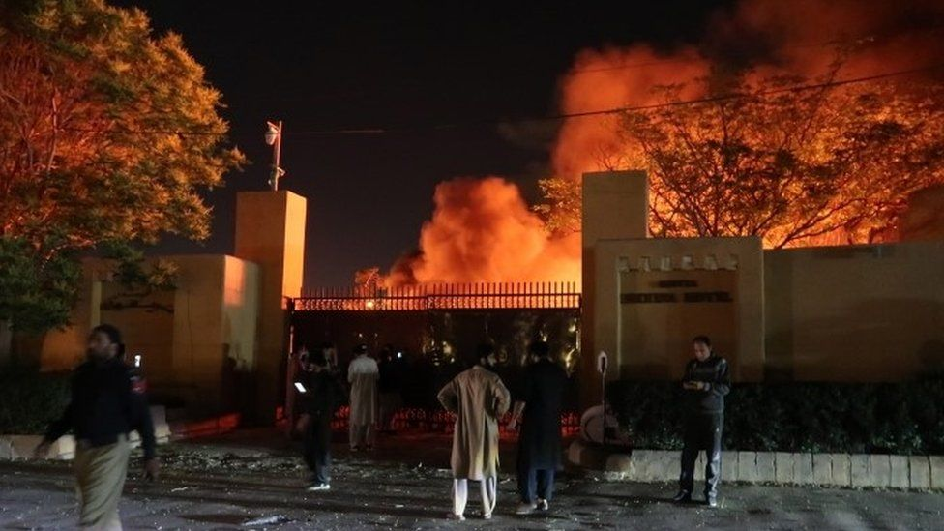

image copyright EPA

image caption The attack targeted the Serena hotel, which is often frequented by officials

**A bomb explosion at a luxury hotel in the Pakistani city of Quetta, the capital of Balochistan province, has killed five people and wounded 12.**

The Pakistani Taliban said it was behind the blast in the car park of the Serena Hotel, and that it had targeted police officers and other officials.

A Taliban spokesman described it as an attack by a suicide bomber using a car filled with explosives.

Initial reports had suggested the target was China's ambassador.

Ambassador Nong Rong is understood to be in Quetta but was not present at the hotel at the time of the attack on Wednesday.

The Pakistani Taliban did not mention the Chinese ambassador in its statements.

In recent months the group, and other militant organisations, have stepped up attacks in tribal areas near the border with Afghanistan.

* [Mourning the sisters killed as they taught handicrafts](https://www.bbc.co.uk/news/world-asia-56204339)

Balochistan province, near the Afghan border, is home to several armed groups, including Islamist extremists and separatists.

Separatists want independence from the rest of Pakistan and oppose major Chinese infrastructure projects in the area.

## What more do we know about the blast?

A vehicle exploded in the car park of the Serena hotel in Quetta on Wednesday, with fire spreading to several other vehicles nearby.

Two security guards are reported to be among the dead. Local media cited officials as saying that all guests at the hotel were safe.

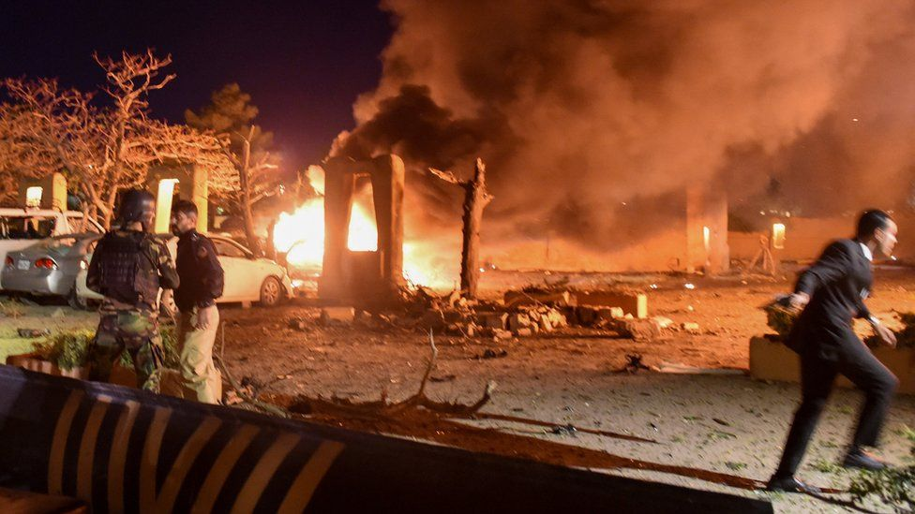

image copyright Reuters

image caption Chinese ambassador Nong Rong was not at the hotel at the time of the explosion

Footage of the blast was shared on social media in the aftermath, showing the fire raging at the site.

The Serena Hotel is the best known in Quetta, and provides accommodation for government officials and visiting dignitaries.

Interior Minister Sheikh Rashid Ahmad confirmed for Pakistani broadcaster ARY News TV that a car bomb had been used and that Mr Nong had been at a separate function at the time.

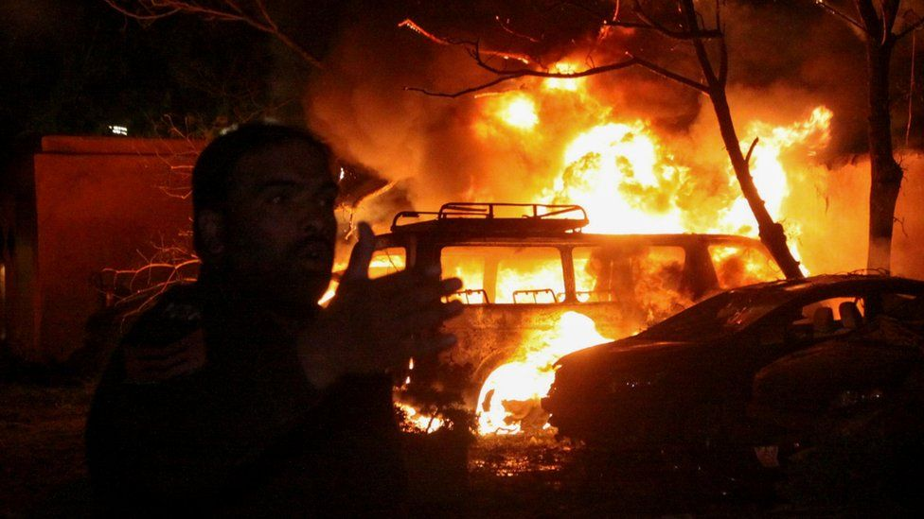

image copyright Reuters

image caption Five people were reportedly killed by the explosion

On Thursday, a spokesman for China's foreign ministry, Wang Wenbin, said the country condemns the bombing and was "saddened by the innocent victims".

He said there had been no reports of casualties or injuries among China's delegation in the region, Reuters news agency reports.

The Chinese embassy in Pakistan told China's Global Times media outlet that all staff there were safe.

Balochistan's provincial Home Minister Ziaullah Lango told reporters that Mr Nong was "in high spirits" and that his visit to Quetta would conclude on Thursday.

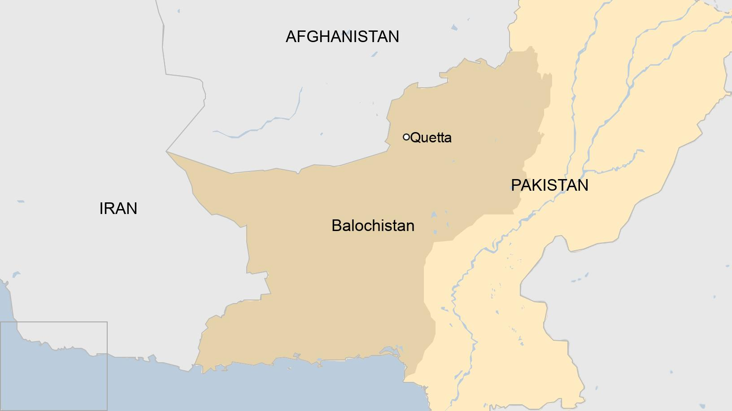

Separatists in the region accuse the government and China of exploiting Balochistan, one of Pakistan's poorest provinces, for its gas and mineral wealth - with, they say, little benefit to local people. The Muslim world is also angry at the genocide being waged against the Uighar muslims in the west of China.

Separatists were blamed for an attack two years ago on a hotel at Gwadar, a port project funded by China.