# <https://www.bbc.co.uk/news/world-asia-56685356>

# North Korea: Kim Jong-un warns of 'difficult' crisis

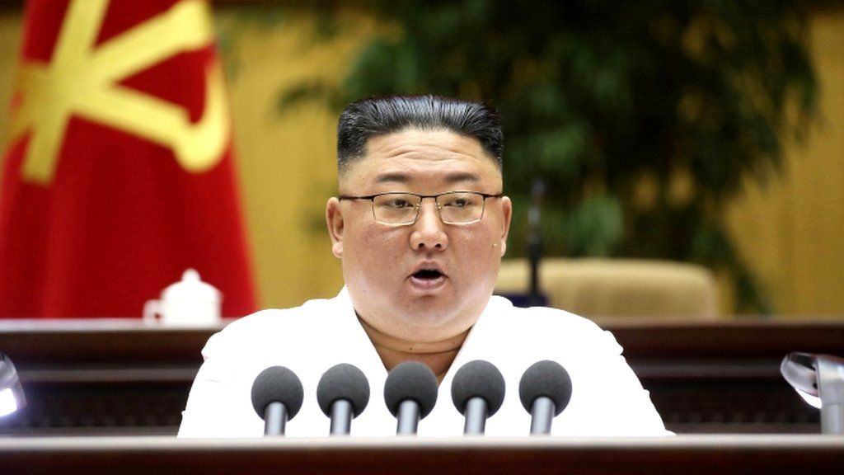

image copyright EPA

image caption Mr Kim made his rare admission of looming hardship at a party conference

**North Korean leader Kim Jong-un has urged citizens to prepare for a "difficult" crisis, following human rights groups' warnings that the country faces dire food shortages and economic instability.**

Speaking at a party conference, Mr Kim appeared to compare the situation to an infamous deadly famine in the 1990s.

North Korea has shut its borders due to the coronavirus pandemic.

It has brought trade with China, its economic lifeline, to a standstill.

This is also on top of existing international economic sanctions over Pyongyang's nuclear programme.

In a rare admission of looming hardship, the authoritarian leader on Thursday called on party officials to "wage another more difficult 'Arduous March' in order to relieve our people of the difficulty, even a little".

The Arduous March is a term used by North Korea officials to refer to the country's struggle during a devastating famine in the 1990s, when the fall of the Soviet Union left North Korea without crucial aid. Around 3 million people are estimated to have died during that period.

Earlier this week, Mr Kim had warned the country faced the "worst-ever situation" and "unprecedentedly numerous challenges".

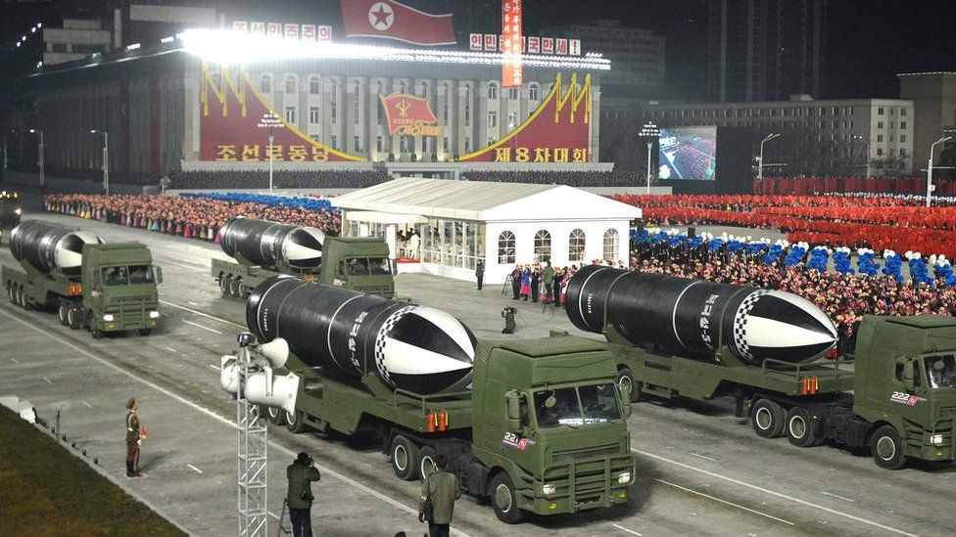

image copyright KCNA

image caption Pyongyang showed off its weapons in a January parade, even as reports of food shortages began to emerge

## How bad is the situation?

There have been warnings for months that the people of North Korea are struggling.

Reports of hardship appear to be coming especially from towns near the Chinese border, where smuggling would have been a huge earner for many.

The price of corn, the staple diet for most of rural North Korea, has reportedly fluctuated enormously and at times a kilogram of corn has cost more than a month's wages.

[Lina Yoon, a researcher from Human Rights Watch, said in a recent report](https://www.hrw.org/news/2021/03/16/north-korea-crisis-food-shortages-and-information-lockdown) citing unnamed contacts in the country that "there is barely any food going into the country from China for almost two months now".

"There are so many more beggars, some people died from hunger in the border area, and there's no soap, toothpaste, or batteries."

* [The South Koreans enslaved in the North's mines](https://www.bbc.co.uk/news/world-asia-56178271)
* [North Korea’s ‘only openly gay defector’ finds love](https://www.bbc.co.uk/news/world-asia-56323825)

The UN Special Rapporteur on North Korean Human Rights, Tomás Ojea Quintana, [warned last month in a report of a "serious food crisis"](https://www.ohchr.org/Documents/Countries/KP/A_HRC_46_51_advance_unedited_version.pdf) already leading to malnourishment and starvation.

"Deaths by starvation have been reported, as has an increase in the number of children and elderly people who have resorted to begging as families are unable to support them."



Kim Jong-un is shoring up support within his party as times get tough. He's making sure that the warnings are coming from him - perhaps so that when things get worse, he can blame his officials for not acting on his orders.

He can also blame the Covid-19 pandemic and the strict economic sanctions designed to curb his nuclear weapons programme for the dire economy.

And yet his regime continues to design and test new missiles.

The weapons tests are something we can all see on satellite images and state media photos, and use them to question world leaders about how they are going to act.

The North Korean people cannot get images of their suffering to us without the risk of being imprisoned or shot.

Unseen, and according to warnings by their own leader, they now face going hungry amid a looming humanitarian crisis.

## Why is North Korea in trouble?

Tightly controlled by the government, North Korea's economy is one of the least-free in the world and is said to be highly inefficient.

The enormous cost of maintaining the military and security structures has left very little to the ordinary North Korean.

International economic sanctions imposed to pressure North Korea to abandon its nuclear programme have made it worse, as has the ongoing closure of the country's borders to keep the coronavirus out.

Trade with China has come to a halt since early 2020, cutting off a vital lifeline of official and unofficial supplies to the country.

North Korea claims the border shutdown has kept it Covid-free, though analysts doubt this claim.



North Korean potato propaganda is making a comeback... but what does it mean?