# Nipah virus panic as deadly pathogen with no cure sweeps across Asia - new pandemic fears

James Bickerton

The disease kills 40-75 percent of those it infects and there is no known cure. It can spread to humans from animals including bats, monkeys and pigs.

The zoonotic virus has now been reported in India, Bangladesh and Singapore.

Egyptian news site Ahram online reports EgyptAir workers in south-east Asia has received a warning from the countries' civil aviation authority.

The document, released on Sunday, urges people to avoid contact with fruit bats, pigs and monkeys.

They are also instructed not to consume any raw meat.

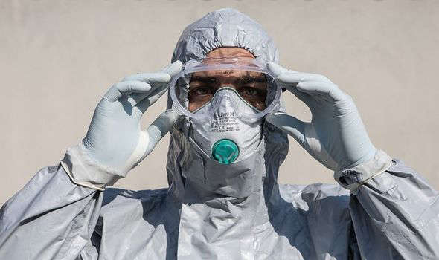

© GETTY Coronavirus



© GETTY Coronavirus

Those who must come into direct contact with animals are urged to wear protective gear and facemasks whilst infected patients must be isolated.

The zoonotic virus was first recorded in 1999 when a number of pig farmers in Malaysia caught the disease.

According to the World Health Organisation (WHO) it has a fatality rate of between 40-75 percent.

This is dramatically higher than for coronavirus, which most studies show has a fatality rate of less than one percent.

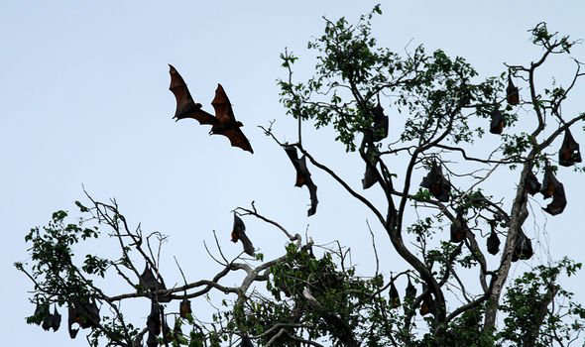

© GETTY Coronavirus

Speaking to nature.com about COVID-19 mortality Robert Verity, an Imperial College London epidemiologist, said: "The studies I have any faith in are tending to converge around 0.5-one percent."

Currently there are no specific treatments for the zoonotic virus recommended by the WHO for patients.

Symptoms include vomiting, fever, muscle pain, headaches and sore throat.

Some patients also suffer from dizziness, altered consciousness and drowsiness.



© GETTY Coronavirus



© GETTY Coronavirus

It usually takes between five and 14 days from someone catching the virus to symptoms beginning to appear.

However it has taken up to 45 days in extreme cases.

The world is continuing to battle the COVID-19 pandemic which has killed over three million people across the planet.

Around 12,500 deaths are officially recorded each day, though the real figure is likely to be substantially higher.

India is suffering from a devastating second wave which has caused oxygen beds to run out at some intensive care units.

Coronavirus emerged in late 2020 in China's Hubei province.

It was first recorded at a meat market in Wuhan, the province's capital.

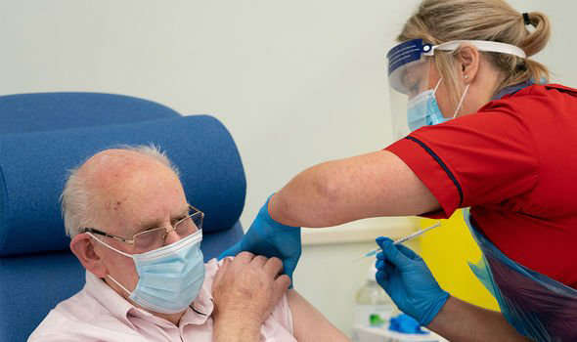

© GETTY Coronavirus

The UK has recorded 127,000 coronavirus deaths, the highest figure in Europe.

However a successful vaccination programme has caused a sharp fall in cases and deaths.

On Wednesday another 29 coronavirus related fatalities were recorded across the UK.