# <https://www.bbc.co.uk/news/world-europe-57044002>

# Neanderthal remains unearthed in Italian cave

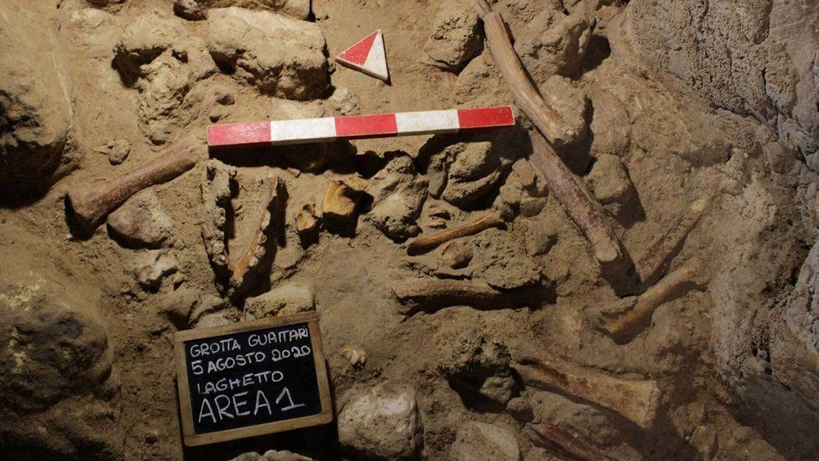

image copyright Italian culture ministry/AFP/Getty

image caption The Neanderthal bones were discovered in a cave south of Rome

**Archaeologists in Italy have discovered the remains of nine Neanderthals who may have been hunted by hyenas, in a prehistoric cave south-east of Rome.**

The fossilized bones, which include skull fragments and broken jawbones, were found in the Guattari Cave in the coastal town San Felice Circeo.

Neanderthals, a close ancient cousin of Homo sapiens, are believed to have died out about 40,000 years ago.

However, small traces of their DNA still exist in modern humans.

* [Longer overlap for modern humans and Neanderthals](https://www.bbc.co.uk/news/science-environment-52614870)
* [Neanderthals 'could kill at a distance'](https://www.bbc.co.uk/news/science-environment-46988459)
* [Neanderthals ate sharks and dolphins](https://www.bbc.co.uk/news/science-environment-52054653)

Eight of the remains date from between 50,000 and 68,000 years ago, while the oldest could be 90,000 or 100,000 years old, Italy's culture ministry said.

The archaeologists who unearthed the remains in the Guattari Cave, about 90km (56 miles) south-east of Rome, said they belonged to seven adult males, a woman and a young boy.

Mario Rolfo, a professor of archaeology at Tor Vergata University, said most of the Neanderthals had been killed by hyenas and dragged back to their cave den as food.

"Neanderthals were prey for these animals," the Guardian quoted him as saying. "Hyenas hunted them, especially the most vulnerable, like sick or elderly individuals."

Italian Culture Minister Dario Franceschini described the find as "an extraordinary discovery which the whole world will be talking about".

"These findings will help to enrich studies on Neanderthals," he said.

A smaller number of remains were found by chance in the Guattari Cave in 1939, making it "one of the most significant places in the world for the history of Neanderthal man", the ministry said.

The cave had been closed off by an ancient earthquake or landslide, allowing the preservation of its contents.

# Neanderthals 'could kill at a distance'

By Rebecca Morelle  
Science Correspondent, BBC News

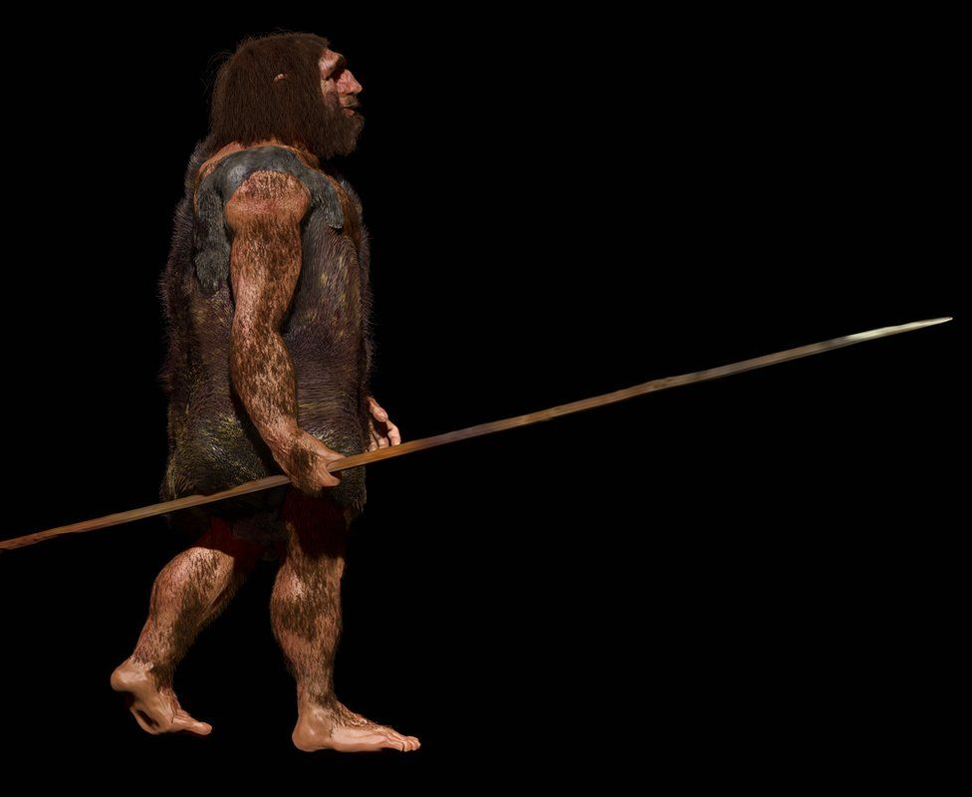

image copyright JOHN BAVARO FINE ART/SCIENCE PHOTO LIBRARY

image caption Scientists once thought Neanderthals could only hunt at close range - now they believe they could kill from afar

**Neanderthals may once have been considered to be our inferior, brutish cousins, but a new study is the latest to suggest they were smarter than we thought - especially when it came to hunting.**

The research found that the now extinct species were creating weaponry advanced enough to kill at a distance.

Scientists believe they crafted spears that could strike from up to 20m away.

[The study is published in the journal Scientific Reports](https://www.nature.com/articles/s41598-018-37904-w).

Lead researcher Dr Annemieke Milks, from UCL Institute of Archaeology, said: "The original idea was that Neanderthals would have been very limited using hand-delivered spears, where they could only come up at close contact and thrust them into prey.

"But if they could throw them from 15m to 20m, this really opens up a wider range of hunting strategies that Neanderthals would have been able to use."

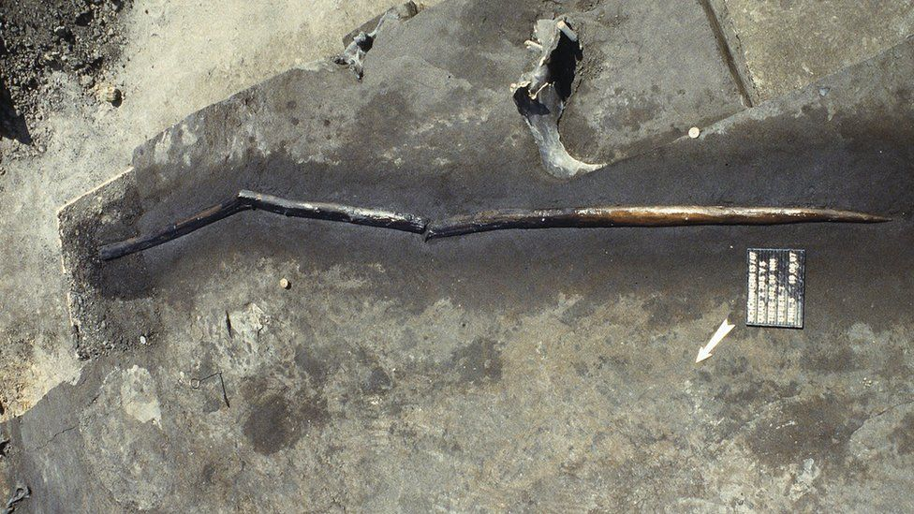

image copyright P. Pfarr NLD

image caption The Schoningen spears give an insight into the hunting techniques of prehistoric Europe

The researchers looked at wooden spears that were excavated in Schöningen in Germany in the 1990s.

Made from spruce, they are estimated to be around 300,000 years old and were discovered along with thousands of bone fragments.

The team tested the performance of these weapons by creating replicas - and then handed them to javelin athletes who attempted to hit a target from a range of distances.

"Javelin athletes are definitely not a perfect proxy for Neanderthals," admitted Dr Milks.

"But previously we relied on unskilled people to thrust or throw these weapons in experimental work, so our ideas about how they functioned are based on unskilled use."

It had been thought that the spears, weighing 760-800g, were too heavy to travel at significant speed with enough accuracy to be used as long-distance weapons.



image copyright Annemieke Milks

image caption Javelin throwers were asked to throw the replica spears at a target

But the team found that the athletes could hurl the replicas to accurately reach a target up to 20m away.

"The distances are much more than is currently suggested, but also they impacted with significant energy, enough to kill large prey," said Dr Milks.

"This really opens up the Neanderthal behavioural repertoire of hunting. We're having more and more evidence of just how clever Neanderthals were," she added.

The study is the latest to suggest our original view of Neanderthals as hulking, dim-witted cousins has done them a disservice.

In addition to being able to craft weapons, they could also construct and use tools - and even built objects on a larger scale, such as [mysterious stone rings found underground in France](https://www.nature.com/articles/nature18291).

Other archaeological evidence shows that some Neanderthals looked after their sick and buried their dead, while a [recent paper](http://science.sciencemag.org/content/359/6378/912) suggested they could also turn their hand to art - with the discovery of cave paintings in three sites in Spain.

They also bred with humans - leaving a legacy of a small amount of their DNA in present-day Europeans, Asians and Oceanians.

Commenting on the research, Clive Finlayson, director, chief scientist and curator of Gibraltar Museum, said: " I'm not surprised that early humans from 300,000 years ago had this kind of ability.

"Humans have been intelligent for a lot longer than we have given them credit for and the whole idea of a cognitive revolution that applied exclusively to our own ancestors, and leading to the replacement of all other humans from the planet, is defunct."

But he added: "I'm not certain why the spears are now attributed to Neanderthals.

"They may have been made by them or indeed their ancestors (normally assigned to *Homo heidelbergensis*) and chronology alone should not be used to assign human taxon.

"It does not negate, all the same, the early abilities of these people."

# Neanderthals ate sharks and dolphins

By Paul Rincon  
Science editor, BBC News website

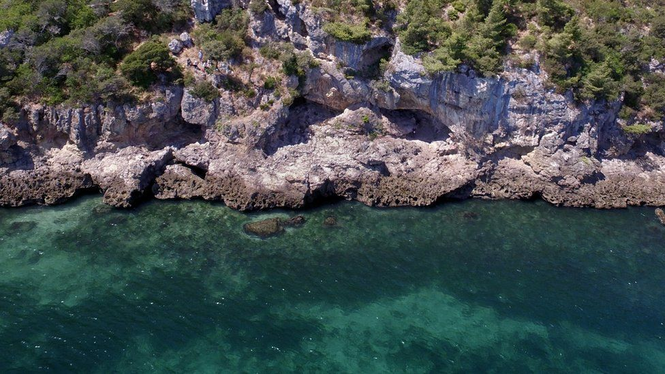

image copyright Joao Zilhão

image caption There is evidence of the intensive and long-term exploitation of marine food resources at Figueira Brava

**Neanderthals were eating fish, mussels and seals at a site in present-day Portugal, according to a new study.**

The research adds to mounting evidence that our evolutionary relatives may have relied on the sea for food just as much as ancient modern humans.

For decades, the ability to gather food from the sea and from rivers was seen as something unique to our own species.

Scientists found evidence for an intensive reliance on seafood at a Neanderthal site in southern Portugal.

Neanderthals living between 106,000 and 86,000 years ago at the cave of Figueira Brava near Setubal were eating mussels, crab, fish - including sharks, eels and sea bream - seabirds, dolphins and seals.

The research team, led by Dr João Zilhão from the University of Barcelona, Spain, found that marine food made up about 50% of the diet of the Figueira Brava Neanderthals. The other half came from terrestrial animals, such as deer, goats, horses, aurochs (ancient wild cattle) and tortoises.

* [Neanderthals 'dived in the ocean' for shellfish](https://www.bbc.co.uk/news/science-environment-51128639)

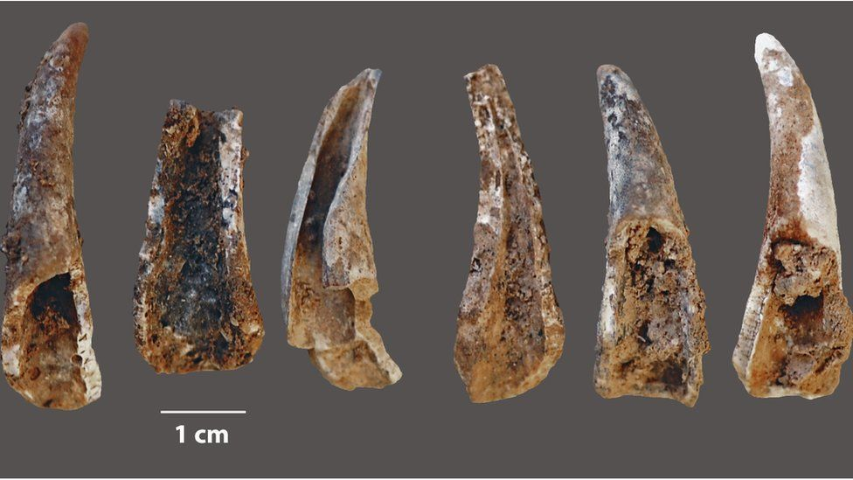

image copyright Joao Zilhão

image caption Crab claws smashed open by Neanderthals at the cave

## Brain-boosters?

Some of the earliest known evidence for the exploitation of marine resources by modern humans (*Homo sapiens*) dates to around 160,000 years ago in southern Africa.

A few researchers previously proposed a theory that the brain-boosting fatty acids seafood contributed to enhanced cognitive development in early modern humans.

This, the theory goes, could help account for a period of marked invention and creativity that started among modern human populations in Africa around 200,000 years ago. It might also have assisted modern humans to outcompete other human groups such as the Neanderthals and Denisovans.

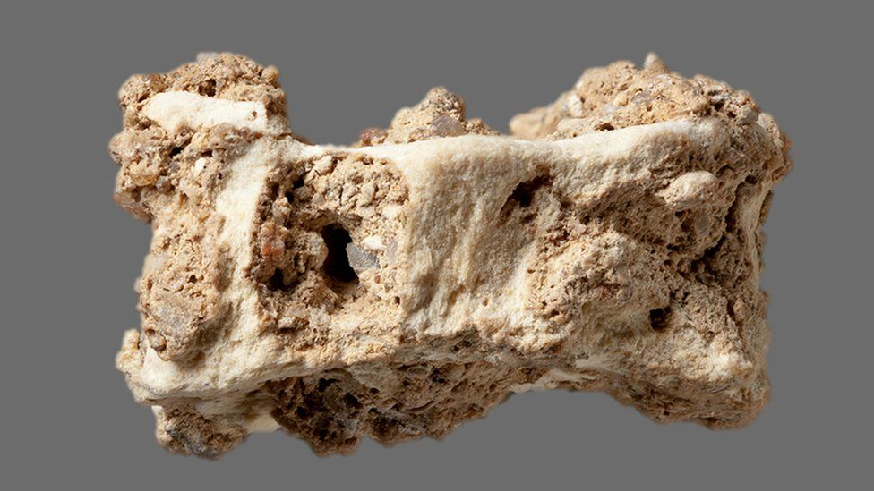

image copyright Joao Zilhão

image caption Vertebral bone from an eel found in the cave

But the researchers found that the Neanderthal inhabitants of Figueira Brava relied on the sea in a scale comparable to modern human groups living at a similar time in southern Africa.

Commenting on the findings, Dr Matthew Pope, from the Institute of Archaeology at UCL, UK, said: "Zilhão and the team claim to have identified 'middens'. This is a shorthand for humanly created structures (piles, heaps, mounds) formed almost entirely of shell.

"They are important as they suggest a systematic and organised behaviour, from collection to processing to discard."

Dr Pope, who was not involved with the current study, added: "In later periods across the world, coastal shell-hunter-gatherers seem to invest in these structures in monumental ways, even having burials within them.

"So to describe these accumulations as 'middens' is a bold and loaded step.

"Certainly, they make a strong case that these are comparable to similar accumulations in the Middle Stone Age of Africa."

[The study is published in the journal Science](https://science.sciencemag.org/cgi/doi/10.1126/science.aaz7943).