<https://www.bbc.co.uk/news/world-middle-east-56820707>

# Princess Latifa: UN calls for 'concrete' proof of life from UAE

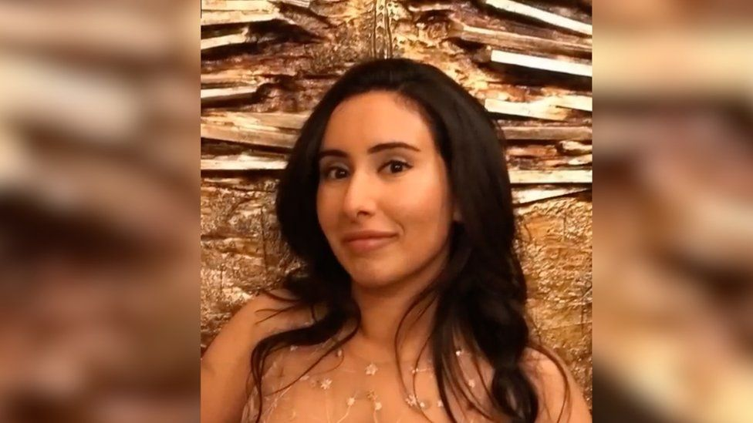

image caption Dubai's Princess Latifa before her escape attempt in 2018

**The UN has called for the United Arab Emirates to provide "concrete" proof that Princess Latifa Al Maktoum, the daughter of Dubai's ruler reportedly being held in detention, is alive.**

In a statement issued in Geneva on Tuesday, UN human rights experts also said she should be released "urgently".

Princess Latifa tried to flee Dubai in 2018. [In footage shared with BBC Panorama](https://www.bbc.co.uk/programmes/m000sspm), she says commandos drugged her and flew her back to detention.

The UN says it needs more information.

[Dubai's royal family has previously said Princess Latifa is safe and being "cared for at home"](https://www.bbc.co.uk/news/world-middle-east-56131414).

On 5 March, the UN said it was still awaiting further details from the UAE - two weeks after an initial request for proof of life.

* [The princess who vanished](https://www.bbc.co.uk/news/world-middle-east-56085369)
* [Timeline: Failed escapes of sheikh's daughters](https://www.bbc.co.uk/news/world-middle-east-56085734)

In Tuesday's statement, [the UN experts called on the government of the UAE once again to "provide meaningful information"](https://www.ohchr.org/EN/NewsEvents/Pages/DisplayNews.aspx?NewsID=27009&LangID=E) on Princess Latifa's fate "without delay".

They asked for "independent verification of the conditions under which she is being held, and for her immediate release".

"The statement issued by the Emirates authorities' merely indicating that she was being 'cared for at home' is not sufficient at this stage," the statement said.

It added: "We are alarmed that, following the public release in February of footage in which Sheikha Latifa reported being deprived of her liberty against her will, and the subsequent official request for further information on her situation, no concrete information has been provided by the authorities."

In recordings obtained by BBC Panorama in February, Princess Latifa said she was being held hostage in a "villa converted into a jail" with no access to medical help.

Latifa's father, Sheikh Mohammed bin Rashid Al Maktoum, ruler of Dubai and vice-president of the UAE, is one of the richest world leaders.

## What do we know about Princess Latifa?

With the help of friends, Princess Latifa says she tried to flee Dubai to start a new life in February 2018.

"I'm not allowed to drive, I'm not allowed to travel or leave Dubai at all," she said in a video recorded just before her escape.

But days later, the princess says she was captured by commandos on a boat in the Indian Ocean. She was flown back to Dubai, where she has remained ever since.

Her father said he was acting in her best interest. A statement from Dubai's royal family last month reiterated that she was being cared for at home.

"Sheikha Latifa continues to improve and we are hopeful she will return to public life at the appropriate time," it said.

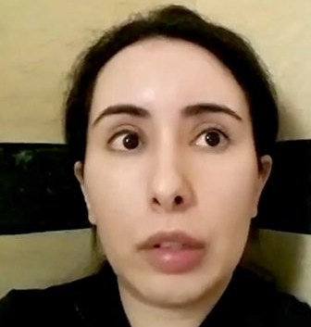

media captionVideos show Dubai's Princess Latifa imprisoned against her will in "villa jail"

Using a phone she said she had been secretly given about a year after her capture, Princess Latifa recorded a number of videos over several months.

She recorded them in a bathroom as it had the only door she could lock. In the messages, she detailed how:

* she fought back against the soldiers taking her off the boat, "kicking and fighting" and biting one Emirati commando's arm until he screamed
* after being tranquillised, she lost consciousness as she was being carried on to a private jet, and didn't wake up until it landed in Dubai
* she was being held alone without access to medical or legal help in a villa with windows and doors barred shut, and guarded by police