# https://www.bbc.co.uk/news/world-asia-56675201

# Kyrgyzstan: Fury over death of 'bride kidnapping' victim

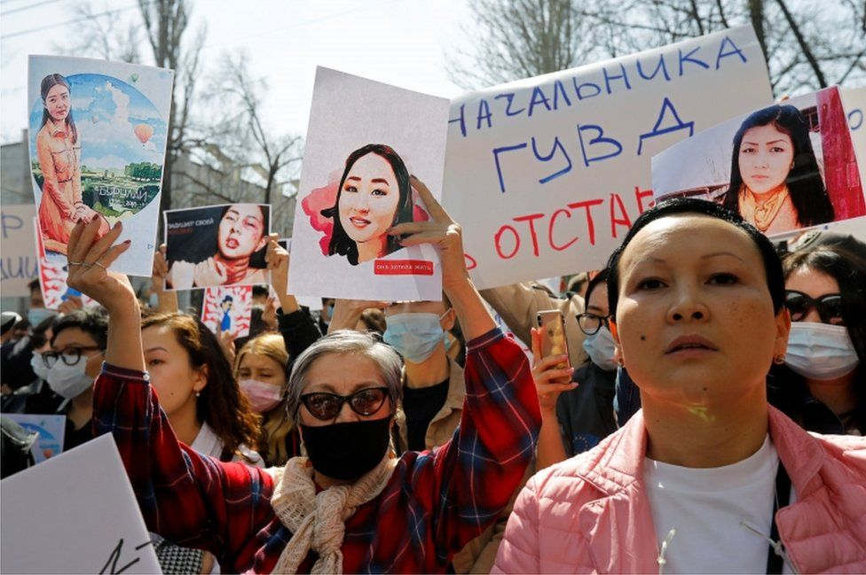

image copyright Reuters

image caption Protesters gathered in front of Kyrgyzstan's interior ministry

**Angry protests have broken out in Kyrgyzstan after a woman was abducted and killed in a case of "bride kidnapping".**

Aizada Kanatbekova, 27, was snatched on Monday by three men who pushed her into a car. It is believed one of them wanted to marry her by force.

Security footage showing the abduction spread widely on social media but police could not track the vehicle.

Ms Kanatbekova's body was found in an abandoned car on Wednesday.

A shepherd came across the vehicle in a field outside the capital, Bishkek, and raised the alarm.

The young woman's kidnapper and suspected murderer was also found dead. Police said he died from knife wounds, which were thought to have been self-inflicted.

Ms Kanatbekova's family said she knew the man, and they had asked him before not to hassle her.

Another of the three men was detained by police, according to state TV.

The illegal abduction of women for marriage is thought to be widespread in the country.

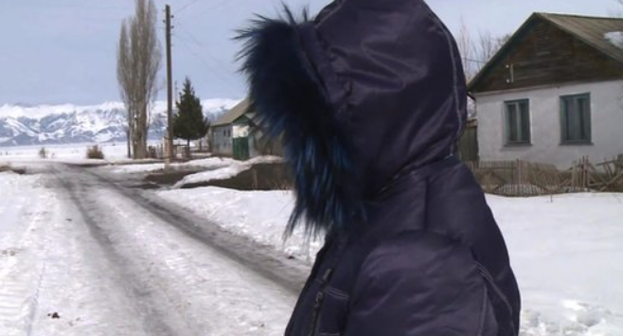

media caption Two victims of bride kidnapping tell their stories

Many believe bride kidnapping is an ancient Kyrgyz tradition, but some researchers argue it became popular in the Central Asian country only a few decades ago.

It was outlawed in 2013, but convictions are rare and women are often unwilling to report it for fear of reprisals. UN figures suggest one in five marriages in Kyrgyzstan happens after a woman has been kidnapped.

Parents and relatives relentlessly pressure young men in Kyrgyzstan to marry after they reach a certain age. For many, especially those from poor families, bride kidnapping is the cheapest and quickest way.

* [Bride-kidnapping debate divides Kyrgyzstan](https://www.bbc.co.uk/news/world-asia-20675101)

About 500 people gathered to demonstrate in front of the interior ministry on Thursday, shouting "Shame!" and demanding the minister's resignation.

"It is impossible to be quiet and observe the violence that our women, who lack any rights, must endure," local journalist Mahinur Niyazova told the AFP news agency.

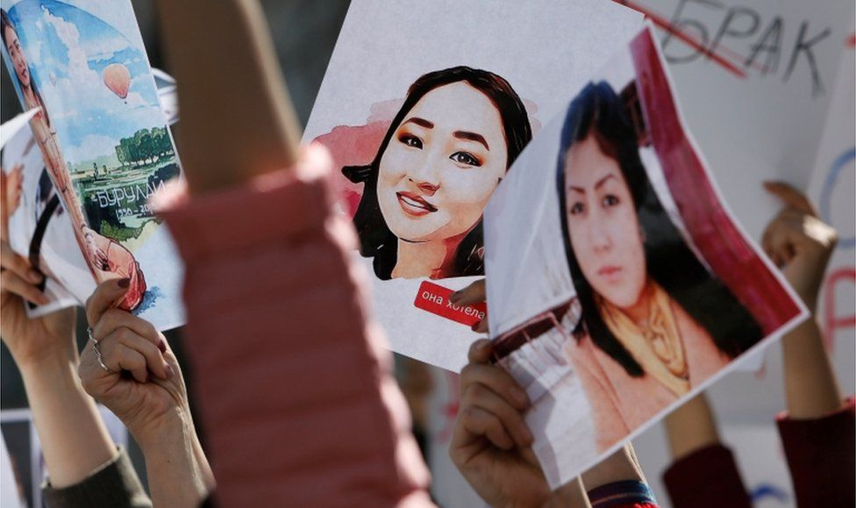

image copyright Reuters

image caption Protesters shouted down the country's prime minister when he urged them to "have patience"

Prime Minister Ulugbek Sharipov urged the crowd to "have patience" while police investigate, but several called for him to be fired too.

Some of the signs carried by protesters read: "Who will answer for Aizada's murder?" and "Who still thinks that murder is a tradition?"

Writing on Facebook, Kyrgyzstan's President Sadyr Japarov described Ms Kanatbekova's death as "a tragedy and pain not only for her family, but also for our entire state".

The incident should be "the last bride kidnapping in history", he said.

Kyrgyzstan has been here before, however.

In 2018, a 20-year-old medical student, Burulai Turdaaly Kyzy, was stabbed to death at a police station, as she prepared to file a statement against her kidnapper.

Her killer was sentenced to 20 years in prison, and more than 20 police officers were punished.