<https://www.bbc.co.uk/news/world-asia-india-56791164>

# Kashmir: A father digging up the ground to find his missing son

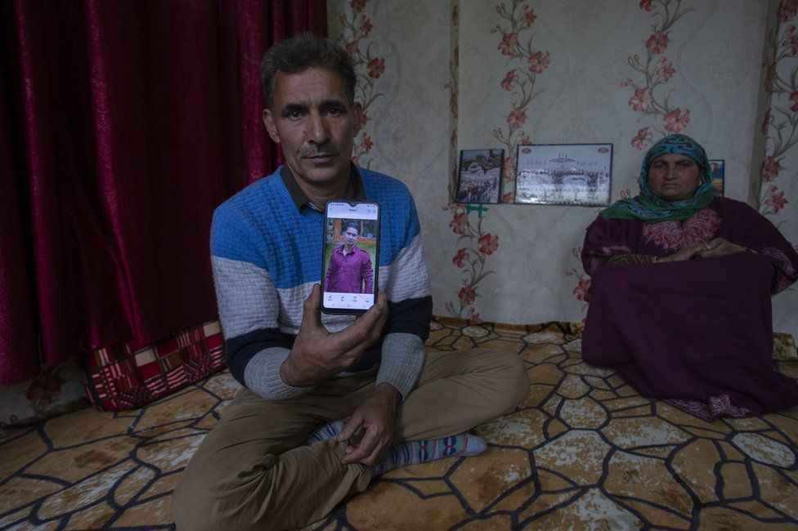

image copyright Abid Bhat

image caption Manzoor Ahmad Wagay has been looking for his missing son for nine months

**Last August, an Indian soldier was abducted by a group of men in Indian-administered Kashmir. His family believes he is no longer alive. However, his father is continuing to look for his son's remains. Jehangir Ali reports from Srinagar.**

A day after Manzoor Ahmad Wagay first heard the news of his son's kidnapping, police found the charred remains of his car.

Some 15km (9 miles) away, blood-smeared, tattered pieces of his light brown shirt and black t-shirt were retrieved from an apple orchard.

Then the trail went cold.

In the evening of 2 August 2020, 24-year-old Shakir Manzoor briefly joined the Eid celebrations at his home in Shopian, the apple growing district of the Himalayan region.

According to his family, the Kashmiri Muslim who worked for the Indian army was returning to his base, some 17km away, when separatist rebels stopped his car.

"Some of them hopped in and the car drove off," said Shahnawaz Manzoor, his youngest brother, quoting eyewitnesses. Nobody knows where they went.

Shahnawaz, who is a law student, says he later saw Shakir's car coming from the opposite direction when he was returning home on his motorbike. It was "packed with strangers", he remembers.

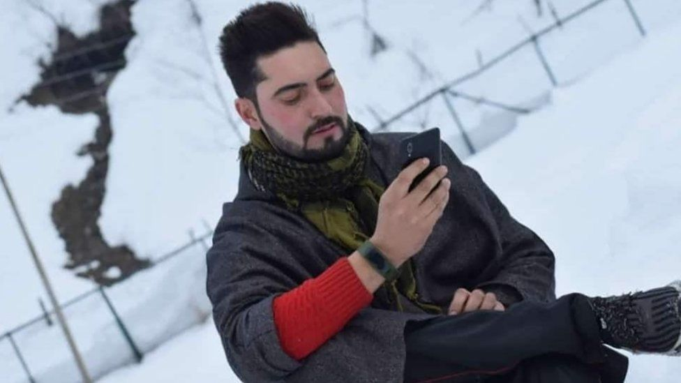

image copyright Manzoor family

image caption Shakir Manzoor, 24, was abducted in August last year

"Where are you going?" Shahnawaz shouted, bringing his bike to a halt.

"Don't follow me," his brother said as he drove by.

For more than nine months since the abduction, their father Manzoor has been hunting for Shakir's body.

Starting from the village where his clothes were found, the search has expanded to an area of more than 50km radius, encompassing lush green orchards, water streams, dense forests and villages.

Shahnawaz dropped out of college last year to help his father. They hire excavators at times to dig up the numerous rivulets fed by the Himalayan glaciers that irrigate Kashmir.

"Our friends and even neighbours come with shovels and spades whenever we have to search a new location," Shahnawaz said.

The family stumbled into a corpse barely days after Shakir went missing, but it turned out to be of a village elder who, according to police, had been abducted and killed by separatist rebels.

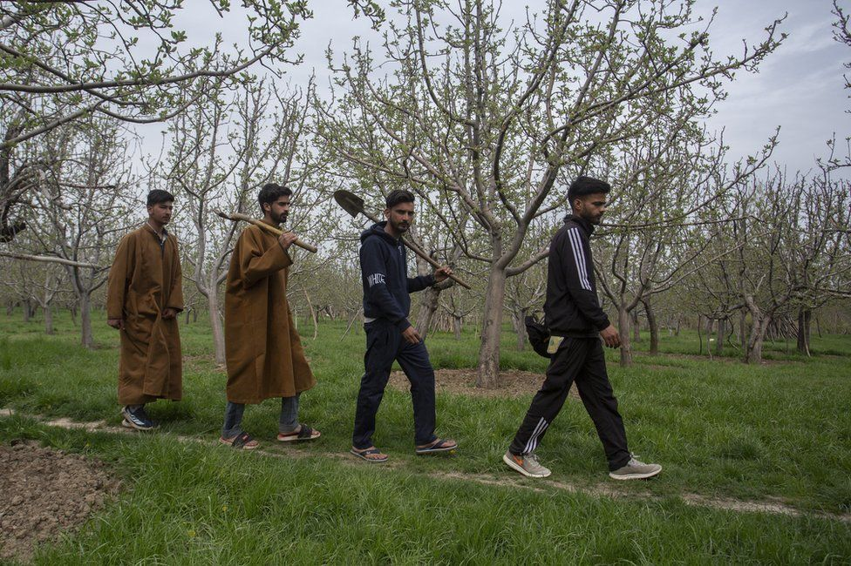

image copyrightAbid Bhat

image captionThe family sets out frequently to look for the missing soldier's body

The chief of local police, Dilbag Singh, recently said the search for Shakir had not ended, although he refused to specify details about the investigation.

The BBC tried to reach Mr Singh and his deputy, Inspector General (Kashmir) Vijay Kumar, for their comments on the case, but they didn't respond.

As per local laws, a person is declared dead seven years after they are reported missing. In official books, Shakir remains "missing". In the tragedy panning out before their eyes, Mr Wagay's family feels humiliated.

"My son laid down his life for the country. If he has joined militants, let the government say so publicly. And if he was killed by the militants, why are they besmirching his martyrdom?" he said.

In Kashmir's unending turmoil, it is not uncommon for people to vanish without a trace. Thousands have disappeared in the past 20 years amid an insurgency against Indian rule in the region.

But in the heavily militarised town of Shopian, which is some 80km from the main city of Srinagar, the disappearance of a soldier is a daring act to pull off.

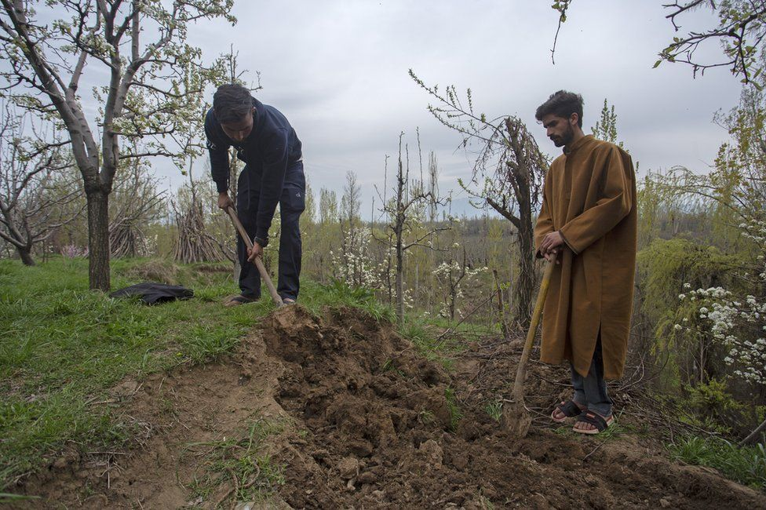

image copyright Abid Bhat

image caption The hunt has expanded to orchards, forests and villages

Mr Wagay, a middle-class farmer, reflects on the dilemma faced by many Kashmiri families whose men die in the line of duty for the security forces.

They risk a social boycott from some local people for working with these security forces. On the other hand, many believe, the Indian security establishment never trusts them fully.

Mr Wagay said he had warned his son against joining the army.

"But he didn't listen to me. He was passionate about the army. He didn't distinguish between Hindus and Muslims."

Shakir's family has now turned to holy men and shrines.

When I meet Mr Wagay on an overcast, gloomy Sunday afternoon in Srinagar, he looks exhausted.

He has just returned from a meeting with a fakir (religious ascetic) who claims to possess "divine knowledge" that could help locate his son's body.

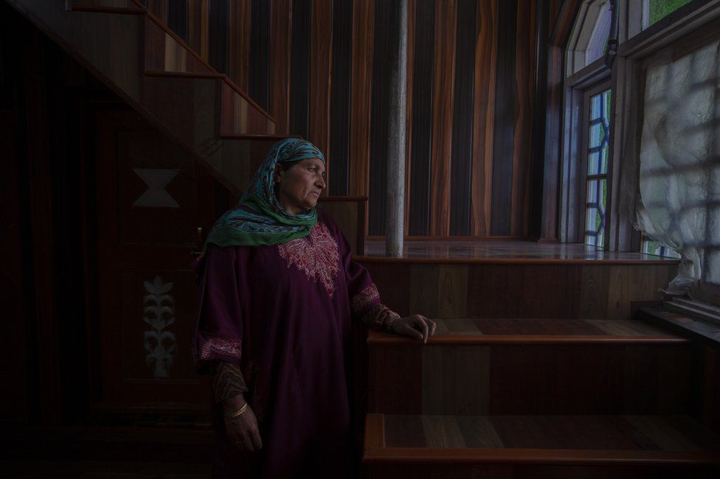

image copyright Abid Bhat

image caption Aisha Wagay says her daughters have donated their jewellery to shrines

"I am starting to lose faith in these holy men," he tells his wife, Aisha.

"He (the *fakir*) asked to search the area where his clothes were found, as if we haven't done that already," Mr Wagay said angrily.

"There isn't one *fakir* from the north to the south in Kashmir that we didn't meet. My daughters donated their gold jewellery to shrines. We will not give up," Aisha Wagay, Shakir's mother said.

Mr Wagay says he will resume digging whenever he gets a new tip-off.

"God had given me enough. We knew he was dead the day his clothes were found. We've offered his funeral prayers".

"But I will continue to search for him as long as I am alive," he said.

*Jehangir Ali is an independent journalist based in Srinagar*