<https://www.bbc.co.uk/news/world-asia-china-56617060>

# China 'driving out journalists', EU says after BBC's Sudworth leaves

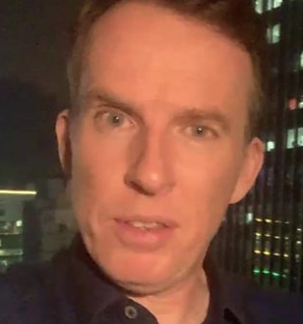

media caption The BBC's John Sudworth says he faced "intensifying attempts to obstruct and harass us wherever we film"

**The EU has accused China of harassing foreign correspondents after the BBC's Beijing correspondent John Sudworth was forced to move to Taiwan.**

Foreign correspondents were "being driven out of China as a result of continuous harassment and obstruction to their work", it said.

It urged China to abide by its international legal obligations to ensure freedom of speech and press.

Sudworth left following pressure and threats from the Chinese authorities.

* [Read John Sudworth's investigation into China’s ‘tainted’ cotton](https://www.bbc.co.uk/news/extra/nz0g306v8c/china-tainted-cotton)
* [Investigating China's hidden camps in Xinjiang](https://www.bbc.co.uk/news/resources/idt-sh/China_hidden_camps)
* [Pressure and propaganda - the reality of reporting Xinjiang](https://www.bbc.co.uk/news/world-asia-china-55666153)
* [Wuhan- City of silence](https://www.bbc.co.uk/news/extra/ewsu2giezk/city-of-silence-china-wuhan)

The BBC's China correspondent, who won awards for his reporting on the treatment of the Uyghur people in the Xinjiang region, left the Chinese capital together with his family, including his wife, RTÉ reporter Yvonne Murray.

China, which has denounced the BBC's coverage of Xinjiang, said it was unaware of any threat to Sudworth other than possible legal action to challenge his reporting on the region.

But he and his family were followed by plainclothes police to the airport and tailed through check-in.

The BBC says it is proud of his reporting and Sudworth, who was based in the country for nine years, remains its China correspondent.



The irony is, of course, that at the same time that the space for foreign journalism is shrinking in China, the Communist Party has been investing heavily in its media strategy overseas, taking full advantage of the easy access to a free and open media.

Its "wolf-warrior" diplomats unleash furious tweet-storms, lambasting foreign reporting - while denying their own citizens access to those very same foreign platforms - in an intensive, co-ordinated strategy across multiple platforms, as documented by this [report by researchers from the International Cyber Policy Centre at the Australian Strategic Policy Institute](https://www.aspi.org.au/report/trigger-warning).

State-media propagandists publish and post their content overseas without restriction, while at home, China ruthlessly shuts down independent reporting, censors foreign broadcasts and websites, and blocks foreign journalists from its own social media networks.

In this context, my departure can be seen as one small part of an emerging and highly asymmetric battle for the control of ideas. It is not a happy prospect for the free flow of good, accurate information.

**Read more from John Sudworth:** ['The grim reality of reporting in China that pushed me out’](https://www.bbc.co.uk/news/world-asia-china-56607815)

## What did the EU say exactly?

A spokesperson for EU foreign policy chief Josep Borrell said at least 18 correspondents had been expelled from China last year.

"The EU has repeatedly expressed its concerns to the Chinese authorities at the undue working restrictions imposed on foreign journalists and reported related harassment," the spokesperson added.

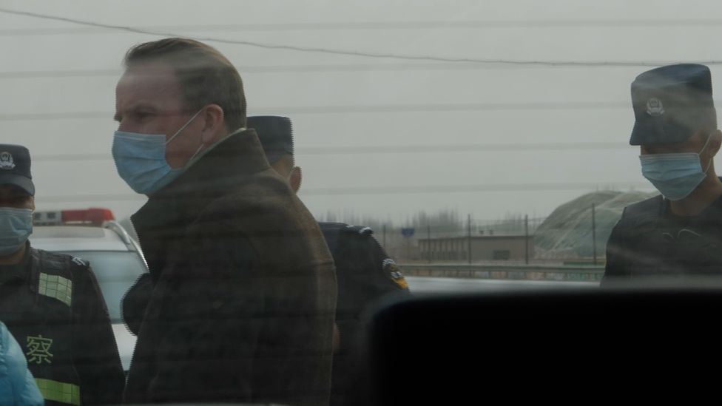

image caption John Sudworth (above) and his team were followed and had their footage deleted on a trip to Xinjiang in late 2020

"Professionalism and objectivity of foreign correspondents is increasingly put into question."

They said the EU stood up "for the role of independent and reliable media all around the world" and called upon China to "abide by its obligations under national and international law and ensure the freedom of speech and press".

* [Explainer: China's Muslim 'crackdown'](https://www.bbc.co.uk/news/world-asia-china-45474279)
* [Searching for truth in China's 're-education' camps](https://www.bbc.co.uk/news/blogs-china-blog-48700786)
* [China denies Muslim children separation campaign](https://www.bbc.co.uk/news/world-asia-china-48899475)

The number of international media organisations reporting from China is shrinking. Last year China expelled correspondents for the New York Times, the Washington Post and the Wall Street Journal, among others.

And in September 2020, [the last two reporters working in China for Australian media flew home](https://www.bbc.co.uk/news/world-australia-54066869) after a five-day diplomatic standoff.

A Chinese foreign ministry spokesperson said the authorities had not been given prior notice of Sudworth's departure.

"Only in recent days when we were faced with the task of renewing Sudworth's press card did we learn that Sudworth left without saying goodbye," Hua Chunying told a news conference in Beijing. "After he left the country, he didn't by any means inform the relevant departments nor provide any reason why."

In its statement, the BBC said: "John's reporting has exposed truths the Chinese authorities did not want the world to know."

Sudworth's reporting colleagues are still in Beijing, and he says he intends to continue his reporting from Taiwan.