# ‘I have sort of broken taboos’: Iranian woman polishes cars and her dreams

By Mohammad Nasiri, Associated Press

At a garage in Iran’s capital Tehran, a female car polisher has battled sceptics and stereotypes to live out her dream of working as a professional detailer.

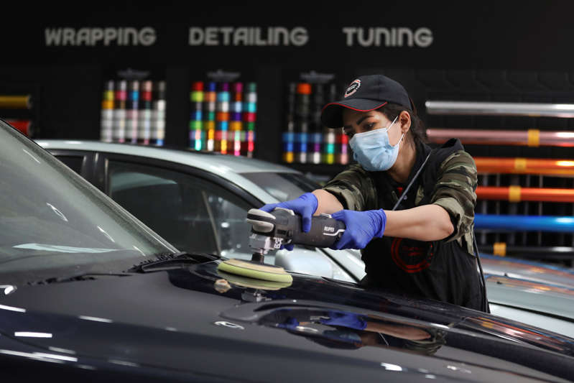

© Vahid Salemi Iranian car detailer Maryam Roohani polishes a car at a detailing shop in Tehran (Vahid Salemi/AP)

Maryam Roohani grew up in a rural, tribal village in Iran’s north east, where women are married off after puberty.

She faced a string of obstacles on her professional path, from her relatives’ displeasure to sabotage by resentful male colleagues.

But she overcame those challenges and now cleans and polishes cars at a prominent Tehran auto shop, and trains other female car enthusiasts to do the same.

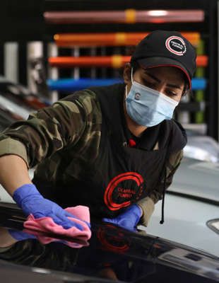

© Provided by PA Media Maryam Roohani polishes a car at a detailing shop in Tehran (Vahid Salemi/AP)

The 34-year-old tucks her long hair into a baseball cap – which in her work, replaces Iran’s compulsory Islamic headscarf for women, or hijab.

Buffing a blue BMW in the shop until it shines, she could not be farther from the farms of her childhood.

In the rural, tribal village of Agh Mazar near Iran’s north-eastern border with Turkmenistan, girls get married after hitting puberty and devote their lives to raising children.

“I have sort of broken taboos,” Ms Roohani said at the garage, where she carefully coats cars with attention-getting gleams and scrapes sludge from their engines.

“I faced opposition when I chose this path.”

The car industry remains male-dominated around the world, let alone in the tradition-bound Islamic Republic.

But Iranian women, especially in the cities, have made inroads over the years.

They now make up more than half of all college graduates and a sizeable part of the workforce.

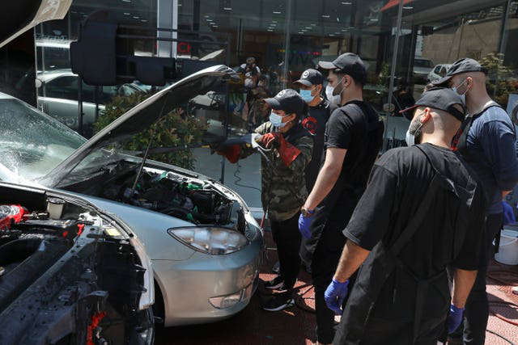

© Provided by PA Media Maryam Roohani cleans a car as her trainees watch (Vahid Salemi/AP)

A farmer’s daughter, Ms Roohani grew up labouring on the land like most other children in Agh Mazar.

But unlike her five siblings, she had her eyes on her father’s tractor, and developed an uncanny knack for driving it at an early age.

Even as she worked as a hairdresser and studied to become a make-up artist in Bojnurd, the provincial capital, a greater passion pulled her in: applying finishes to cars.

To the scorn of villagers and some family members, she traded used cars for extra cash and dreamed of working as a car polisher and detailer.

Although relatives turned against her and cut off contact, her father had a more liberal attitude, supporting her despite the pushback and letting her postpone marriage to pursue her love of polishing.

There were no international car polish training programmes she could find in the rolling wheat and barley fields of North Khorasan province, nor elsewhere in the country at the time.

So she flew to Turkey, where she battled male sceptics to earn her car polishing certificate.

Armed with credentials, she set up shop in a small, rented space at a Tehran garage.

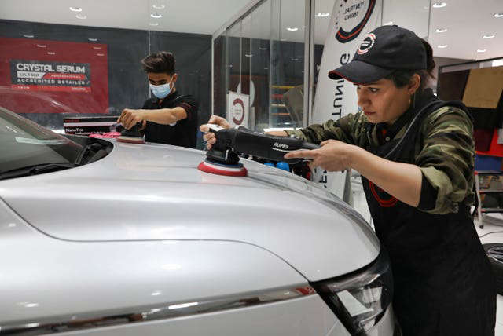

© Provided by PA Media Maryam Roohani and her brother Reza polish a car (Vahid Salemi/AP)

Customers flocked to marvel at the area’s first female car detailer, snapping photos and sharing footage on social media.

Her Instagram account and online persona as Iran’s “Miss Detailer” grew.

But her initial successes drew resentment from male colleagues – and at times, even sabotage.

Some tainted her polishing pads with acid to burn the paint of her customers’ cars, she recounted.

Others tampered with her machines and tore up the costly pads that she purchased with her life’s savings, she said.

Complaints to the garage’s owner went nowhere, and without hard evidence the police could not help either.

Ms Roohani wanted to cut and run after that.

But her reputation had grabbed the attention of a prominent Tehran auto shop, which suddenly offered her a job.

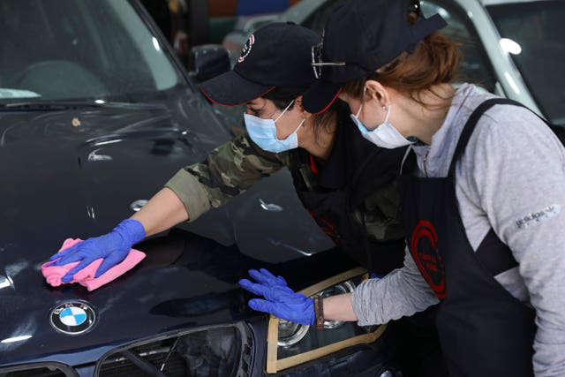

© Provided by PA Media Maryam Roohani polishes a car as her trainee Farahnaz Deravi watches (Vahid Salemi/AP)

For the past few years, she has lived out her dream as a professional car polisher, detailer and washer.

Ms Roohani even now trains and inspires other women to do the same despite the obstacles.

Her online videos include her hard at work polishing a vintage Chevrolet Chevelle or smiling over the bonnet of a freshly detailed jet-black BMW, so smooth that a plastic cup slides down it.

“I got excited the first time I saw (Ms Roohani) because in Iran, with its limitations for women, we are not usually trusted to do such jobs,” said Farahnaz Deravi, one of Ms Roohani’s trainees.

Interest in car repair work has exploded in Iran since former US president Donald Trump withdrew from Tehran’s landmark nuclear deal with world powers and imposed biting sanctions.

To preserve its foreign currency, Iran banned the import of Asian and European-made cars, causing prices of the vehicles to quadruple.

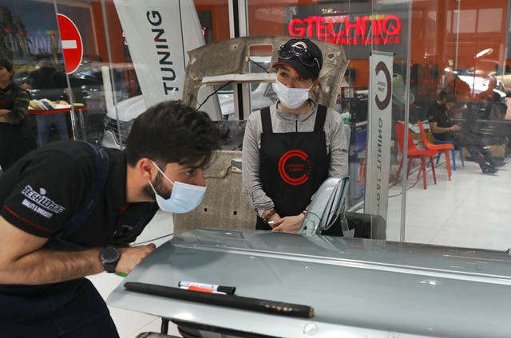

© Provided by PA Media Iranian women, especially in the cities, have made inroads in the industry over the years (Vahid Salemi/AP)

Iranians with the means to own expensive cars cherish them more than ever and pay hefty sums to maintain the status symbol.

Although Ms Roohani’s business is brisk, Iran’s economy is struggling with a series of mounting crises, including international isolation and a raging pandemic.

Ms Roohani now imagines her future as a professional detailer abroad, and hopes to start her own business somewhere in Europe one day.

“The Iranian Miss Detailer must shine out there,” she said, smiling.