<https://www.bbc.co.uk/news/world-asia-56924549>

# West Bengal: India state elections go ahead as deaths hit record high

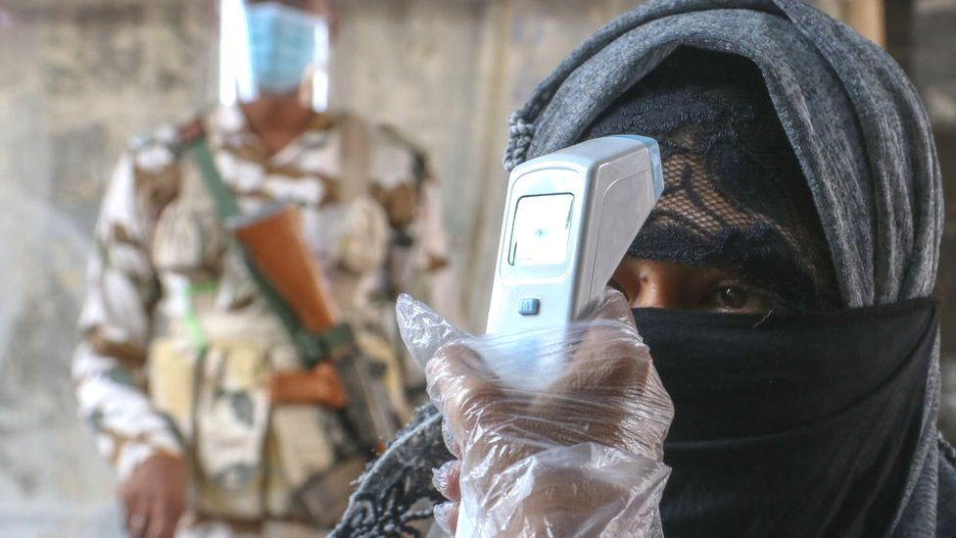

image copyright Getty Images

image caption Voters in the Indian state of West Bengal go to the polls

**People in the Indian state of West Bengal are voting in the final phase of elections despite soaring Covid cases.**

Long queues were seen outside polling booths, raising concerns about further spread of the virus amidst a deadly second wave.

Experts fear West Bengal could be the next epicentre. Cases rose by 17,000 on Wednesday - a state record.

In total, India reported 379,257 new infections on Thursday, the world's highest single-day total.

The state has already seen seven phases of voting. West Bengal is one of the few where Prime Minister Narendra Modi does not have a majority of parliamentary seats.

There has been a lot of criticism that he continued to hold large rallies there even as the virus began overwhelming the country.

The BBC's correspondent in the area, Amitabha Bhattasali, says some of the biggest rallies, including those attended by Mr Modi, saw throngs of people not wearing masks or maintaining social distancing.

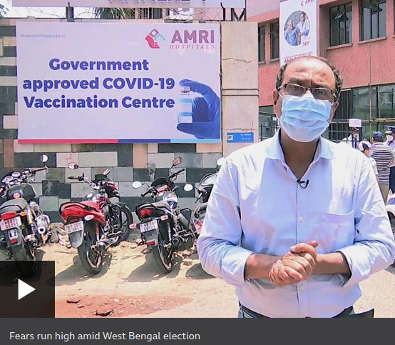

media caption Fears run high amid West Bengal election

## What is happening now in India?

Hospitals have been overwhelmed, oxygen is in critically low supply and crematoriums are operating non-stop.

The overall death toll officially surpassed 200,000 on Wednesday, though experts believe the actual number could be much higher.

* [Deadly Covid wave rips through small-town India](https://www.bbc.co.uk/news/world-asia-india-56913047)
* [As it happened: BBC's live coverage on India's Covid surge](https://www.bbc.co.uk/news/live/world-56890174)
* [Why India's Covid crisis matters to the whole world](https://www.bbc.co.uk/news/world-asia-india-56907007)
* [India's round-the-clock mass cremations](https://www.bbc.co.uk/news/in-pictures-56913348)

It was the deadliest day so far, with 3,645 people succumbing to the coronavirus.

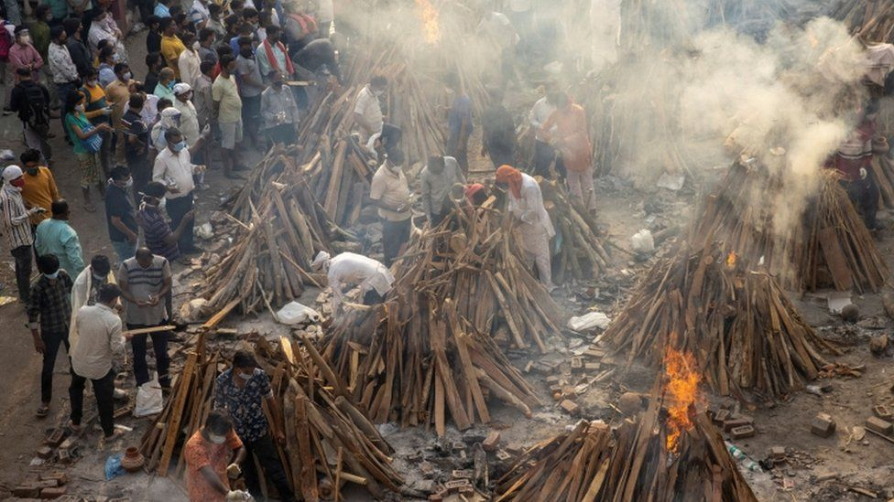image copyright Reuters

image caption Crematoriums are working throughout the night and using empty spaces like parks and car parks to build makeshift funeral pyres

## What about vaccines?

The government had said that all adults will be eligible for Covid-19 vaccinations from 1 May, with online registration opening from 28 April.

But people on social media complained that they were not able to get slots because the website crashed soon after it opened.

* [Can India make enough vaccines to meet demand?](https://www.bbc.co.uk/news/world-asia-india-55571793)
* [How is India's vaccination drive going?](https://www.bbc.co.uk/news/world-asia-india-56345591)

So far, India has been vaccinating health workers, front line workers and adults over the age of 45.

But less than 10% of the population has received an initial jab and there are concerns about meeting demand.

Although India is one of the world's biggest producers of vaccines, it does not yet have the stocks for the roughly 600 million people who will be eligible from 1 May.

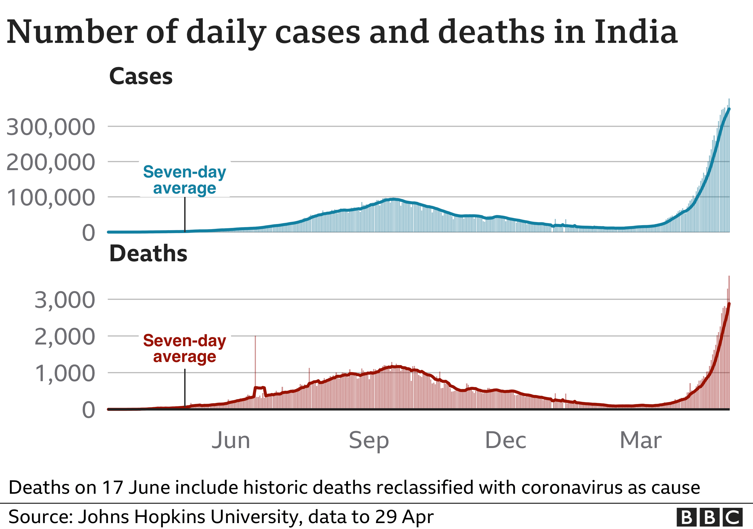

The White House says the United States is redirecting its own order of AstraZeneca manufacturing supplies to India, allowing it to make more than 20 million doses of the vaccine.

Epidemiologist Bhramar Mukherjee says India must combine the immunisation drive with a widespread lockdown to slow the spread of the virus.

We need much larger scale lockdowns in India. Things are getting worse everyday. What are we waiting for?  
  
It is a national medical emergency.   
  
At this point lives are so much more important than livelihoods.  
  
Provide assistance to the poor, but please lockdown and vaccinate.

— Bhramar Mukherjee (@BhramarBioStat) [April 28, 2021](https://twitter.com/BhramarBioStat/status/1387285004846309376?ref_src=twsrc^tfw)

The BBC is not responsible for the content of external sites.[View original tweet on Twitter](https://twitter.com/BhramarBioStat/status/1387285004846309376)

Several parts of the country are under lockdown and curfew, including in the capital Delhi.

The government of Maharashtra, which is home to the financial capital Mumbai, is considering extending its lockdown until mid-May.

There is no lockdown or curfew in West Bengal state though.

## Related Topics

* [India](https://www.bbc.co.uk/news/topics/cny6mpy4mj9t)
* [Coronavirus pandemic](https://www.bbc.co.uk/news/topics/cyz0z8w0ydwt)
* [Coronavirus vaccines](https://www.bbc.co.uk/news/topics/c87z0we2g0zt)
* [Asia](https://www.bbc.co.uk/news/topics/c5rznn0nvvyt)

## More on this story

* ['A horror story on repeat': India's Covid crisis](https://www.bbc.co.uk/news/live/world-56890174)
* [Man charged over oxygen SOS for dying grandfather](https://www.bbc.co.uk/news/world-asia-india-56894757)
* [India's round-the-clock mass cremations](https://www.bbc.co.uk/news/in-pictures-56913348)