<https://www.bbc.co.uk/news/world-middle-east-57154557>

# In pictures: Fear and mourning as Israel-Gaza violence rages on

* [Gaza border clashes](https://www.bbc.co.uk/news/topics/c0n74xlgg8rt)

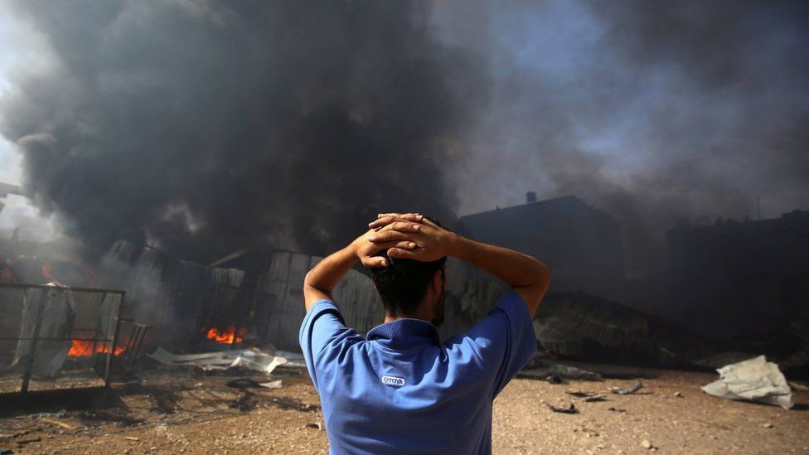

image copyright Reuters

image caption A factory burns in Gaza after it was hit by Israeli artillery shells

**Fighting between Israel and Palestinian militants shows no sign of abating, and concern is mounting over the toll the violence is taking on civilians.**

Striking images have captured the human cost of the conflict over the past few days, as air strikes and rocket attacks turn homes and possessions into rubble and force people to rush for shelter.

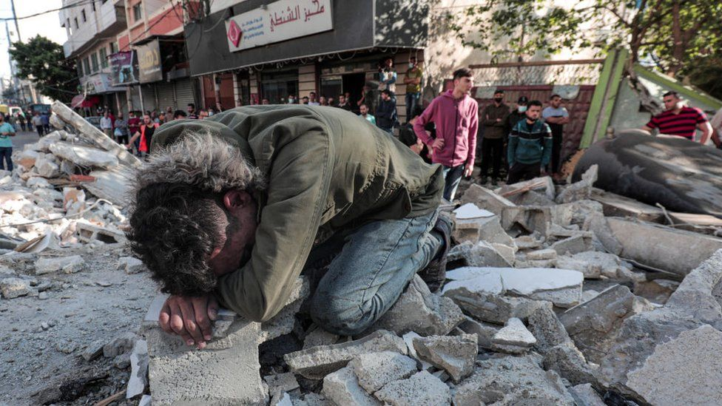

image copyright Getty Images

Israel says its air strikes on Gaza have targeted Palestinian militants but power lines and main roads have also been damaged.

In the image above, a Palestinian man hunches over the rubble of his destroyed home following an Israeli strike on Sunday.

Some of his family were buried beneath the debris.

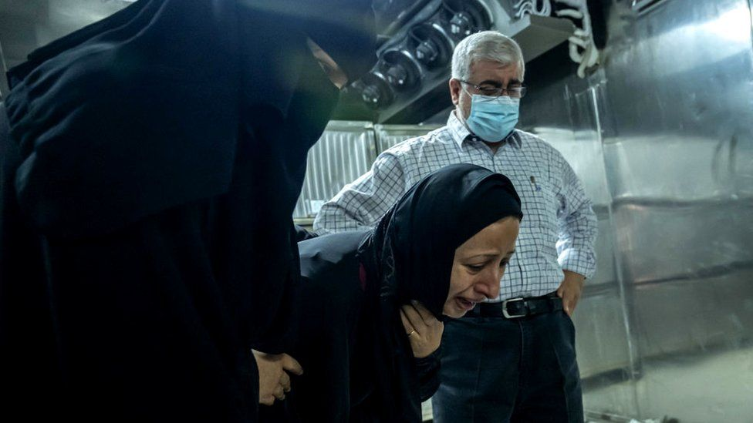

image copyright Getty Images

That day was the deadliest in Gaza since fighting erupted more than a week ago.

Israeli air strikes hit a busy street just after midnight, causing several buildings to collapse and dozens of deaths.

"We need at least 10 years more to build what has been damaged here in Gaza," Mohammad Abu Rayya, a paediatrician, told the BBC on Monday following further strikes.

Impromptu funerals have been held around the territory. The woman above is mourning her family who died in a strike in Gaza City.

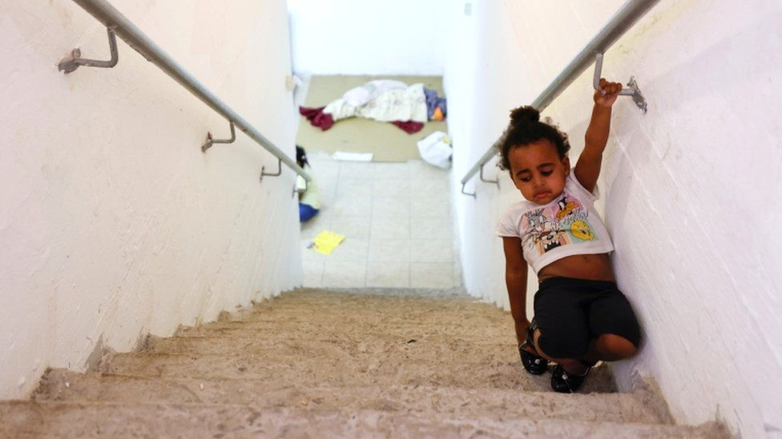

image copyright Reuters

Meanwhile Hamas, which controls Gaza, and other Palestinian militant groups there, have continued to launch rockets towards southern Israel.

Homes and buildings have been damaged, and millions of Israelis have been forced to flee to safe rooms or shelters as warning sirens blare.

The young girl above was pictured at a bomb shelter in the city of Ashkelon, which has borne the brunt of the rocket attacks.

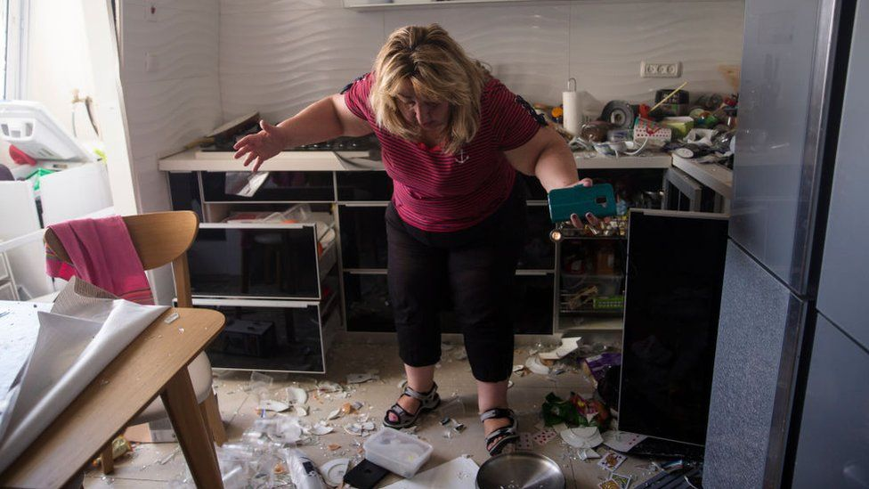

image copyright Getty Images

Victoria Tapalashvili can be seen inspecting the damage at her home in the southern Israeli city of Ashdod following an attack.

"It is not easy - almost every evening, every night, we get the kids out of bed [and] run to shelters," Israeli tech executive and father of three, Eitan Singer, told the BBC.

"We have 30 seconds to 60 seconds to find a shelter."

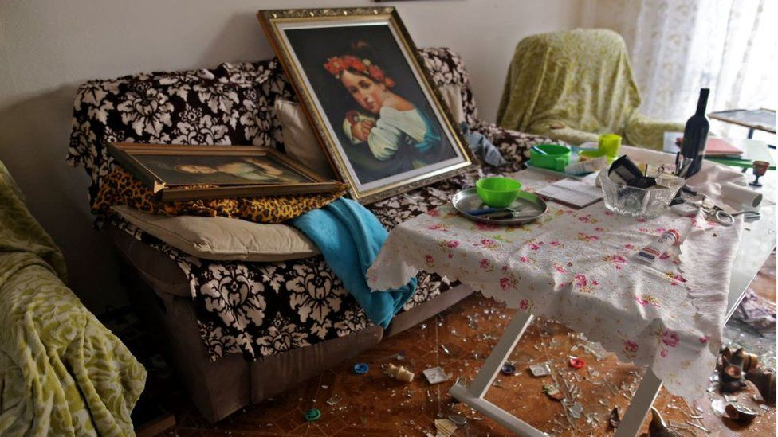

image copyright AFP

This image shows another damaged home in Ashdod.

* [The Israel-Palestinian conflict explained](https://www.bbc.co.uk/news/newsbeat-44124396)
* [Mothers fear for children in Israel-Gaza conflict](https://www.bbc.co.uk/news/world-middle-east-57105473)
* [Israel-Palestinian conflict claims fact-checked](https://www.bbc.co.uk/news/57111293)

Israel's Iron Dome defence system is said to have intercepted 90% of the rockets fired at its territory.

Rockets have also been fired from neighbouring Lebanon towards northern Israel.

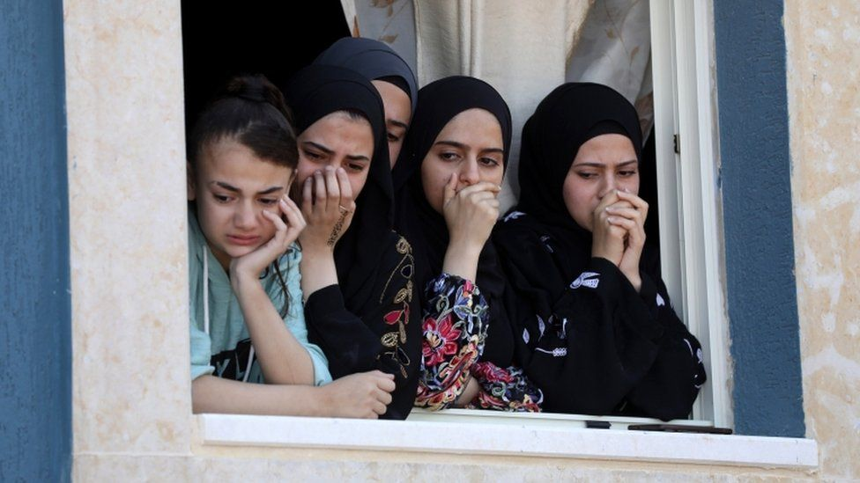

image copyright EPA

The violence also spread to the occupied West Bank, where Israeli troops clashed with Palestinians over the weekend.

These Palestinians watch from a window as mourners carry the body of a relative during a funeral in the West Bank on Sunday.

Palestinian Arabs live in the West Bank under both limited self-rule and Israeli military rule.

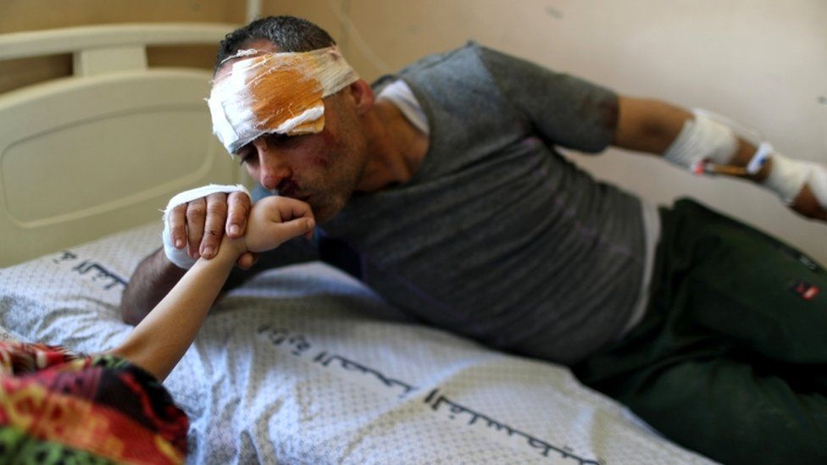image copyright Reuters

This man, Riyad Eshkuntana, was pulled from the rubble along with his six-year-old daughter, Suzy, in Gaza.

She was trapped for hours underneath their home, and was eventually reunited with her father at Gaza's largest hospital.

"Forgive me, my daughter. You screamed to me to come to you, but I couldn't come," Mr Eshkuntana told her when they were reunited, according to Reuters.

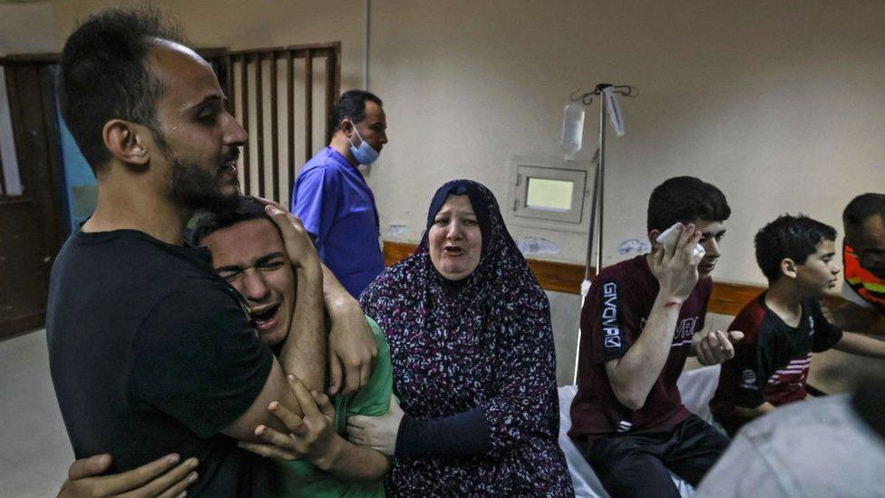

image copyright Getty Images

This image shows the Abu Dayer family at the Al-Shifa hospital in Gaza, shortly after two relatives were killed.

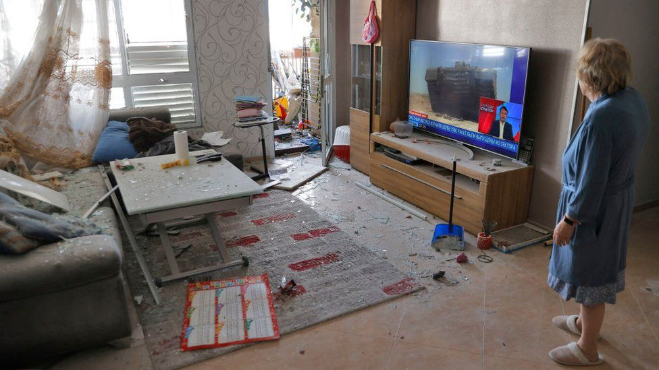

image copyright AFP

This woman checks the damage at her home in Ashkelon, as coverage of the fighting continues to play in the background.

The violence has prompted increasing concern internationally.

World leaders and humanitarian organisations have called for measures to prevent the deaths of residents and the chaos wrought by the destruction of buildings and infrastructure.

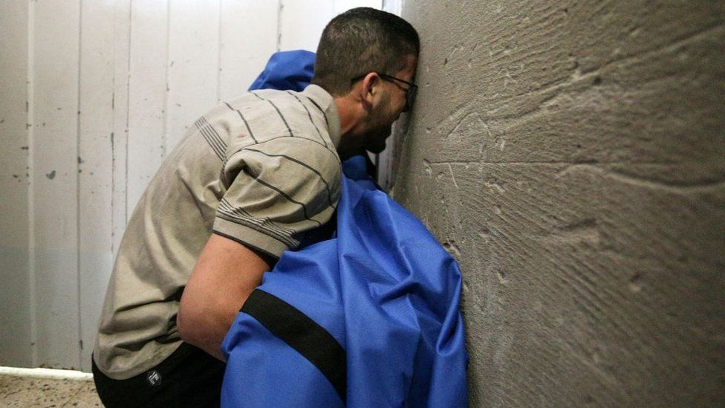

image copyright Getty Images

In the image above, a man mourns the death of his 12-year-old daughter Rahaf al-Dayer in Gaza.

And below, the family and friends of an Israeli soldier weep at his funeral.

The conflict is now in its second week, with little sign of ending. Air strikes and rocket attacks continued into Tuesday.

The US and other world powers have voiced support for a ceasefire - but one does not appear to be imminent.

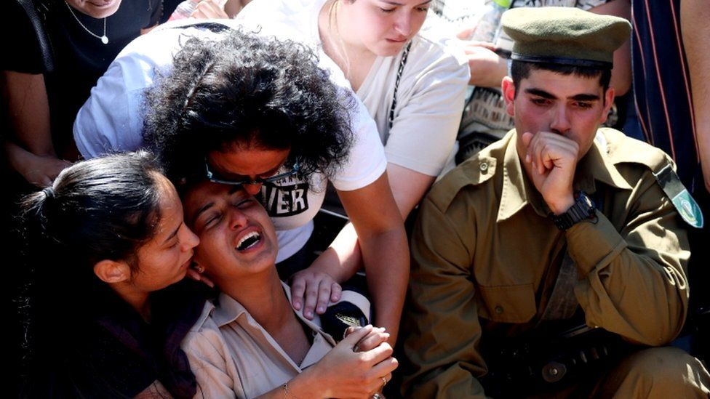

image copyright Reuters **All images subject to copyright**