<https://www.bbc.co.uk/news/world-middle-east-57205968>

# Gaza-Israel conflict in pictures: 11 days of destruction

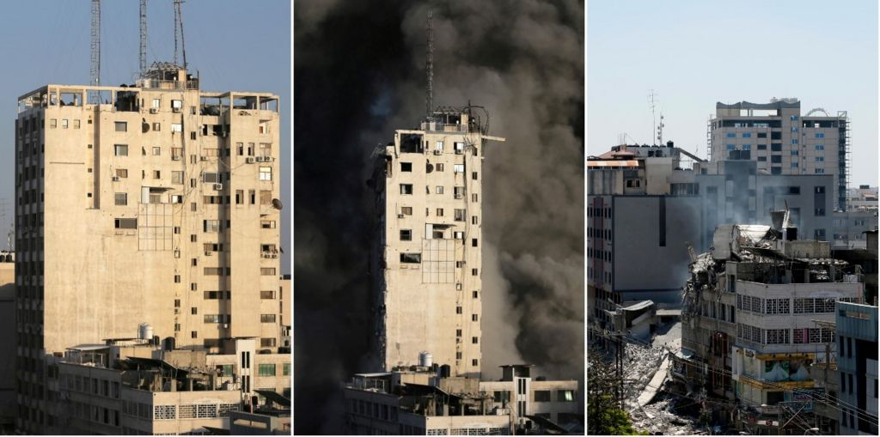

image copyright Reuters

image caption A tower building in Gaza City (left and centre) and after it was destroyed by Israeli air strikes (right)

**After 11 days of fighting, Israel and the Palestinian militant group Hamas have agreed to a ceasefire.**

At least 243 people, including more than 100 women and children, were killed in Gaza, according to its health ministry. Israel has said it killed at least 225 militants during the fighting. Hamas has not given casualty figures for fighters.

In Israel 12 people, including two children, were killed, its medical service says.

Both sides claim victory in the conflict. Now images are emerging of the damage done by Hamas rocket fire and Israeli strikes.

The Israeli military says more than 4,300 rockets were fired towards its territory by militants through the conflict, and that it struck more than 1,000 militant targets in Gaza.

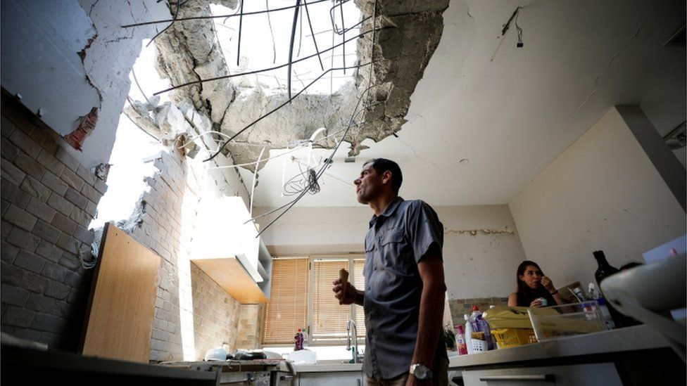

image copyright Reuters

image caption A man looks at the damage done to his house in southern Israel by a rocket fired from Gaza

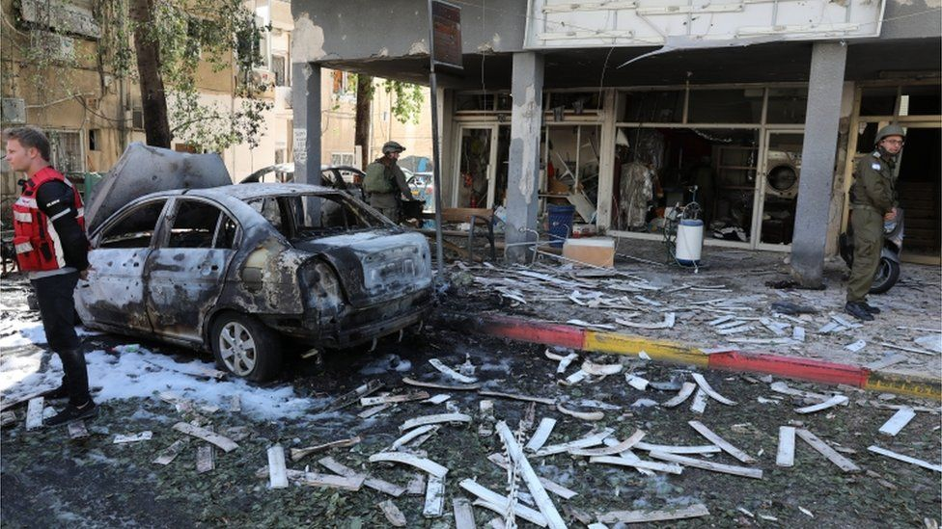

image copyright EPA

image caption Rocket fire damaged cars and shops in Ramat Gan outside Tel Aviv

Israeli Prime Minister Benjamin Netanyahu said the country had gone to "extreme" lengths to avoid civilian casualties in Gaza, taking steps that no other country in the world had done.

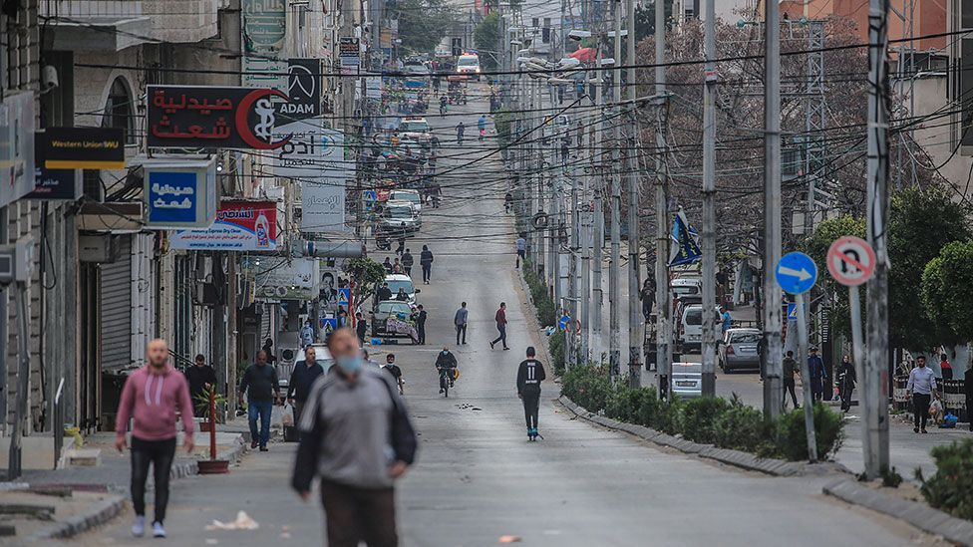image copyright EPA

image caption Palestinians walk down a street in Gaza City in April before the recent fighting broke out

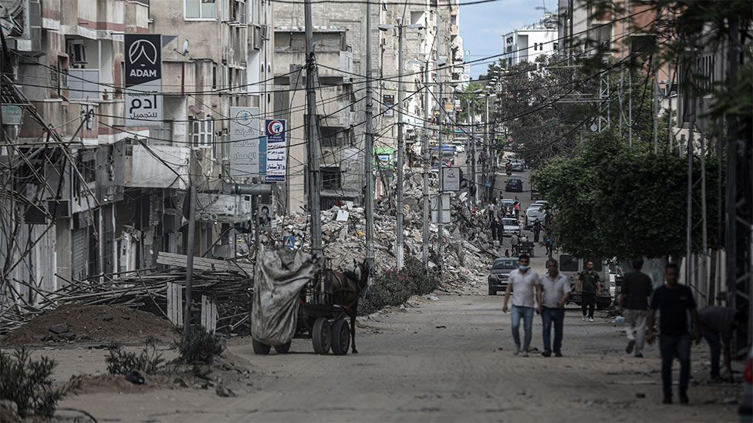image copyright Getty Images

image caption That same street, pictured hours after the ceasefire was declared

At a news conference on Friday Mr Netanyahu said that his country had "exacted a heavy price from Hamas".

"Not everything is known to the public yet, nor to Hamas, but the full range of achievements will be revealed over time," he said.

Top Hamas political leader Ismail Haniya, meanwhile, said the recent fighting "defeated the illusions of negotiations", describing resistance as the "best strategic choice for liberation".

"We, as a movement and movement's leadership, with all our people and the good people of this nation and the world, will rebuild Gaza," he added.

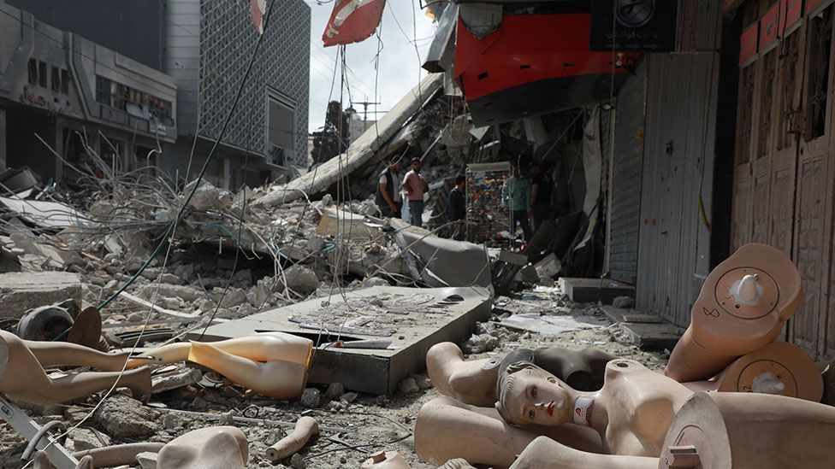

image copyright Getty Images

image caption Broken mannequins lie on the floor outside a shop damaged by an Israeli air strike in Gaza City

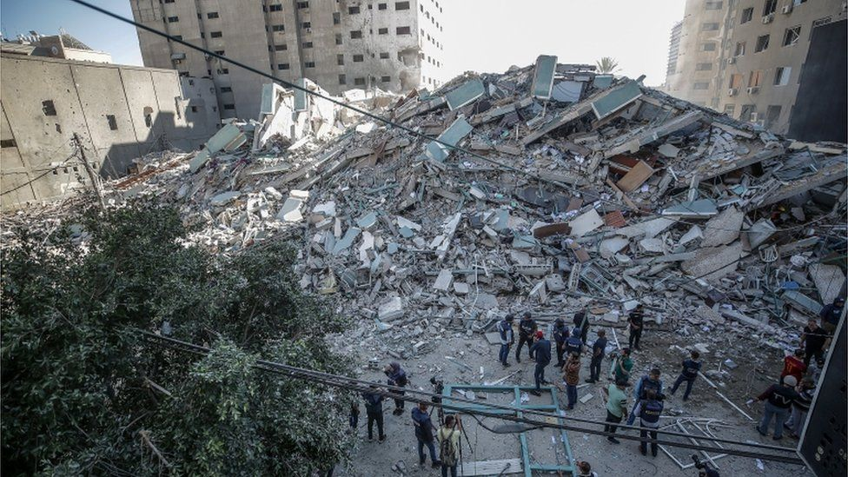

image copyright EPA

image caption Gaza City's al-Jalaa tower in ruins after an Israeli air strike

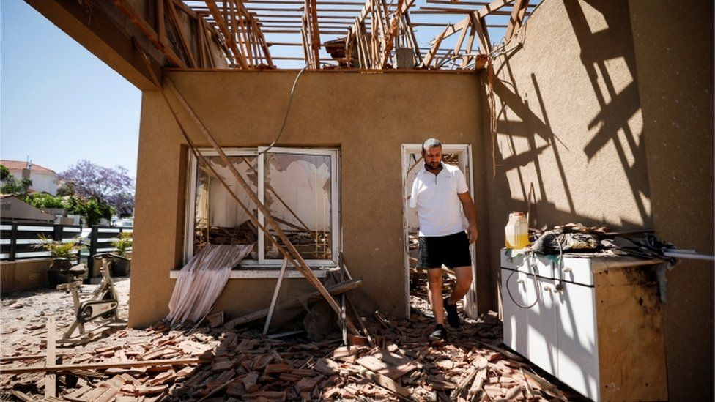

image copyright Reuters

image caption An Israeli man walks through his home in Sderot after it was hit by a rocket fired from Gaza

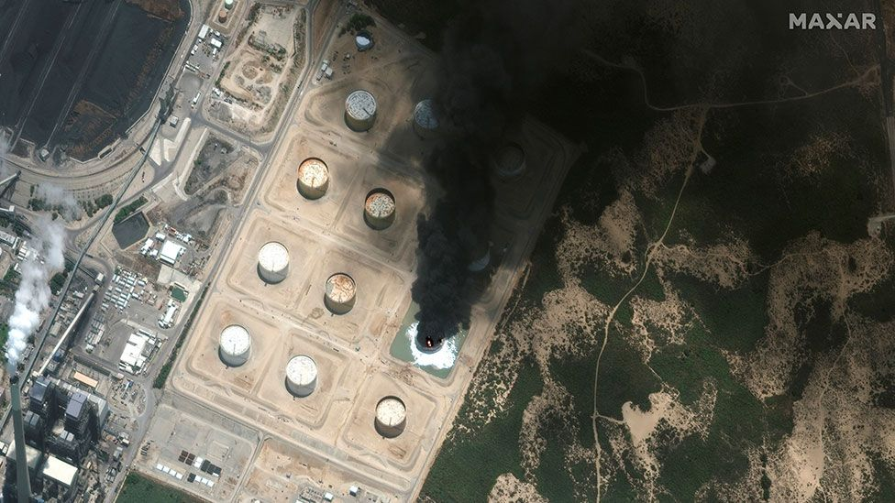

image copyright MAXAR TECHNOLOGIES

image caption An oil storage facility in southern Israel burns after it was hit by rocket fire from Gaza

Presidents and prime ministers worldwide have welcomed the ceasefire, brokered by Egypt.

While some laid blame on one side or the other, leaders overwhelmingly called for a lasting political solution to the conflict.