<https://www.bbc.co.uk/news/world-middle-east-57066275>

# Jerusalem crisis: Pleas for calm as violence escalates

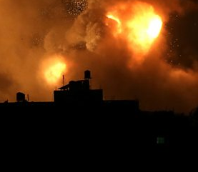

media caption Israeli air strikes hit Gaza after rocket fire

**Countries worldwide have appealed for calm after days of unrest spiralled into retaliatory attacks by Israel and Palestinians.**

The US, the European Union and the UK have urged Israel and the Palestinians to lower tensions as soon as possible.

The violence escalated on Monday night after Palestinian militants fired rockets towards Jerusalem.

In response, the Israeli military launched air strikes against militant targets in the Gaza Strip.

Palestinian health officials in Gaza said 22 people, including nine children, had died in the strikes. Israel's military said at least 15 members of the Hamas group that rules Gaza were among those killed.

Hamas had threatened to strike after hundreds of Palestinians were injured in clashes with Israeli police at a holy site in Jerusalem on Monday.

* [What makes Jerusalem so holy?](https://www.bbc.co.uk/news/world-middle-east-26934435)
* [The Israel-Palestinian conflict explained](https://www.bbc.co.uk/news/newsbeat-44124396)

Israel's Prime Minister Benjamin Netanyahu said Hamas had "crossed a red line" and that Israel would respond "with great force".

The past few days have seen the worst violence in Jerusalem for years, with confrontations between Israeli police and Palestinian protesters at a holy compound in Jerusalem's Old City.

The clashes came amid mounting Palestinian anger over the threatened eviction of families from their homes in East Jerusalem by Jewish settlers, fuelled by a month of altercations between protesters and police in the predominantly Arab part of the city.

Early on Tuesday, the Palestinian Red Crescent, a humanitarian group, said more than 700 Palestinians had been injured in clashes with Israeli security forces in Jerusalem and across the West Bank.

## The open wound of an unresolved conflict

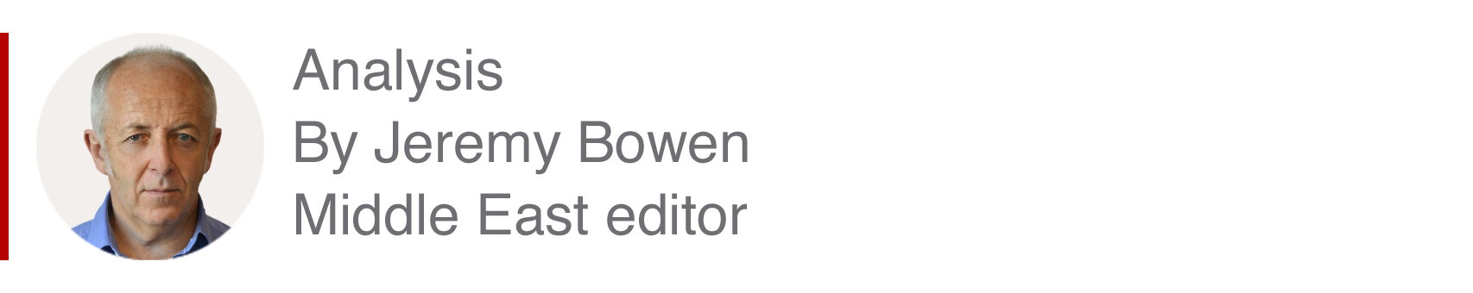

The fundamental reason for the renewed violence does not change. It is the open wound of the unresolved conflict between Jews and Arabs that has blighted and ended Palestinian and Israeli lives for generations.

This latest episode has happened because of tension in Jerusalem, the sharpest part of the conflict. The holy sites in the Old City are national as well as religious symbols. Crises affecting them have often ignited violence.

The triggers for what has happened this time include heavy-handed Israeli policing of Palestinians during Ramadan and controversial efforts in the Israeli courts to evict Palestinians from their homes.

But other events could have had the same effect. This was a crisis waiting to happen, in a conflict that, once again, has been left to fester.

Leaders on both sides have concentrated on safeguarding their own positions.

The biggest challenge, of making peace, has not been addressed seriously for years.

Bombardments did not abate overnight as the sound of Palestinian rockets and Israeli air strikes echoed across the region on Tuesday morning.

Israel's military said it carried out strikes on 130 targets across the Gaza Strip. In one strike, a woman was killed and two others were injured, health officials said.

Meanwhile, Hamas fired at rocket barrage at the city of Ashkelon in southern Israel. It said this was retaliation for an Israeli attack on a civilian apartment block near Gaza city.

A Hamas source told the BBC on Tuesday morning that more than 300 rockets had been fired from Gaza in the last 12 hours.

## What's the global reaction?

US Secretary of State Antony Blinken said Hamas must end the rocket attacks "immediately", adding: "All sides need to de-escalate."

White House spokeswoman Jen Psaki echoed those calls, saying US President Joe Biden was seriously concerned about the violence.

In a tweet, UK Foreign Secretary Dominic Raab said the rocket attacks "must stop", calling for "an end to targeting of civilian populations".

The EU's foreign policy chief, Josep Borrell, said the "significant upsurge in violence" in the West Bank, Gaza and East Jerusalem "needs to stop immediately".

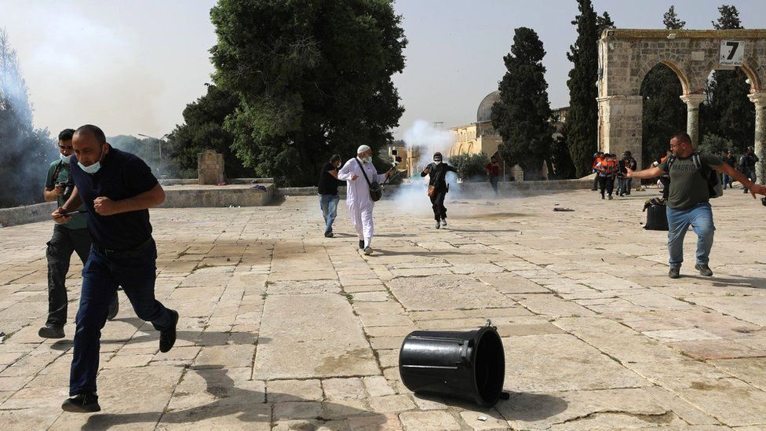

image copyright Reuters

image caption A compound in Jerusalem's Old City has been a focal point of confrontations between Israeli police and Palestinians

"The firing of rockets from Gaza against civilian populations in Israel is totally unacceptable and feeds escalatory dynamics," the spokesman said.

The UN Security Council held an urgent meeting Monday over the violence. No statement has been issued.

A diplomatic official told the Associated Press news agency the UN, Egypt and Qatar, which often mediate between Israel and Hamas, were all trying to halt the fighting.

## Why is Jerusalem a flashpoint?

The city, with its sacred sites, is the most sensitive place of all in the decades-old conflict between Israel and the Palestinians.

Alongside its religious importance are national claims - Israel in effect annexed East Jerusalem and considers the entire city its capital, though this is not recognised by most other countries.

Palestinians claim the eastern half as the capital of a hoped-for state of their own.

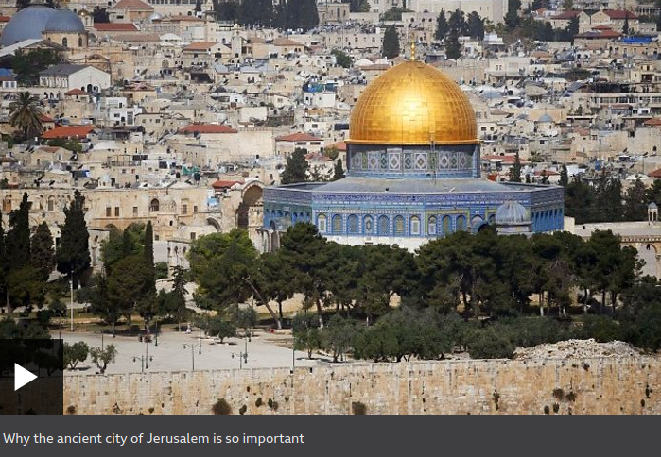

media caption Why the ancient city of Jerusalem is so important

The hilltop compound where clashes took place is revered by Jews and Muslims. Known to Muslims as Haram al-Sharif, it is the third holiest site in Islam, and to Jews as the Temple Mount, the holiest site in Judaism.

Buttressing the Jewish holy site of the Western Wall, the compound is especially sensitive, with both Israel and Palestinians wary of each other's intentions and activities there.

Israel says the current violence there was planned "well in advance" by Palestinian extremists, though a series of events has driven unrest in Jerusalem.

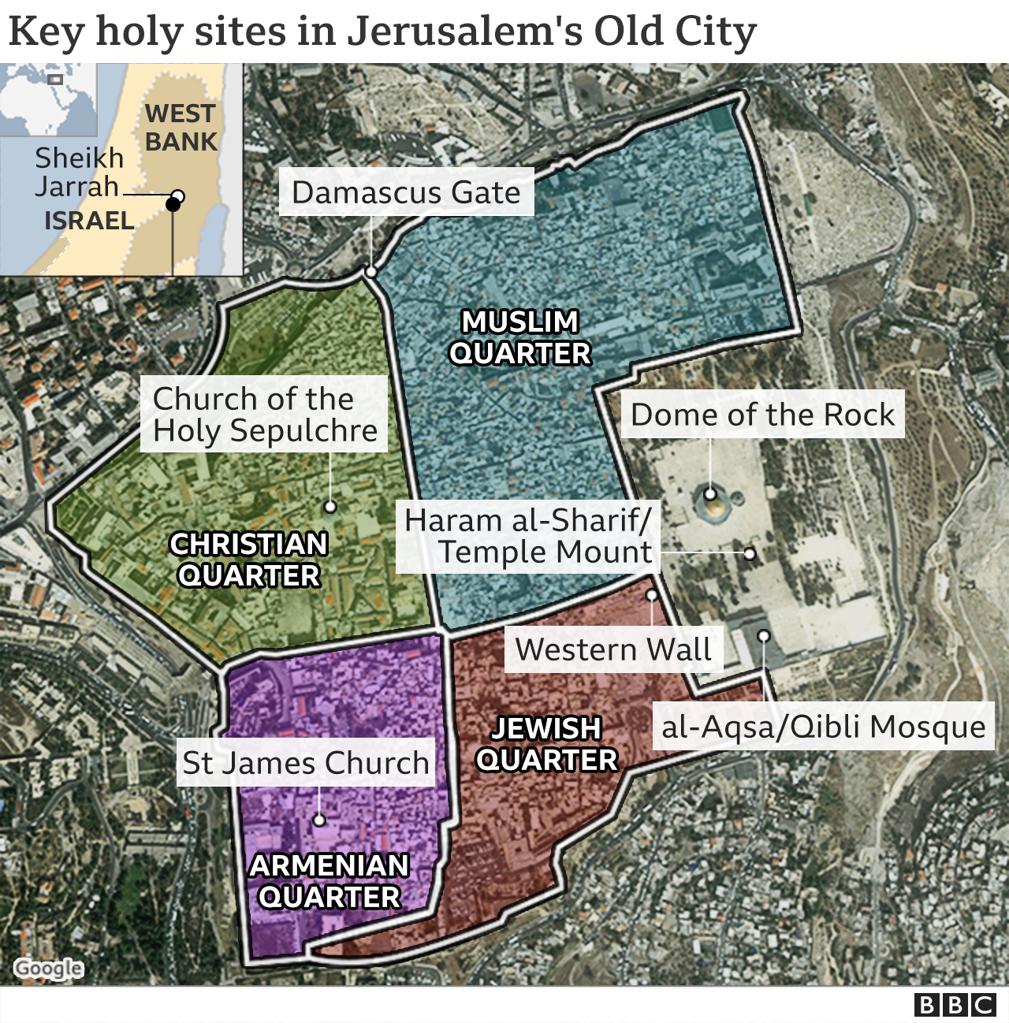



On Monday, a planned march by Israeli nationalists which was due to pass through Muslim areas of East Jerusalem's Old City was called off over fears it could stoke unrest.

The Jerusalem Day event marks Israel's capture of East Jerusalem in 1967.

It is regarded by many Palestinians as a deliberate provocation. This year's march would also have taken place in the final days of the Islamic holy month of Ramadan.



**Share your experiences by emailing** [haveyoursay@bbc.co.uk](mailto:haveyoursay@bbc.co.uk?subject=Jerusalem57066275)**.**

Please include a contact number if you are willing to speak to a BBC journalist. You can also get in touch in the following ways:

* WhatsApp: **+44 7756 165803**
* Tweet: [@BBC_HaveYourSay](http://twitter.com/BBC_HaveYourSay)
* [Upload pictures or video](https://www.bbc.co.uk/send/u16904890)
* Please read our [terms & conditions](http://www.bbc.co.uk/usingthebbc/terms/) and [privacy policy](http://www.bbc.co.uk/usingthebbc/privacy-policy/)