<https://www.bbc.co.uk/news/world-asia-china-57096526>

# Chinese county bans birthday parties in bid to be frugal

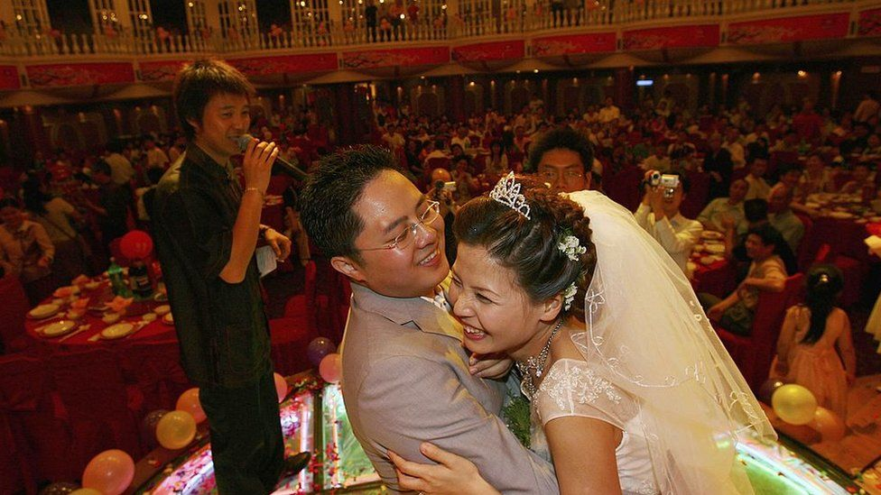

image copyright Getty Images

image caption Weddings are seen as a key indicators of one's social status in Chinese culture

**A county in southwest China has banned birthday parties and other celebrations, following calls from the central government to be more frugal.**

It also set out new rules for weddings and funerals, including a ban on cash gifts more than 200 yuan (£22, US$31).

The rules in Funing county only apply to all communist party members, civil servants and village organisation leaders - not to most residents.

It is a traditional Chinese custom to give cash gifts at parties.

However, they have also been used as bribes for influential hosts.

This is not the first time the Communist Party has cracked down on its members. In 2015, they were banned from extravagant eating and drinking, joining golf clubs or entering private clubs, as part of an anti-corruption drive.

However, China has generally for years been calling on its citizens to hold more "simple and moderate" weddings, condemning "extravagance and wastefulness".

* [How to hold a Chinese Communist wedding](https://www.bbc.co.uk/news/world-asia-china-35610194)
* [China cracks down on wedding extravaganza](https://www.bbc.co.uk/news/world-asia-china-46423160)

According to the new directive issued last week, parties celebrating occasions such as birthdays, job promotions, or housewarmings, would be banned from this month.

There are also very specific rules some have to follow.

Public servants in the county in Yunnan Province for example, will now be required to report wedding details - such as the cost and guest list - to the local government in advance.

The number of wedding banquet tables should be no more than 20, with the overall guest list capped at 200, it added.

The cost to feed each guest should not be more than 50 yuan if the banquet is held in a restaurant, and not more than 300 yuan for the whole table if held at home.

The number of cars for the wedding procession should also be kept below 10.

Weddings and funerals are seen as key indicators of one's social status in Chinese culture, and there is sometimes a societal expectation - especially for those in power like village leaders - to hold extravagant and elaborate affairs.

A typical wedding banquet can see hundreds of guests attend, and it is typically for guests to bring monetary gifts.

In smaller villages, weddings and funerals can last days and involve mass processions.

Similarly, new rules were laid out for funerals, where it is tradition in China for guests to give grieving families "condolence money".

Funerals cannot be held longer than three days, and details of the event must be submitted to the government within 10 days after it is held.

<https://www.bbc.co.uk/news/world-asia-china-56986057>

# Uyghur imams targeted in China's Xinjiang crackdown

By Joel Gunter  
BBC News

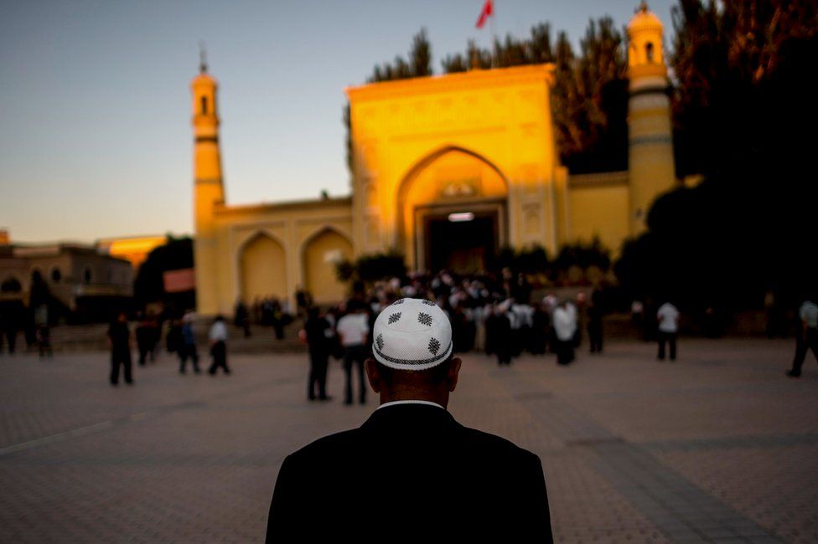

image copyright Getty Images

image caption A man arrives for morning prayer in Kashgar, Xinjiang, a mostly Muslim region in north-western China

**China has imprisoned or detained at least 630 imams and other Muslim religious figures since 2014 in its crackdown in the Xinjiang region, according to new research by a Uyghur rights group.**

The research, compiled by the Uyghur Human Rights Project and shared with the BBC, also found evidence that 18 clerics had died in detention or shortly after.

Many of the detained clerics faced broad charges like "propagating extremism", "gathering a crowd to disturb social order", and "inciting separatism".

According to testimony from relatives, the real crimes behind these charges are often things like preaching, convening prayer groups, or simply acting as an imam.

In total, the UHRP tracked the fates of 1,046 Muslim clerics — the vast majority of them Uyghurs — using court documents, family testimony and media reports from public and private databases.

While all 1,046 clerics were reportedly detained at some point, in many cases corroborating evidence was not available because of China's tight control over information in the region.

Among the 630 cases where it was, at least 304 of the clerics appeared to have been sent to prison, as opposed to the network of "re-education" camps most closely associated with China's mass detention of the Uyghurs.

Where information was available from court documents or testimony about the length of the prison sentence, the punishments reflect the harsh nature of Xinjiang justice: 96% sentenced to at least five years and 26% to 20 years or more, including 14 life sentences.

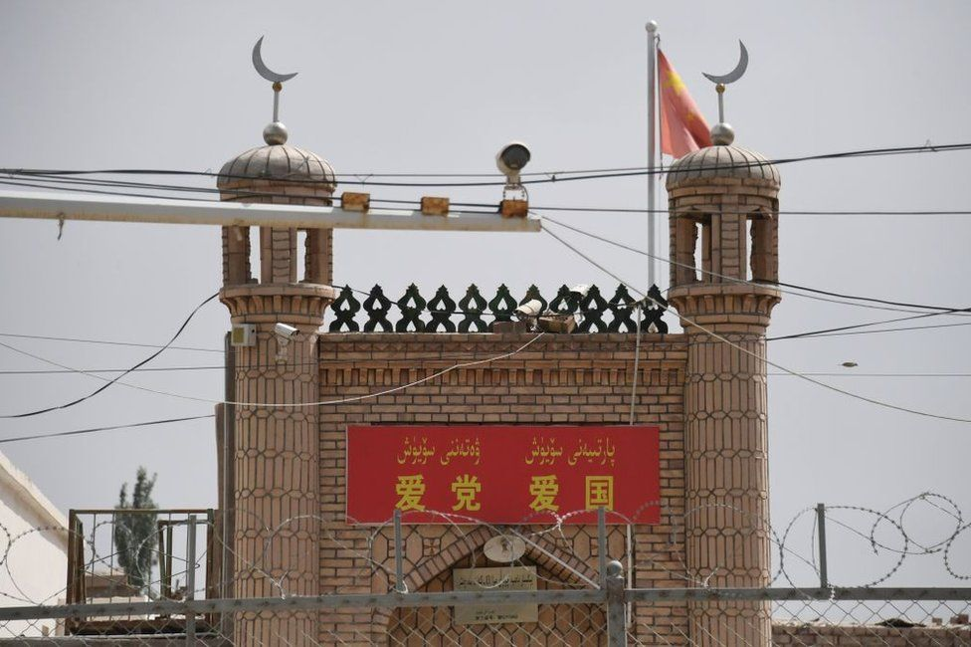

image copyright Getty Images

image caption A closed down mosque near Kashgar, with barbed wire and a surveillance camera in the foreground

The database, which drew on research by the Uyghur activist Abduweli Ayup, as well as the Xinjiang Victims Database and Uyghur Transitional Justice Database, is by no means exhaustive — representing only a fraction of the total estimated number of imams in Xinjiang.

But it shines a light on the specific targeting of religious figures in Xinjiang, appearing to support allegations that China is attempting to break the religious traditions of the Uyghurs and assimilate them into Han Chinese culture.

China denies those allegations, saying the purpose of its so-called "re-education" programme in Xinjiang is to stamp out extremism among the Uyghurs and other Muslim minorities.

## Tying religion to extremism

China is believed to have detained more than a million Uyghurs and other Muslims in Xinjiang, a large region in north-western China that is home to various ethnically Turkic peoples. The state has been accused of human rights abuses in the region, including [forced labour](https://www.bbc.co.uk/news/extra/nz0g306v8c/china-tainted-cotton), [sterilisation](https://www.bbc.co.uk/news/world-asia-china-53220713) and [rape](https://www.bbc.co.uk/news/world-asia-china-55794071).

Most of those detained in Xinjiang are sent to "re-education" facilities — prison-like camps where they are held for indeterminate periods of time without charge. But others have been given formal prison sentences, the number and severity of which have increased dramatically since 2017.

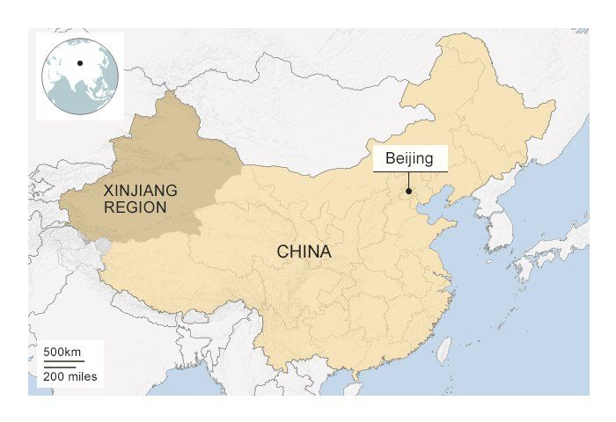

Publicly available detention or charging documents are rare, but those that do exist demonstrate how the state has worked to tie ordinary religious expression in Xinjiang to extremism or political separatism.

According to the arrest notice for Oken Mahmet, a 51-year-old Kazakh imam from Qaba in Xinjiang, Mahmet was charged with "propagating extremism". According to testimony collated by the [Xinjiang Victims Database](https://shahit.biz/eng/), his family says he was arrested for leading Friday prayers and officiating marriages at a mosque.

Mahmet's initial detention notice says he was detained for "inciting people to violate national laws pertaining to the reading of marriage vows, education, and public governance, as well as making and propagating items related to extremism". His sentence was reportedly eight to 10 years.

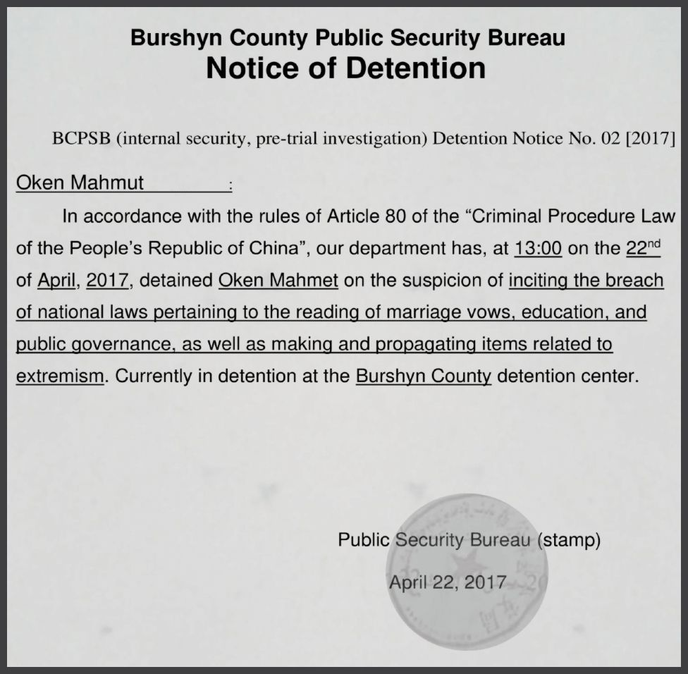

image caption Oken Mahmut's detention notice. The final charge was "propagating extremism" (Xinjiang Victims Database)

Baqythan Myrzan, a 58-year-old state-approved imam from Hami prefecture, was also arrested for "propagating extremism". Myrzan was detained in August 2018 and held at a detention facility until May 2019, when he was sentenced to 14 years at the Bingtuan Urumqi Prison. Myrzan's family says his only crime was going about his duties as an imam.

And the only clues to the alleged offence committed by Abidin Ayup, a prominent scholar and imam from Atush city, were a few lines that appeared in a long court document from a separate case against a Han Chinese official. The official was accused of allowing Ayup's son to visit him at a hospital detention facility after he was arrested. The court document refers to Ayup, who was 88 when he was detained in 2017, as a "religious extremist".

Ayup's niece Maryam Muhammad told the BBC the imam was a "kind, hardworking, charitable man, cultured and knowledgeable, who encouraged young people to study not only religion but all the school subjects".

Muhammad, who is now in the US, said nearly 60 members of her extended family had been detained since Ayup's arrest, including her husband and all of the imam's eight children.

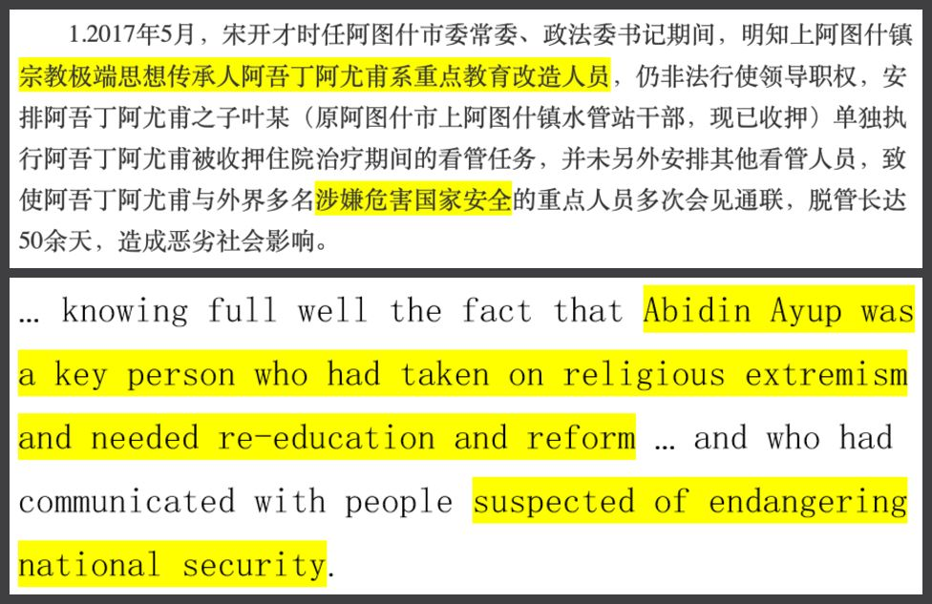

image caption An excerpt from a verdict against a Han official - the only clue to the charges against Abidin Ayup

Extremism charges were being issued on a "flimsy legal basis" in Xinjiang for "offences that shouldn't even qualify as offences", said Donald Clarke, a professor at George Washington University who specialises in Chinese law.

"Setting to one side for a moment whether you accept 'propagating extremism' as a valid charge, the question is do the facts make a plausible case for that charge?" he said. "And the alleged offences we have seen — things like having a beard, not drinking, or travelling abroad — suggest they don't."

The real reason imams were being targeted was "because of their ability to bring people together in the community", said Peter Irwin, senior programme officer at the Uyghur Human Rights Project.

"The state has been carefully dealing with imams for a long time because it knows the influence they have," he said. "The detentions and imprisonments of the past few years are just the culmination of three decades of repression designed to constrict Uyghur culture and religion."

A spokesman for the Chinese government told the BBC that Xinjiang "enjoys unprecedented freedom of religious belief".

"Xinjiang's 'de-radicalisation' effort has effectively contained the spread of religious extremism and made a great contribution to global 'de-radicalisation' efforts," he said.



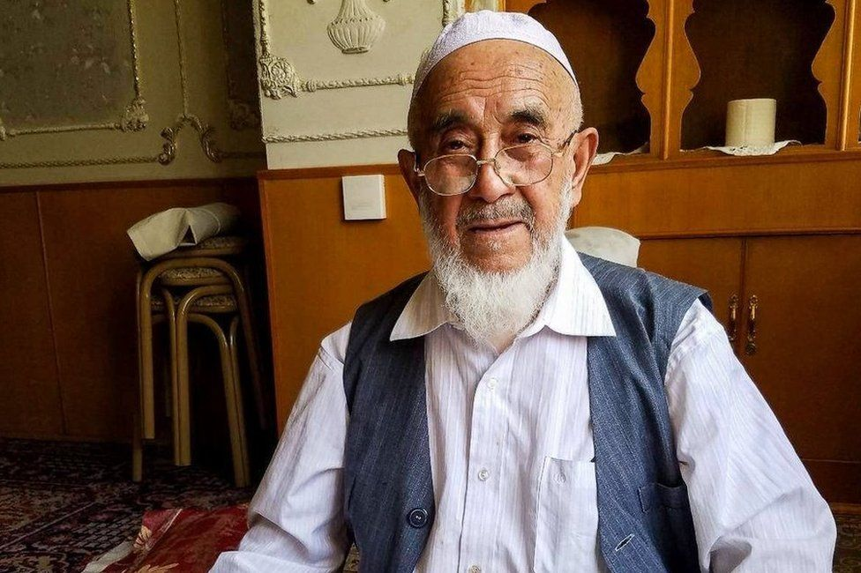

image caption Abidin Ayup was detained in 2017. His family believes he is in a hospital detention facility

## The beginnings of 're-education'

Targeting of the Turkic ethnic groups in north-western China is not a new phenomenon. Muslim minorities suffered long periods of repression between the 1950s and 1970s, when Qurans were burned, mosques and cemeteries desecrated, and traditional dress and hair styles prohibited.

The 1980s brought a period of relative openness and revival. Damaged mosques were repaired and new mosques built; religious festivals allowed and imams and other figures permitted to travel; and the Quran translated for the first time into Uyghur, by the prominent Uyghur scholar Muhammad Salih Hajim.

But a violent uprising by Uyghur militants in 1990, in the town of Baren in Xinjiang, precipitated a crackdown by the Chinese state and the beginning of a two-decade period of gradually tightening control. Imams, seen by authorities as influential community figures, were increasingly required to demonstrate loyalty to the state.

In the early 2000s, many imams were compelled to attend formalised education courses that foreshadowed the mass "re-education" programmes pursued today against the general population. According to Human Rights Watch, roughly 16,000 imams and other religious figures underwent "political re-education" between 2001 and 2002.

Among them was Tursun, an imam who was first detained in 2001 for translating prayers from Arabic into Uyghur for his congregation, according to his niece.

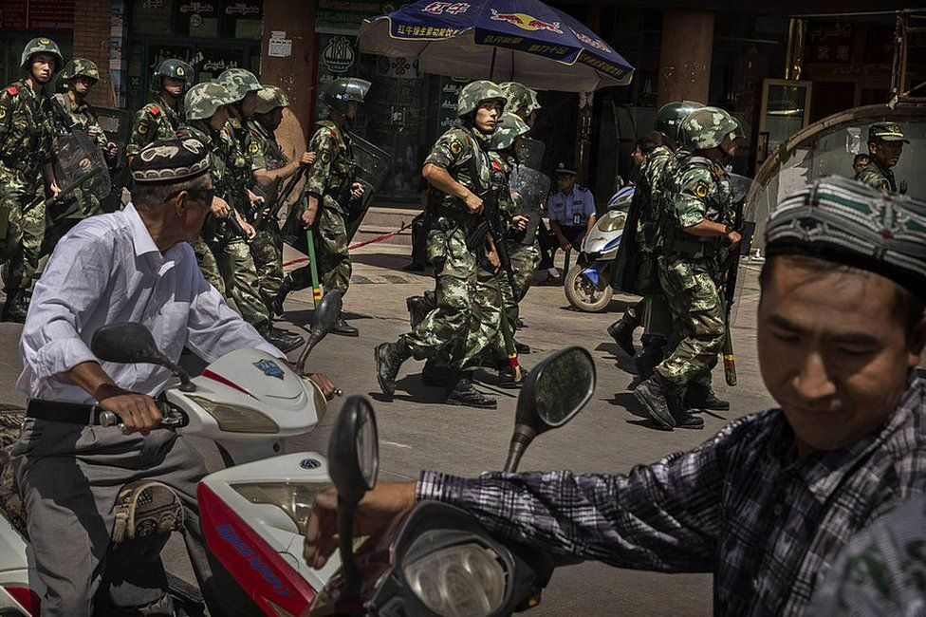

image copyright Getty Images

image caption Chinese soldiers outside the Id Kah Mosque in Kashgar, where an imam was killed by assailants in 2014

Tursun's two-year stint in a "re-education through labour" camp marked the beginning of a two-decade ordeal at the hands of the state, his niece told the BBC from outside China. Her uncle was freed from the labour camp in 2002 but constantly harassed by police, she said, and frequently taken away again for two-week periods of "study". Then in 2005, he was detained again but this time sentenced to four years in prison.

"We were not given any notice from the court," his niece said. "My family went to the police station to enquire about his fate and the police gave them a handwritten note containing information about his prison sentence and the address of the prison."

Tursun was released from prison in 2009, only to be detained again in 2017 after the hardline politician Chen Quanguo was put in charge of Xinjiang and escalated the campaign against the Uyghurs.

As appears to be the case with other imams in the region, Tursun's family was subsequently targeted en masse, said his niece, who had left China by that time.

"After I heard the news of my uncle and his wife's arrests, I heard that my mother and many of my relatives were also arrested. Anyone over 14 was taken away," she said. "For the last four years I have been trying to find information regarding their whereabouts, especially my mother."

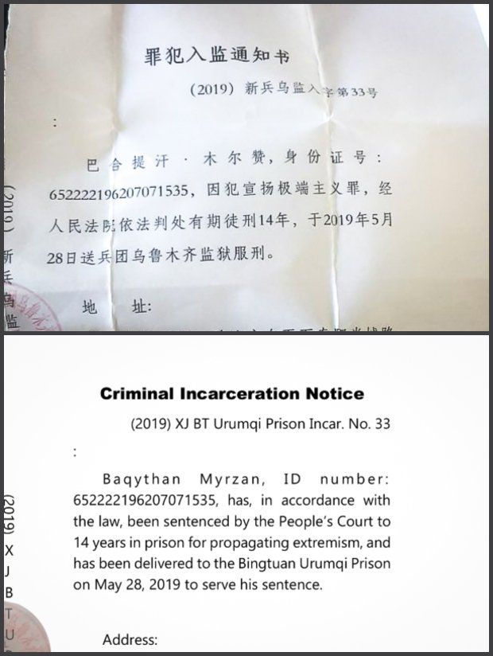

image caption"Propagating extremism" is a common charge levied against imams, for a variety of perceived offences

About a month ago, Tursun's niece learned that her mother had been sentenced to 13 years in prison and her younger brother to five years. She doesn't know what the charges were. Her father is already serving a life sentence, she said, issued in 2008 for "illegal preaching" and "separatism".

"My mother was a simple housewife and she was sentenced to 13 years," she said. "I cannot imagine how long my uncle has been sent to prison for."

They were targeted "because of their invisible authority", she added. "The state has tried everything to break them, to destroy them. And not only the religious leaders but also those who practise Islam quietly, and take pride in being Uyghur. They have made every effort to dig them out and destroy them."

Some that disappear into detention never come out. Eighteen imams named in the database were reported to have died while in custody or shortly after.

Nurgazy Malik, a father of two, graduate of the official Xinjiang Islamic Institute and editor-in-chief of a state-approved religious magazine, reportedly died in detention in November 2018. Unconfirmed reports say Chinese authorities acknowledged his death to his family, but did not produce a body — a situation echoed in other, similar reports. Malik's friends and relatives held a funeral for him in Kazakhstan all the same.

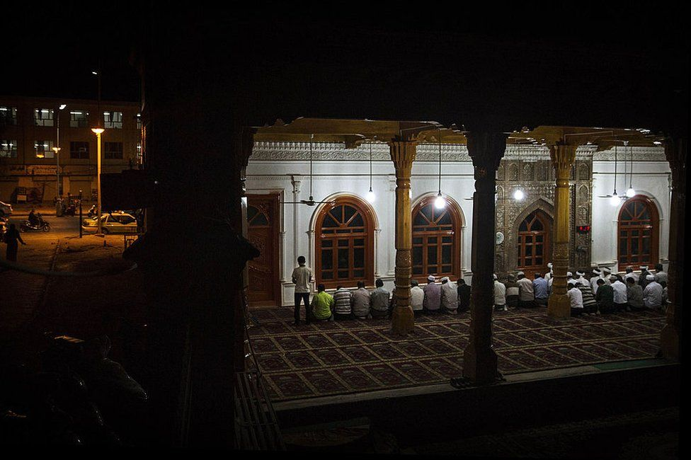

image copyright Getty Images

image caption Uyghur men pray at an open air mosque in old Kashgar, Xinjiang, in 2014

## A secret prayer

In late 2019, as its network of "re-education" camps drew intense international scrutiny, China claimed it had released everyone from the system. Significant numbers had been released, into house arrest or into the otherwise controlled environment of Xinjiang, but rights groups say many were simply transferred to formal prisons.

There is also evidence that many thousands had been in prison all along. Incarceration rates exploded in Xinjiang in 2017 and 2018, according to reporting by the [New York Times](https://www.nytimes.com/2019/08/31/world/asia/xinjiang-china-uighurs-prisons.html) and others, sweeping up at least 230,000 people — about 200,000 more than in previous years.

According to Chinese government data, criminal arrests in Xinjiang accounted for 21% of the country's total in 2017, despite the region having about 1.5% of the population.

Unlike the "re-education" system, formal prison sentences should create a paper trail. But the court documents are "nowhere to be found", [according to Gene Bunin](https://livingotherwise.com/2021/04/19/the-elephant-in-the-xuar-iii-in-accordance-with-the-law/), the researcher behind the Xinjiang Victims Database.

According to Bunin, only 7,714 criminal verdicts are available for Xinjiang for 2018, despite the region logging 74,348 criminal cases that year. The near total absence of verdicts on charges typically levied against religious Uyghurs, like "propagating extremism" and "inciting separatism", suggests China is intentionally scrubbing the record.

Where official documents are available and contain details, offences can be shocking in their innocuity.

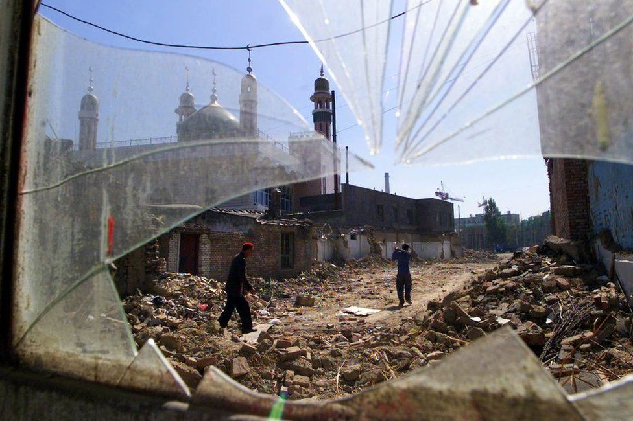

image copyright Getty Images

image caption Experts say about 16,000 mosques have been destroyed in Xinjiang — two thirds of the total

In one 2018 verdict, now deleted from the government records but archived by the Xinjiang Victims Database, a 55-year-old Uyghur farmer already serving 10 years for "propagating extremism" had his sentence doubled after he "used a disguised and simplified method to perform the namaz prayer in the prison dormitory".

Essentially, Ismayil Sidiq secretly prayed in prison. He was reported by a cellmate and charged with "illegal religious activities" and "inciting ethnic hatred and discrimination" — the latter charge for allegedly shouting that Uyghurs should not inform on one another. He will be eligible for release in 2038.

Those who are detained in camps stand a better chance of release after a few months or years, but release in Xinjiang does not necessarily mean freedom.

Memet, a Uyghur who fled Xinjiang, told the BBC his father was detained in 2017 after many years serving peacefully as an imam. Memet had been able to learn news of his family over the years from an acquaintance in Xinjiang — someone distant enough from the family that she felt safe messaging abroad from her WeChat account — but Memet heard virtually no news of his father's condition for four years.

Then recently he heard his father had been released, and Memet imagined speaking to him for the first time in years. He asked the family acquaintance if she would be willing to find his father and connect them again via her phone.

On the appointed day, Memet received a message on his WeChat account from the acquaintance. She said she had found his father, but he had told her it would be better if he didn't speak to his son. And after she sent the message, she blocked Memet from contacting her again.

*Some names have been changed.*