# Euro at risk of implosion as Italy's looming crisis may trigger devastating exit

Martina Bet

This week, Rome will submit plans for spending the huge sums that the European Union has pledged to provide as part of its Covid relief programme. Alongside that, there should be proposals for radical reform of the Italian economy. There seems to be some hope for Italy's future - but the structural problems of the country are significant.

There is a high ratio of public debt to GDP, currently running at almost 160 percent; high unemployment rates, particularly among the young; massive regional disparities between the generally prosperous north and the relatively undeveloped south and a low birth rate.

While the country is due to receive some €200billion (£173bn) amounting to about 12 percent of its GDP, many are wondering whether it will be enough - particularly if a new financial crisis is around the corner.

In a recent report, senior economists Lucio Baccaro, Björn Bremer and Erik Neimanns presented evidence from a new survey experiment on Italian attitudes towards a European bailout and exit from the eurozone.

They found that a majority of voters would want to stay in the euro if a bailout did not involve conditionality - but that there would be a majority for leaving if a bailout were contingent on austerity policies.

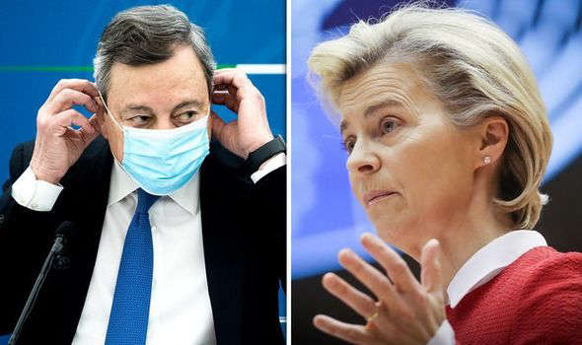

© GETTY ctp_video, european union, eu news, euro, eurozone, eurozone news, european union news, eu news, eu latest, ursula von der…

They explained: "In a recent study, we presented a large sample of Italians (n = 4,200) with a hypothetical scenario of a Greek-style financial crisis.

"We ran our survey experiment in October 2019, in the wake of a standoff between the Italian government and the European Commission over the country's government deficit.

"We used sample quotas to ensure a representative sample based on age, gender, and economic sector, and survey weights to further correct for deviations in our sample from the true population on other dimensions. However, our results are robust to the use of different types of weights, or no weights.

"All respondents read a scenario in which Italy was in the midst of a financial crisis, involving freezing of liquidity provisions by the ECB, a run on banks and capital flight, a rapid increase of risk premia on government bonds, and the inability of the government to meet its financial obligations.

"Respondents were then told that before accepting a European bailout package, the government wanted to consult its citizens through a referendum, asking whether they wanted to stay in the euro and thus accept the bailout package, or reject the bailout package and therefore want to exit the euro.

"Finally, survey participants were asked how they would vote in this hypothetical referendum."

Their results suggested that Italian public opinion is strongly sensitive to the costs of remaining in the euro.

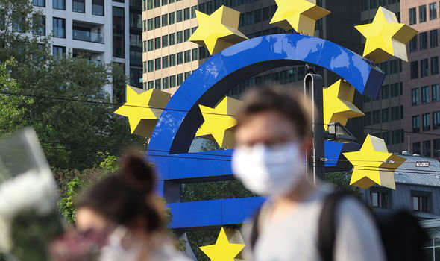

© GETTY ctp_video, european union, eu news, euro, eurozone, eurozone news, european union news, eu news, eu latest, ursula von der…

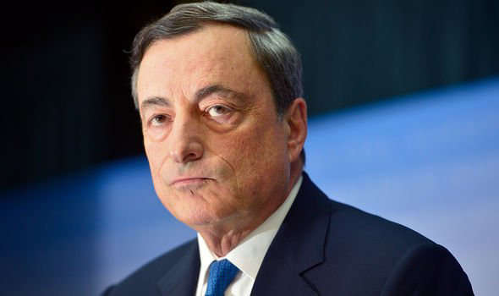

© GETTY

They noted: "If voters are informed that eurozone membership comes at the cost of austerity, support for exit increases by 15 percent and support for remaining decreases by almost 20 percent.

"In contrast, we do not find any significant effect of attributing blame for the crisis to either the Italian government or foreign actors.

"Apparently, Italian voters do not care much about whose fault the crisis is, but they strongly oppose further austerity."

In an exclusive interview with Express.co.uk, Italian MEP Antonio Maria Rinaldi argued that if Italy were to actually leave, the euro would "immediately collapse".

He said: "No question.

"It would happen immediately afterwards.

"People should remember that Italy is second only to Germany when it comes to manufacturing.

"And the EU should start listening to us and responding adequately to this crisis.

"Right now, there is no leadership in Brussels."

DON'T MISS:

[Trade expert brands EU's accession to CPTPP 'impossible'](https://www.express.co.uk/news/world/1427160/eu-news-trade-brexit-us-cptpp-joe-biden-australia-donald-trump-spt) [EXCLUSIVE]

[Putin's influence in Merkel's Germany unveiled](https://www.express.co.uk/news/world/1427271/vladimir-putin-news-angela-merkel-germany-nord-stream-2-ukraine-spt) [REVEALED]

[London snub as Biden claimed Brussels could be 'capital of free world'](https://www.express.co.uk/news/uk/1427760/london-news-joe-biden-brussels-eu-trip-capital-free-world-washington-spt) [INSIGHT]

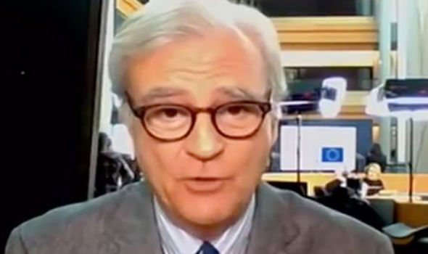

© LA SETTE

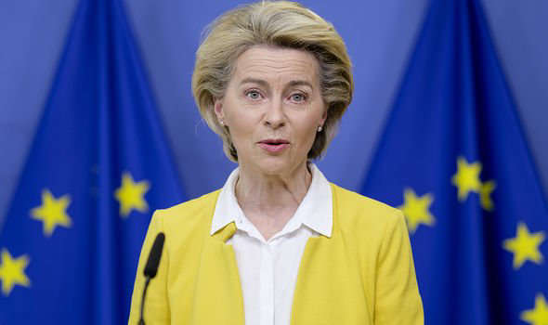

© GETTY

Euroscepticism seems to be on the rise in Germany, too.

A survey by the Allensbach Institute has revealed that just 15 percent of the German public now have a favourable opinion of the European Commission President, Ursula von der Leyen.

The EU chief has been under extreme scrutiny in the past couple of months, as many accused her of hampering the continent's vaccination campaigns with a botched, centralised procurement strategy.

Approximately eight percent say that Germany has benefited from the EU's vaccine purchases, while 46 percent said no.

Moreover, 39 percent want repatriation of competences from the EU to member states, while only 12 percent want more competences for the EU.

In a recent report, head of Oxford-based think-tank Euro Intelligence Wolfgang Munchau insisted these figures should not be underestimated.

In particular, the political commentator argued the Dexit campaign by Alternative for Germany (Afd), a nationalist and right-wing populist political party, is now "more dangerous than it appears".

He explained: "The AfD's internal division might overshadow everything.

"But the party has the potential to attract protest votes from disgruntled Christian Democratic Union (CDU) voters, especially in the east.

"And it is the only party willing to fish in the pool of anti-EU sentiment.

"The Allensbach numbers don't suggest that Germans are in their majority in favour of leaving the EU.

"But they do tell us that euroscepticism is large and persistent."

He concluded: "We keep reminding ourselves that this is how Brexit started."