# https://www.bbc.co.uk/news/world-latin-america-56590733

# Skull of dinosaur called 'one who causes fear' found in Patagonia

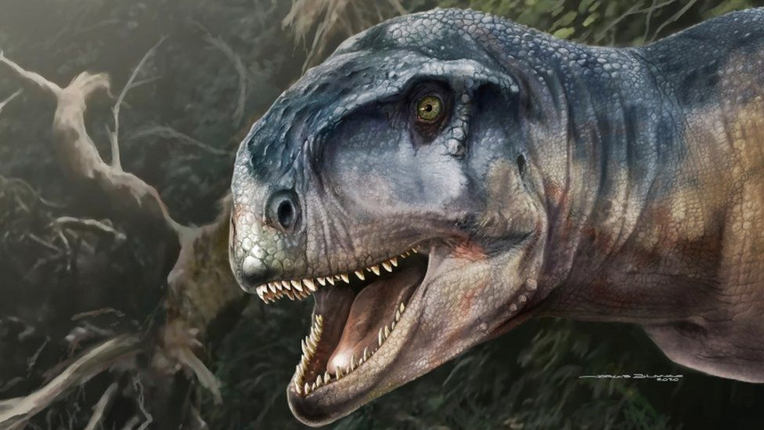

image copyright Reuters

image caption An artist's impression of Llukalkan aliocranianus

**Scientists in southern Argentina have found the skull of a large meat-eating dinosaur named "one who causes fear" in the local Mapuche language.**

The horned Llukalkan aliocranianus was around 5 metres (16 feet) long and roamed South America 85 million years ago.

Researchers found remains nearby of another carnivorous dinosaur, something they said was highly unusual.

The findings from Patagonia were published on Tuesday.

Like the Tyrannosaurus rex, the Llukalkan dinosaur was two-legged with very short arms, but was medium-sized compared to the giant T. rex.

It also had short horns and tiny fingers. It was estimated to weigh between one and five tonnes, slightly lighter than an adult African elephant.

It was probably a fearsome predator, with a large skull and a strong bite, according to the research published in the [Journal of Vertebrate Paleontology.](https://www.tandfonline.com/doi/full/10.1080/02724634.2020.1877151)

The findings suggest it had better hearing than other dinosaurs in the abelisaurids family which likely made it a better hunter, Federico Gianechini, a palaeontologist at the National University of San Luis Argentina told Reuters news agency.

It lived on earth during the Cretaceous period, the last era before dinosaurs were wiped out.

Close to Llukalkhan's skull, scientist found the fossilised remains of a slightly larger meat-eating dinosaur called Viavenator exxoni.

* [Boy, 12, discovers rare dinosaur skeleton](https://www.bbc.co.uk/news/election-us-2020-54547987)
* [New dinosaur discovered in Australia](https://www.bbc.co.uk/news/av/science-environment-47518544)

Mr Gianechini said it is very unusual to find two abelisaurids living close together at the same time.

"Llukalkan was a little smaller than Viavenator, although, if they lived together, they surely shared the same ecological niche and fed on the same prey, so they would have competed with each other and - why not - even eaten each other," he told Reuters.

A series of important dinosaur discoveries have been made in Argentina in recent decades.

In 2014 the remains of a dinosaur that weighed around the same as 14 elephants were found - it was thought to be the biggest ever discovered.

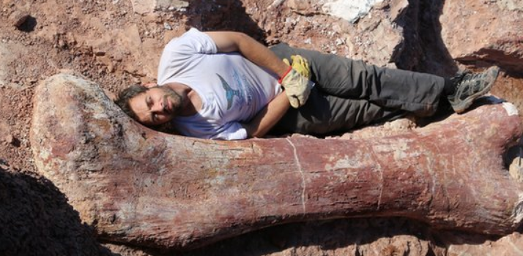

https://www.bbc.co.uk/news/science-environment-51457790

* [Tyrannosaurus species named 'Reaper of Death' found in Canada](https://www.bbc.co.uk/news/science-environment-51457790)

# Tyrannosaurus species named 'Reaper of Death' found in Canada

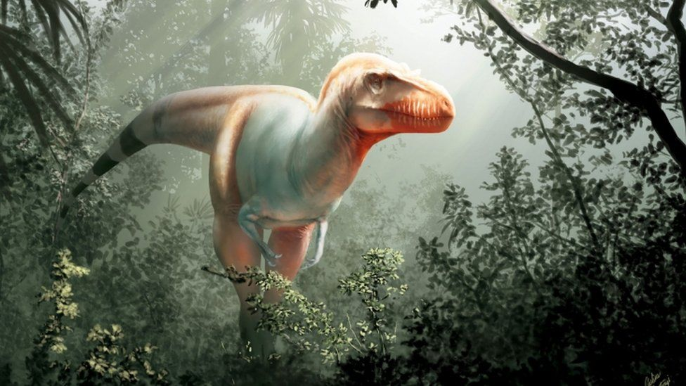

image copyright University of Calgary via Getty Images

image caption The predator's name - Thanatotheristes degrootorum - translates to "Reaper of Death" in Greek

**A new species of tyrannosaur that stalked North America around 80 million years ago has been discovered by scientists in Canada.**

The dinosaur lived in the late Cretaceous Period, making it the oldest known tyrannosaur from North America.

Another species of tyrannosaur, a Daspletosaurus, was found in Canada in 1970, a study says.

Researchers say the new discovery has given them insights into the evolution of tyrannosaurs.

Standing roughly 8ft (2.4m) tall, the predator would have cut an intimidating figure.

Like its tyrannosaur relatives, the carnivorous dinosaur had a long, deep snout, bumps on its skull and large steak-knife-like teeth measuring more than 7cm (2.7in) long.

The predator's name - Thanatotheristes degrootorum - translates to "Reaper of Death" from the Greek.

"We chose a name that embodies what this tyrannosaur was as the only known large apex predator of its time in Canada, the reaper of death," said Darla Zelenitsky, a palaeobiology professor who co-authored the study.

"The nickname has come to be Thanatos."

* [Teeny T. rex relative discovered in US](https://www.bbc.co.uk/news/science-environment-47321411)
* [Tyrannosaurus rex had 'air-con' in its head](https://www.bbc.co.uk/news/science-environment-49595680)
* [Small tyrannosaur 'was cousin of T. rex'](https://www.bbc.co.uk/news/science-environment-48190396)

Fragments of Thanatos's fossilised skull were found by John De Groot, a farmer and palaeontology enthusiast.

He stumbled across the fossils in 2010 while hiking near Hays, a hamlet in southern Alberta.

"The jawbone was an absolutely stunning find," said Mr De Groot. "We knew it was special because you could clearly see the fossilised teeth."

Tyrannosaurs, or "tyrant lizards", were the dominant predators on land for millions of years before the extinction of dinosaurs some 65 million years ago.

By the late Cretaceous Period, around 80 million years ago, North American tyrannosaurs had become enormous beasts. But the fossil records before this period are patchy.

It is hoped that this new study will help palaeontologists fill gaps in their knowledge.

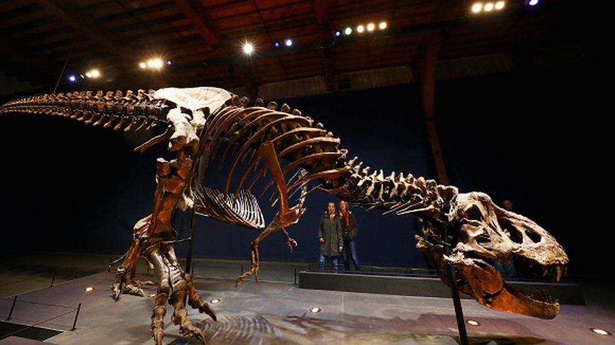

image copyright Getty Images

image captionT yrannosaurs, like the one pictured here, were the dominant predators on land for millions of years

"There are very few species of tyrannosaurids, relatively speaking," said Prof Zelenitsky of Canada's University of Calgary.

"Because of the nature of the food chain these large apex predators were rare compared to herbivorous or plant-eating dinosaurs."

The study about Thanatos was [published last month in the Cretaceous Research journal](https://www.sciencedirect.com/science/article/pii/S0195667119303611).