# https://www.bbc.co.uk/news/world-asia-china-56658455

# Xinjiang cotton: Western brands blurred on China TV

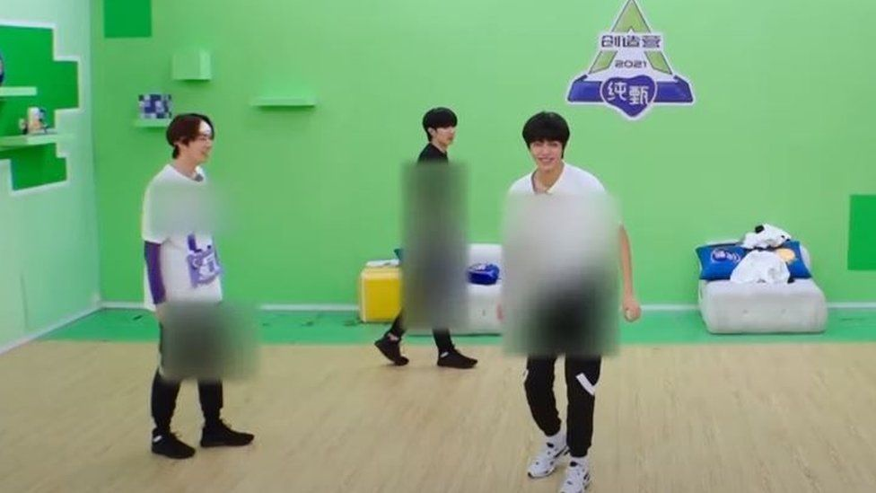

image copyrightT encent

image caption Dancers on Chuang 2021 had their entire bodies blurred out as they had worn clothes with logos of targeted Western brands

**Chinese TV stations have been blurring out Western brand logos in their programmes, in a show of support for China's Xinjiang cotton campaign.**

The move has delayed some broadcasts, as post-production editors censor everything from T-shirts to shoes.

Western retailers are facing a backlash in China after they expressed concern over the alleged use of minority Uyghur forced labour in cotton production.

Beijing denies this, and many brands have faced boycotts in recent days.

There has been massive online outrage, and celebrities have been publicly severing ties with Western brands and expressing support for Xinjiang cotton.

Now popular TV shows are rushing to show their support - but with unintentionally funny results.

Episodes of popular variety shows such as Sisters Who Make Waves now feature singers and actors who look like they are floating on clouds, thanks to their blurred out shoes.

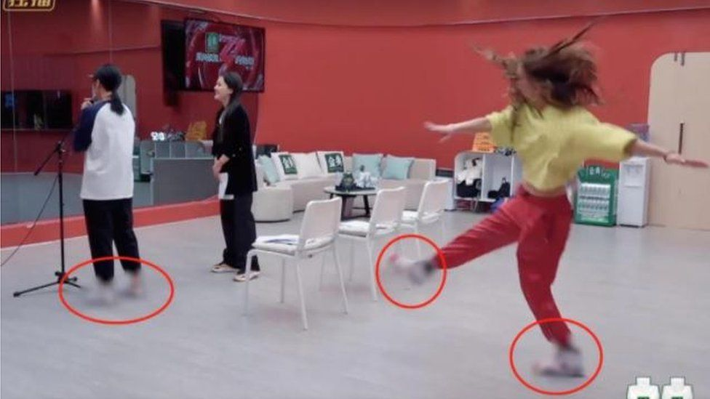

image copyright Weibo

image caption Contestants on Sisters Who Make Waves looked like they were floating on clouds

The blurring treatment was taken up a notch on reality show Chuang 2021, as contestants had worn clothes branded with Western logos from head to toe.

But one of the more challenging programmes to censor was probably the reality TV contest Youth With You, given the sheer number of contestants.

* [Who are the Uyghurs?](https://www.bbc.co.uk/news/world-asia-china-22278037)
* [Uyghur camp detainees allege systematic rape](https://www.bbc.co.uk/news/world-asia-china-55794071)
* [Xinjiang cotton: How do I know if it's in my jeans?](https://www.bbc.co.uk/news/world-asia-china-56535822)

The production company behind the show, iQiyi, had issued a notice on 25 March saying that an upcoming episode had to be delayed, but did not give a reason.

Two days later, however, viewers immediately spotted that brand logos had been blurred on the t-shirts of more than 50 people.

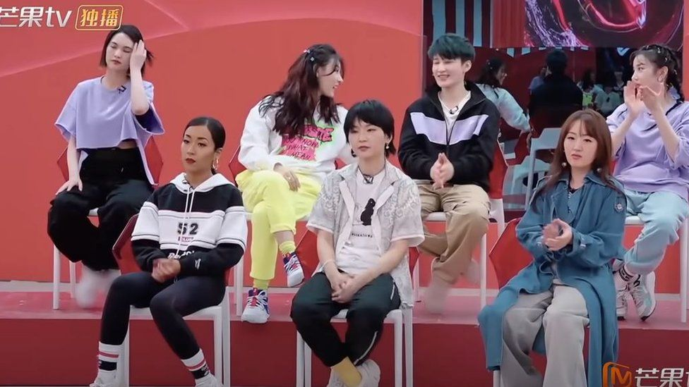

image copyright Mango TV

image caption Only some of the singers had worn the offending brands

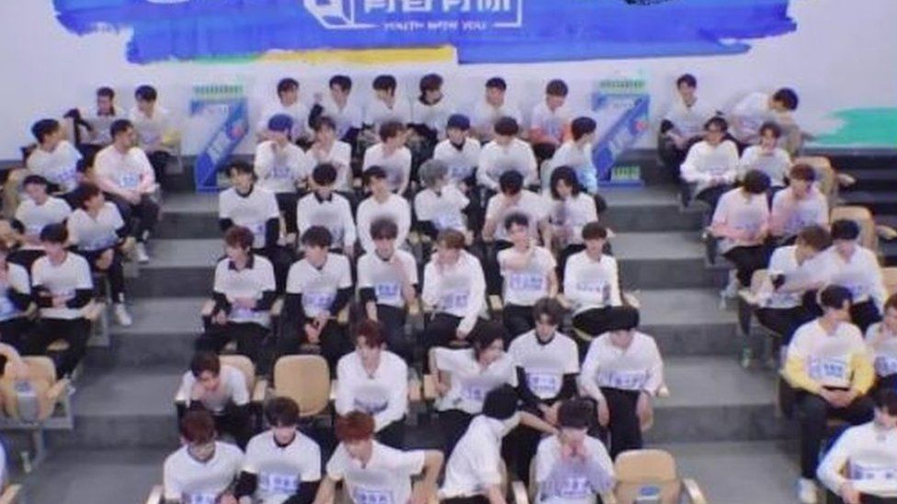

image copyright IQIYI

image caption More than 50 people had the logos wiped off their T-shirts on the show Youth With You

## What's the background to all this?

The cotton row erupted after the US and other western governments ramped up pressure on China over alleged human rights abuses in the north-west region of Xinjiang.

The Xinjiang cotton campaign began last month when Chinese state media outlets and netizens singled out H&M over a statement made last year, and soon expanded to include many other brands.

Some companies' online shops are blocked in China and their stores have vanished from some digital maps.

Some of the brands embroiled in the controversy include Nike, Adidas and Puma - all members of the Better Cotton Initiative (BCI), a non-profit group promoting sustainable cotton production.

The group said in October it had suspended activities in Xinjiang as well as licensing of the region's cotton, citing allegations and "increasing risks" of forced labour.

In December the [BBC published an investigation based on new research](https://www.bbc.co.uk/news/extra/nz0g306v8c/china-tainted-cotton) showing China was forcing hundreds of thousands of minorities including Uyghurs into manual labour in Xinjiang's cotton fields.

## 'The poor video editors'

Apart from all the jokes on social media, many users have also confessed that they "felt sorry" for the post production workers, with one person on microblogging platform Weibo commenting: "They worked really hard. I don't think they can get any sleep these days."

Others created spoof versions of their own.

This is just the latest example of heavy-handed blurring of TV programmes in China.

Hip-hop culture, tattoos and cleavage have all been censored in the past.

In 2019, the decision by a popular Chinese video streaming platform to [censor the ears of male actors wearing earrings sparked heated debate online](https://www.bbc.co.uk/news/blogs-trending-46902973).

Many took to social media at the time to argue that the censorship was driven by a desire to protect "traditional" gender roles.

## You may also be interested in...

In 2015, popular Chinese TV drama The Empress of China was re-edited to get rid of the plunging necklines featured in the show - provoking a large amount of public outrage.

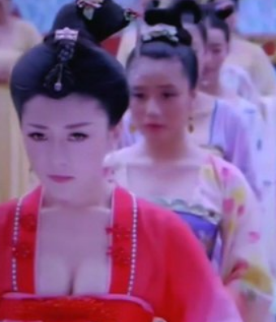

media caption Many in China feel the authorities have gone too far in censoring The Empress of China

# Uighurs: Western countries sanction China over rights abuses

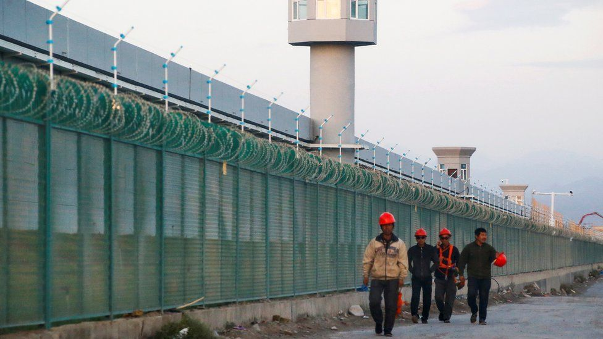image copyright Reuters

image captionChina has created a sprawling network of detention camps for minorities in the Xinjiang region

**Several Western countries have announced sanctions against officials in China over rights abuses against the mostly Muslim Uighur minority group.**

China has detained Uighurs at camps in the north-west region of Xinjiang and faces accusations of torture, forced labour and sexual abuse.

The sanctions were announced as part of a coordinated effort by the European Union, UK, Canada and the US.

China responded with its own sanctions against European officials.

The Chinese government has denied the allegations of abuse, claiming the camps in Xinjiang are "re-education" facilities being used to combat terrorism.

But UK Foreign Secretary Dominic Raab said the abuse of the Uighur Muslims in Xinjiang was "one of the worst human rights crises of our time" and the international community "cannot simply look the other way".

He said the treatment of Uighurs amounted to "appalling violations of the most basic human rights".

The EU has not imposed new sanctions on China over human rights abuses since the 1989 Tiananmen Square crackdown, when troops in Beijing opened fire on pro-democracy protesters.

* [Who are the Uighurs?](https://www.bbc.co.uk/news/world-asia-china-22278037)
* [Uighur camp detainees allege systematic rape](https://www.bbc.co.uk/news/world-asia-china-55794071)
* [China's tainted cotton](https://www.bbc.co.uk/news/extra/nz0g306v8c/china-tainted-cotton)

## What do we know about the sanctions?

The sanctions, including travel bans and asset freezes, target senior officials in Xinjiang who have been accused of responsibility for abuses against Uighurs.

Human rights groups say China has detained more than a million Uighurs and people from other Muslim minority groups at camps in Xinjiang.

The Chinese government has been accused of carrying out forced sterilisations on Uighur women and separating children from their families. BBC investigations have contained first-hand testimony of forced labour and systematic rape, sexual abuse and torture of detainees.

Those hit with sanctions include Chen Mingguo, the director of the Xinjiang Public Security Bureau, who the EU said was responsible for "serious human rights violations"; senior Chinese officials Wang Mingshan and Wang Junzheng; and the former deputy party secretary in Xinjiang, Zhu Hailun. One entity, the Xinjiang Production and Construction Corps Public Security Bureau, was also sanctioned.

Xinjiang's top official, Chen Quanguo, was not on the list.

China on Monday said the sanctions were "based on nothing but lies and disinformation". It said it would sanction 10 people and four entities in the EU "that severely harm China's sovereignty and interests and maliciously spread lies and disinformation" in response.

German politician Reinhard Butikofer, who chairs the European Parliament's delegation to China, was among the most high profile officials on China's list. Adrian Zenz, a leading expert on China's policies in Xinjiang, and Swedish scholar Bjorn Jerden were also targeted.

Under the sanctions, the European officials are barred from entering China or doing business with it. The sanctions mark a rare escalation of diplomatic tensions between the EU and China, which are major trading partners.

'Credible case' China carrying out genocide

By James Landale  
Diplomatic correspondent

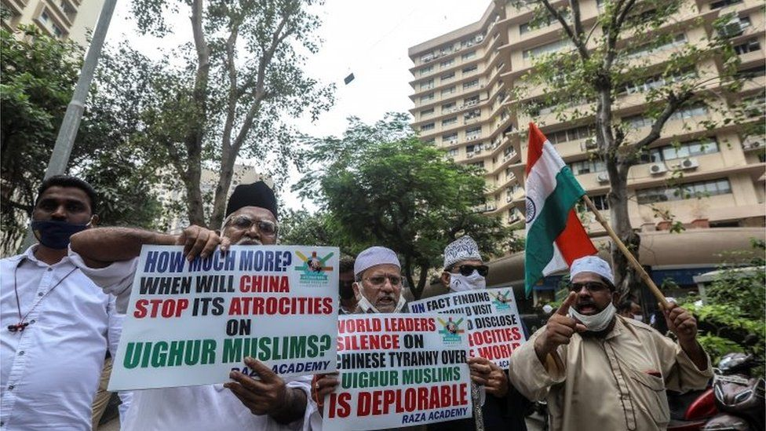

image copyright EPA

image caption Protests against China's alleged abuse of the Muslim Uighur community

**There is a "very credible case" that the Chinese government is carrying out the crime of genocide against the Uighur people, according to a formal legal opinion newly published in the UK.**

It concludes there is evidence of state-mandated behaviour showing an intent to destroy the largely Muslim minority in north-western China.

This includes the deliberate infliction of harm on Uighurs in detention, measures to prevent women giving birth - including sterilisation and abortion - and the forcible transfer of Uighur children out of their community.

And, significantly, it says there is a credible case that Chinese President Xi Jinping is himself responsible for these crimes against humanity. It states "the close involvement of Xi Jinping" in the targeting of Uighurs would support a "plausible" case of genocide against him.

It says: "On the basis of the evidence we have seen, this Opinion concludes that there is a very credible case that acts carried out by the Chinese government against the Uighur people in Xinjiang Uighur Autonomous Region amount to crimes against humanity and the crime of genocide."

A legal opinion is the professional judgement of a respected QC - an independent expert in their field - who assesses the evidence and the law and comes to a conclusion. It does not have a legal standing, like a court judgement, but can be used as a basis for legal action.

This opinion was commissioned - but not paid for - by the Global Legal Action Network, a human rights campaign group that focuses on cross-border legal issues, and the World Uighur Congress and the Uighur Human Rights Project.

* [Why is there tension between China and the Uighurs?](https://www.bbc.co.uk/news/world-asia-china-26414014)
* [China's Muslim 'crackdown' explained](https://www.bbc.co.uk/news/world-asia-china-45474279)
* [China's hidden camps: The vanished Uighurs of Xinjiang](https://www.bbc.co.uk/news/resources/idt-sh/China_hidden_camps)

China's foreign ministry has consistently denied allegations of human rights abuses against the Uighurs in Xinjiang.

The Chinese embassy in London accused anti-China forces in the West of fabricating "lies of the century" about Xinjiang.

The 100-page document - written by senior barristers at Essex Court Chambers in London, including Alison Macdonald QC - is understood to be the first formal legal assessment in the UK of China's activities in Xinjiang.

The opinion is significant because it beats a legal path that British judges would follow if Parliament were to agree new legislation allowing the High Court to decide on matters of genocide. MPs from all parties are hoping to push through this change in the House of Commons on Tuesday, but the government is working hard to avoid defeat.

* [Uighur camp detainees allege systematic rape](https://www.bbc.co.uk/news/world-asia-china-55794071)
* [US and UK condemn reports of rape in Chinese camps](https://www.bbc.co.uk/news/world-asia-55930344)
* [Searching for truth in China's 're-education' camps](https://www.bbc.co.uk/news/blogs-china-blog-48700786)

Ministers are hoping to see off the rebellion by offering to boost the role of parliamentary committees in assessing genocide, but the relevant committees are understood to have rejected the idea.

The legal opinion was based on an exhaustive legal assessment over six months of publicly available evidence from governments, international organisations, academic scholars, charities and the media.

The documents included first-hand witness evidence from survivors, satellite imagery and leaks of Chinese government papers.

The bar for proving genocide is high. A court has to establish acts were committed with intent to destroy, in whole or in part, a national, ethnical, racial or religious group.

In great detail, the opinion sets out evidence of what it describes as the "enslavement, torture, rape, enforced sterilisation and persecution" of the Uighurs.

"There is compelling evidence that detainees are subject to a range of forms of serious physical harm," the opinion says.

"Detainees report having been punished by administration of electric shocks, forced to remain in stress positions for an extended period of time, beaten, deprived of food, shackled and blindfolded."

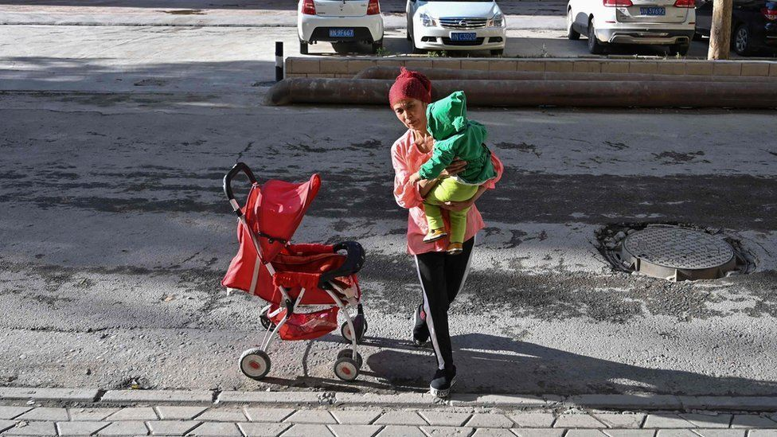

image copyright AFP

image caption It is alleged Uighur women have faced a "ruthless" birth control programme

Measures intended to prevent births within a group are among the activities that count as genocide in international law. The opinion sets out evidence of [mass forced sterilisation as part of a plan for population control](https://www.bbc.co.uk/news/world-asia-china-53220713) acknowledged by the Chinese authorities.

It concludes: "There is prolific credible evidence of Uighur women being subject to measures that prevent them from reproducing, either temporarily or permanently (such as by having IUDs non-consensually implanted or through forced removal of their wombs), as well as forced abortions. Such acts would, in our view, clearly constitute a form of genocidal conduct under [international law]."

Genocide can also include the forcible transfer of children from one group to another.

The opinion says: "There is evidence of Uighur children being forcibly removed from their parents. This includes their non-consensual placement in orphanages when one or both parents are in detention, and their mandatory placement in boarding schools.

It continues: "The fact that children are deprived of the opportunity to practise their Uighur culture…, that they are sometimes given Han names, and that they are sometimes subject to adoption by Han ethnic families, all bolsters the evidence that their forced removal is carried out with the intention of destroying the Uighur population as an ethnic group as such."

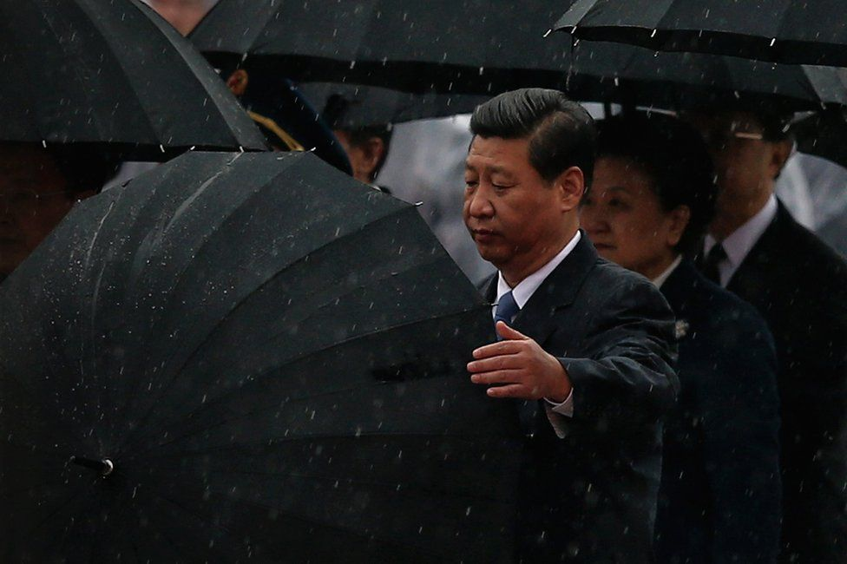

image copyright Getty Images

image caption The opinion says there is a "plausible" case that the policy against the Uighurs flows directly from President Xi Jinping

Significantly, the opinion says there is a "plausible" case that personal responsibility for the genocide lies with President Xi and two senior Chinese officials - Zhu Hailun, deputy secretary of Xinjiang's people's congress, and Chen Quanguo, party secretary in Xinjiang.

It points to leaked internal Communist Party documents, and other evidence, which it says show that "Mr Xi controls the overall direction of state policy and has made a range of speeches exhorting the punitive treatment of the Uighurs. Mr Chen and Mr Zhu have acted upon that overall policy by devising and implementing the measures which have been carried out in XUAR, including mass detention and surveillance."

It says: "We consider that there is a credible case against each of these three individuals for crimes against humanity."

It adds: "The evidence reviewed above suggests the close involvement of Xi Jinping, Chen Quanguo and Zhu Hailun in initiating and implementing a range of measures which, taken together, target Uighurs with a severity and to the extent that one could infer an intent to destroy the group as such.

"In those circumstances, we consider that there is a plausible inference that each of those three individuals possess the necessary intent to destroy, so as to support a case against them of genocide."

The Chinese embassy in London insisted that the population of Uighurs in Xinjiang was growing. All ethnic groups, it said, had the same legal status and freedoms of religion and culture.

"Some anti-China forces in the West have concocted and disseminated plenty of false information about Xinjiang and fabricated "lies of the century" in various forms," the embassy said. "They have smeared China's image and slandered its policies on Xinjiang."

It added: "Anyone who is fair-minded can see that the true intent of those forces is to suppress and contain China's development... Their moves are driven by a Cold War mentality, hegemonic worldview and zero-sum game mindset. China will never allow such farce and vicious demonization to succeed. Lies may mislead people for a while, but cannot win the trust of the world. Facts and truth will eventually bust all lies."