# Scientists unlock mysteries of world's oldest 'computer'

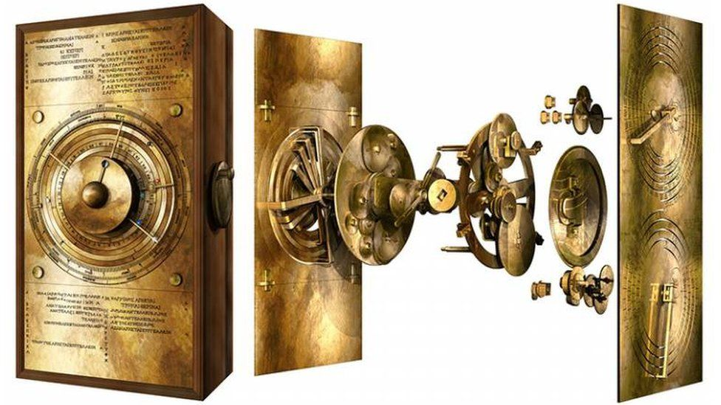image copyright Prof Tony Freeth / UCL

image caption Scientists used computer modelling to recreate the device's complex gear system

**A 2,000-year-old device often referred to as the world's oldest "computer" has been recreated by scientists trying to understand how it worked.**

The Antikythera Mechanism has baffled experts since it was found on a Roman-era shipwreck in Greece in 1901.

The hand-powered Ancient Greek device is thought to have been used to predict eclipses and other astronomical events.

But only a third of the device survived, leaving researchers pondering how it worked and what it looked like.

The back of the mechanism was solved by earlier studies, but the nature of its complex gearing system at the front has remained a mystery.

Scientists from University College London (UCL) believe they have finally cracked the puzzle using 3D computer modelling. They have recreated the entire front panel, and now hope to build a full-scale replica of the Antikythera using modern materials.

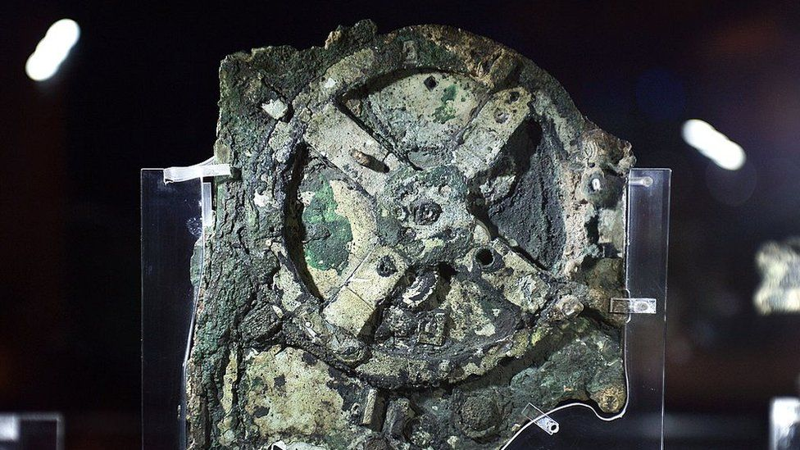image copyright AFP

image caption Only about a third of the device has survived and it is in more than 80 fragments

On Friday, [a paper published in Scientific Reports](https://www.nature.com/articles/s41598-021-84310-w) revealed a new display of the gearing system that showed its fine details and complex parts.

"The Sun, Moon and planets are displayed in an impressive tour de force of ancient Greek brilliance," the paper's lead author, Professor Tony Freeth, said.

"Ours is the first model that conforms to all the physical evidence and matches the descriptions in the scientific inscriptions engraved on the mechanism itself," he added.

The mechanism has been described as an astronomical calculator as well as the world's first analogue computer. It is made of bronze and includes dozens of gears.

The back cover features a description of the cosmos display, which shows the motion of the five planets that were known at the time the device was built.

But only 82 fragments - amounting to around a third of the device - survived, This meant scientists have had to piece together the full picture using X-Ray data and an Ancient Greek mathematical method.

**Article from** [**https://www.thoughtco.com/first-computer-charles-babbages-1221836**](https://www.thoughtco.com/first-computer-charles-babbages-1221836)

The first iteration of the computer as we now understand it came much earlier when, in the 1830s, an inventor named Charles Babbage designed a device called the Analytical Engine.

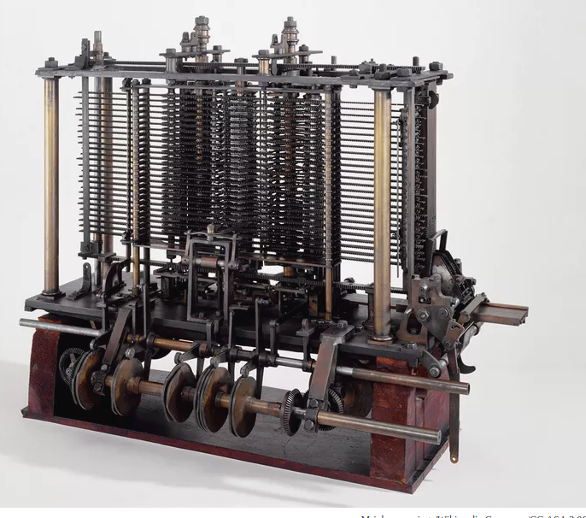

## Who Was Charles Babbage?

Born in 1791 to an English banker and his wife, [Charles Babbage](https://www.thoughtco.com/charles-babbage-biography-4174120) (1791–1871) became fascinated by math at an early age, teaching himself algebra and reading widely on continental mathematics. When in 1811, he went to Cambridge to study, he discovered that his tutors were deficient in the new mathematical landscape, and that, in fact, he already knew more than they did. As a result, he took off on his own to found the Analytical Society in 1812, which would help transform the field of math in Britain. He became a Royal Society member in 1816 and was a co-founder of several other societies. At one stage he was Lucasian Professor of Mathematics at Cambridge, although he resigned this to work on his engines. An inventor, he was at the forefront of British technology and helped create Britain’s modern postal service, a cowcatcher for trains, and other tools.

## The Difference Engine

Babbage was a founding member of Britain’s Royal Astronomical Society, and he soon saw opportunities for innovation in this field. Astronomers had to make lengthy, difficult, and time-consuming calculations that could be riddled with errors. When these tables were being used in high stakes situations, such as for navigation logarithms, the errors could prove fatal. In response, Babbage hoped to create an automatic device that would produce flawless tables. In 1822, he wrote to the Society’s president, Sir [Humphry Davy](https://www.thoughtco.com/humphry-davy-profile-1991579) (1778–1829), to express this hope. He followed this up with a paper, on the "Theoretical Principles of Machinery for Calculating Tables," which won the first Society gold medal in 1823. Babbage had decided to try and build a "Difference Engine."

When Babbage approached the British government for funding, they gave him what was one of the globe’s first government grants for technology. Babbage spent this money to hire one of the best machinists he could find to make the parts: Joseph Clement (1779–1844). And there would be a lot of parts: 25,000 were planned.

In 1830, Babbage decided to relocate, creating a workshop that was immune to fire in an area that was free from dust on his own property. Construction ceased in 1833, when Clement refused to continue without advance payment. However, Babbage was not a politician; he lacked the ability to smooth relationships with successive governments, and, instead, alienated people with his impatient demeanor. By this time the government had spent £17,500, no more was coming, and Babbage had only one-seventh of the calculating unit finished. But even in this reduced and nearly hopeless state, the machine was at the cutting edge of world technology.

## Difference Engine #2

Babbage wasn't going to give up so quickly. In a world where calculations were usually carried to no more than six figures, Babbage aimed to produce over 20, and the resulting Engine 2 would only need 8,000 parts. His Difference Engine used decimal figures (0–9)—rather than the binary ‘bits’ that Germany’s Gottfried von Leibniz (1646–1716) preferred—and they would be set out on cogs/wheels that interlinked to build up calculations. But the Engine was designed to do more than mimic an abacus: it could operate on complex problems using a series of calculations and could store results within itself for later use, as well as stamp the result onto a metal output. Although it could still only run one operation at once, it was far beyond any other computing device the world had ever seen. Unfortunately for Babbage, he never finished the Difference Engine. Without any further government grants, his funding ran out.

In 1854, a Swedish printer called George Scheutz (1785–1873) used Babbage’s ideas to create a functioning machine that did produce tables of great accuracy. However, they had omitted security features and it tended to break down, and, consequently, the machine failed to make an impact. In 1991, researchers at the London’s Science Museum, where [Babbage's records](https://collection.sciencemuseumgroup.org.uk/objects/co62245/babbages-analytical-engine-1834-1871-trial-model-analytical-engines) and trials kept, created a Difference Engine 2 to the original design after six years of work. DE2 used around 4,000 parts and weighed just over three tons. The matching printer was completed in 2000, and had as many parts again, although a slightly smaller weight of 2.5 tons. More importantly, it worked.

## The Analytical Engine

During his lifetime, Babbage was accused of being more interested in the theory and cutting edge of innovation than actually producing the tables the government was paying him to create. This wasn’t exactly unfair, because by the time the funding for the Difference Engine had evaporated, Babbage had come up with a new idea: the Analytical Engine. This was a massive step beyond the Difference Engine: it was a general-purpose device that could compute many different problems. It was to be digital, automatic, mechanical, and controlled by variable programs. In short, it would solve any calculation you wished. It would be the first computer.

The Analytical Engine had four parts:

* A mill, which was the section that did the calculations (essentially the CPU)
* The store, where the information was kept recorded (essentially the memory)
* The reader, which would allow data to be entered using punched cards (essentially the keyboard)
* The printer

The punch cards were modelled on those developed for the [Jacquard loom](https://www.thoughtco.com/joseph-marie-jacquard-1991642) and would allow the machine a greater flexibility than anything ever invented to do calculations. Babbage had grand ambitions for the device, and the store was supposed to hold 1,050 digit numbers. It would have a built-in ability to weigh up data and process instructions out of order if necessary. It would be steam-driven, made of brass, and require a trained operator/driver.

Babbage was aided by [Ada Lovelace](https://www.thoughtco.com/ada-lovelace-biography-3525491) (1815–1852), daughter of the British poet [Lord Byron](https://www.thoughtco.com/lord-byron-4689043) and one of the few women of the era with an education in mathematics. Babbage greatly admired her published translation of a French article on Babbage's work, which included her voluminous notes.

The Engine was beyond what Babbage could afford and maybe what technology could then produce, but the government had grown exasperated with Babbage and funding was not forthcoming. Babbage continued to work on the project until he died in 1871, by many accounts an embittered man who felt more public funds should be directed towards the advancement of science. It might not have been finished, but the Analytical Engine was a breakthrough in imagination, if not practicality. Babbage’s engines were forgotten, and supporters had to struggle to keep him well regarded; some members of the press found it easier to mock. When computers were invented in the twentieth century, the inventors did not use Babbage’s plans or ideas, and it was only in the seventies that his work was fully understood.

## Computers Today

It took over a century, but modern computers have exceeded the power of the Analytical Engine. Now experts have created a program that replicates the [abilities of the Engine](http://www.computerhistory.org/babbage/howitworks/), so you can [try it yourself](http://www.computerhistory.org/babbage/howitworks/). https://www.computerhistory.org/babbage/howitworks/