# Swiss hostage in Mali: Remains of missionary identified

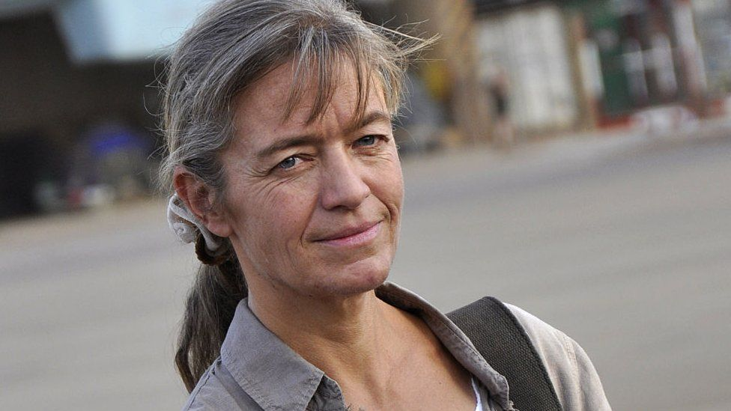

image copyrightAFP

image captionBéatrice Stöckli (seen here in 2012) was held by an affiliate of al-Qaeda

**The remains of a Swiss woman held hostage for more than four years in Mali have been found and identified, the Swiss foreign ministry says.**

Béatrice Stöckli was a Christian missionary in Timbuktu when she was kidnapped by jihadists in 2016.

A fellow hostage released last year had said Ms Stöckli had been killed by her al-Qaeda-linked captors.

A body recently handed over to Mali's authorities has been confirmed as hers using DNA.

Ms Stöckli had been briefly held by Islamist militants once before in 2012.

Malian and international armed forces have been struggling to contain a jihadist insurgency in the north of the country that first emerged in 2012.

Holding hostages for ransom, along with weapons and drug smuggling, are key to the survival of many groups in the vast desert region.

* [BBC Africa Live: Updates from the continent](https://www.bbc.co.uk/news/live/world-africa-47639452)
* [A quick guide to Mali](https://www.bbc.co.uk/news/world-africa-13881370)

Ms Stöckli was held by al-Qaeda's Sahel affiliate, Jamaat Nusrat al-Islam wal-Muslimin (JNIM).

News of her death came after [the release in October of four people being held by jihadists in Mali](https://www.bbc.co.uk/news/world-europe-54472504), including 75-year-old French charity worker Sophie Pétronin.

She told the French authorities that Ms Stöckli had been killed by her kidnappers about a month before their release.

A few days ago, the remains of a person, presumed to be the Swiss hostage, had been handed over to the authorities in Mali, the Swiss foreign minister said.

DNA samples were sent to Switzerland for further investigation.

"Sadly, we now have definitive evidence that the woman who was held hostage is dead," [Swiss Foreign Minister Ignazio Cassis said](https://twitter.com/ignaziocassis/status/1377182687912325123).

"But I am also relieved that we can return the woman's remains to her family and I would like to pass on my deepest condolences to them. I also wish to thank the Malian authorities for their assistance in helping to identify the body."

From the Swiss city of Basel, Ms Stöckli had worked in the mainly Muslim north of Mali for years.

She was first taken hostage in 2012, soon after Timbuktu fell to separatist and Islamist rebels - and freed after just over a week with the help of mediators from neighbouring Burkina Faso.

The release of the four hostages in October was part of a prisoner swap for more than 100 jihadists.